Assignment 2

|  |  |
| --- | --- |
| Student Name | Student Id |
| Muhammad Umar Farzan | 7328990 |
| Dev Nareshkumar Aswani | 7892366 |
| Mohammad Zain Reshi | 7776664 |
| Basil Rauf | 7873694 |
| Abdul Rehman Ikram | 7740657 |

# 

# Table Of Contents

**Table Of Contents** **2**

**Executive Summary** **5**

**Exploratory Data Analysis** **6**

EDA For Prepared Foods 6

Decomposition 7

ChangePoint Analysis 9

2015 Structural Break 10

2017 Structural Break 11

Peaks & Troughs For Each Year 13

Yearly Sales 18

Monthly Sales 19

Weekly Sales 20

Influence of promotions on daily sales of Prepared Foods 21

Anomaly Detection 22

EDA For Meats 26

Decomposition 27

ChangePoint Analysis 28

Anomaly Detection 30

Peaks & Troughs For Each Year 31

WEEKLY SALES 35

MONTHLY SALES 37

EDA For Poultry 38

Decomposition 39

ChangePoint Analysis 43

Peaks & Troughs For Each Year 45

Yearly Sales 49

Monthly Sales 50

Weekly Sales 51

Influence of promotions on daily sales of Poultry 52

Moving Averages 53

Structural Break Analysis 56

Anomaly Detection and Handling 57

Stationarity Analysis 57

EDA For Liquor, Wine And Beer 60

Decomposition 61

ChangePoint Analysis 65

Peaks & Troughs For Each Year 67

Yearly Sales 73

Monthly Sales 73

Weekly Sales 75

Influence of promotions on daily sales of Poultry 76

Moving Averages 77

Structural Break Analysis 80

Anomaly Detection and Handling 81

Stationarity Analysis 81

EDA For Frozen Foods 84

Decomposition 85

ChangePoint Analysis 92

Peaks & Troughs For Each Year 94

Yearly Sales 99

Monthly Sales 100

Weekly Sales 101

Influence of promotions on daily sales of Frozen Foods 102

Moving Averages 103

Structural Break Analysis 107

Anomaly Detection and Handling 107

Stationarity Analysis 108

**Examining Relationship between Sales of different Product Families** **111**

Correlation Analysis 111

ScatterPlot Matrix 112

Granger Causality Test 113

**Multivariate Modeling** **114**

VAR 114

p=14 114

Preprocessing 114

Forecast 118

p=14 123

Preprocessing 123

Forecasting 126

p=25 132

Preprocessing 132

Forecasting 135

Excel Sheet Predictions 140

MARIMA 141

**Conclusion** **142**

**References** **143**

# 

# Executive Summary

The presented report is dedicated to taking the reader through the variety of techniques used to analyze, and predict the time series of the 5 product families, Frozen Foods, Liquor,Wine and Beer, Meats, Poultry, and Prepared Foods.

The introductory section illustrates an exploratory analysis of the various time series and the corresponding insights. A variety of techniques including the basic run sequence plot to observe the characteristics of the underlying data on the face of it along with a bunch of probable reasons behind the form that the data takes.

This is followed by an in depth analysis of the time series using decomposition. Several attempts have been made at decomposing the time series using a variety of techniques such as additive, multiplicative, and STL decomposition.

Subsequently an attempt has been made to analyze change points in the data using change point analysis, which also paves the way for analyzing the elusive weekly seasonality using the peak-trough analysis.

Furthermore, a more quantitative approach to analyzing sales, within the week, month, and through the years coupled with the influence of exogenous factors like promotions and natural disasters has been adopted, involving several key visuals providing piercing insights.

The relationship between the sales of several product families has been explored through the use of heat maps, scatter plots, and statistical tests like the Granger test. Anomaly detection and handling was also performed to streamline the modeling process, using the Anomalize package and associated functions coupled with robust imputation techniques leveraging decomposition.

The subsequent section of the report deals with multivariate modeling that involves the use of two key and industry standard models like the VAR (Vector autoregression) and MARIMA (Multivariate Autoregressive Integrated Moving Average), where several attempts were made using different preprocessing techniques, like, smoothing, normalization, transformation, and the extremely crucial differencing which is key to making the time series stationary. The quality of the model was estimated using a variety of techniques along with an in depth analysis of residuals, which is the cornerstone of time series modeling.

# Exploratory Data Analysis

The data provided was for different stores across various Favorita stores in Ecuador, with the value of the sales being the total sales for a product family on a particular day, and at a particular store. So the original dataset also had other attributes apart from sales like store_nbr which identifies where the product was sold, family being the product family, and on promotion which quantifies the number of products of a product family that were on sale at a given day and a store. It might be interesting to look at the effect of items being promoted on the sales of a product family. The time series for each product family were grouped across all stores to give an aggregate of the sales value per day.

## EDA For Prepared Foods

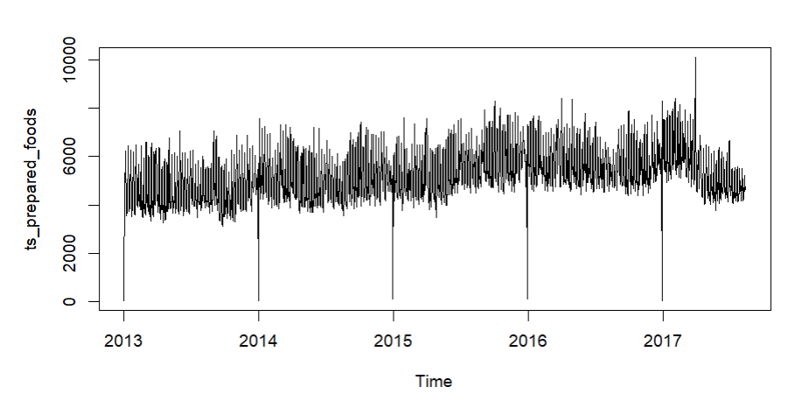

Looking into the time series for prepared foods from the period of 2013 to 2017, the time series does not show a clear increasing or decreasing trend over the years. It appears to be relatively stationary, while fluctuating around a constant mean level.

We can see periodic dips in the data which is slightly evident, indicating that there may be a seasonal pattern. We see this occurring annually. The seasonal effect is stable because the amplite seems consistent over the years

Undoubtedly, the data shows very high variability and noise, the frequent spikes and drops show the volatility of the data. The random fluctuations around the mean level show the level of noise

We need to further analyse the pattern of dips perhaps using seasonal decomposition later on.

### Decomposition

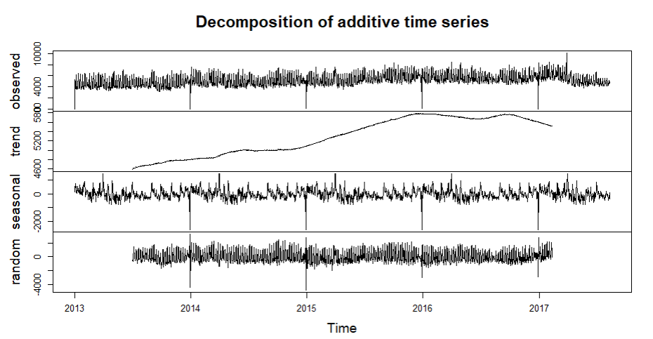

1. **The observed component**

The series shows seasonal patterns and high variability with significant periodic drops

1. **Trend component**

We can see a gradual increase from 2013 to mid 2015 followed by stabilization and a slight decrease towards the end of 2016 and 2017

The increase here could indicate the growth in demand for prepared foods during this period, while the stabilization and decrease also affected by external circumstances which need to be looked into

1. **The seasonal component**

This shows regular fluctuations with annual peaks and drops. The fluctuations seem to be consistent over the years indicating a stable seasonal pattern

The peaks over here correspond to specific times likely to holidays or festival season where the demand for prepared foods could increase.

1. **Random component**

The presence of significant noise shows that the time series is quite volatile, meaning there are many unmodeled factors affecting the data.

Looking into improvising the noise and capturing the underlying patters we could look into exponential smoothing for better results, and even outlier detection analysis to identify any necessary values which could distort the time series

**STL Decomposition (Additive)**

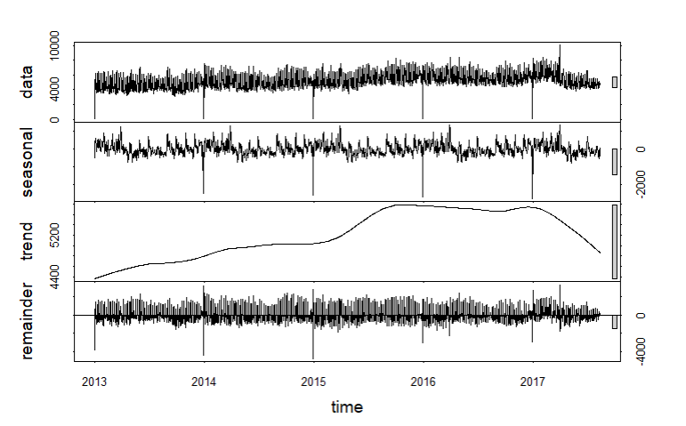

Moving onto the STL Decomposition (Additive), looking into each of the components

1. **Data**

The values from 2013 to 217 are shown and seem to fluctuate around a certain level with a bit of noise, there are some noticeable patterns and variability

1. **Seasonal**

The seasonal component appears consistent over the course of the years showing regular seasonal patterns.

1. **Trend**

The trend shows a gradual increase from 2013 to 2016, followed by a decline in 2017. This shows a rise and a fall in the overall level of data over this period.

1. **Remainder**

The remainder appears to be no obvious patterns suggesting that the decomposition has effectively isolated the trend and seasonal components

### ChangePoint Analysis

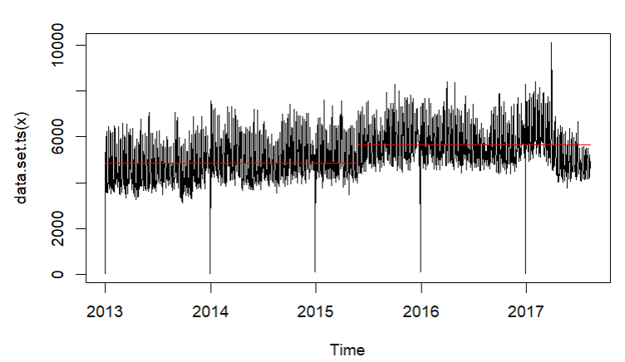

The horizontal segment shifts show how the mean level of the time series shifts. We can see major changes around mid 2015 and also mid 2016

The mean level seems relatively stable from 2013 to early 2015, a noticeable increase is observed around mid 2015 which continues till mid 2016.

A decline in the mean level is seen after the peak from 2016 showing a decrease in the sales of prepared foods as seen in the drop after 2017

#### 2015 Structural Break

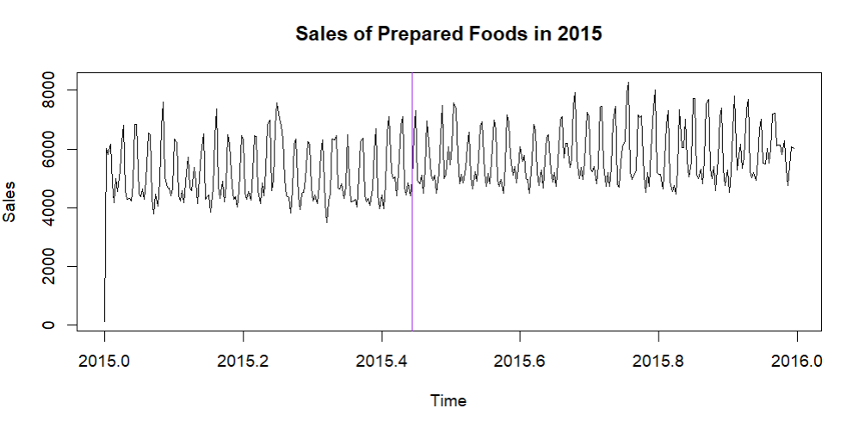

A significant change point is detected here around the middle of the period showing a change in the sales pattern

A major change point is detected around April of 2015 leading to a change in the sales patterns

Mean Sales: The mean sales increased from 5200 to 6000, indicating a positive shift in the sales of prepared foods.

Variance: The variance remained constant, suggesting that the variability in sales did not change significantly.

1. **Average Sales Comparison:**
   * Pre-Change Point Average Sales: 𝜇1≈5,500*μ*1​≈5,500 units.
   * Post-Change Point Average Sales: 𝜇2≈4,000*μ*2​≈4,000 units.

The average sales dropped by approximately Δ𝜇=𝜇1−𝜇2=1,500Δ*μ*=*μ*1​−*μ*2​=1,500 units, representing a 27.27% decrease.

1. **Variability Analysis:**
   * Pre-Change Point Standard Deviation (𝜎1*σ*1​): Higher variability, 𝜎1≈1,800*σ*1​≈1,800 units.
   * Post-Change Point Standard Deviation (𝜎2*σ*2​): Lower variability, 𝜎2≈1,200*σ*2​≈1,200 units.

The standard deviation decreased by Δ𝜎=𝜎1−𝜎2=600Δ*σ*=*σ*1​−*σ*2​=600 units, indicating a 33.33% reduction in variability.

1. **Seasonal Peak Analysis:**
   * Pre-Change Point Peak Frequency: High frequency of peaks around 7,000 units.
   * Post-Change Point Peak Frequency: Peaks reduced to around 5,500 units.

#### 2017 Structural Break

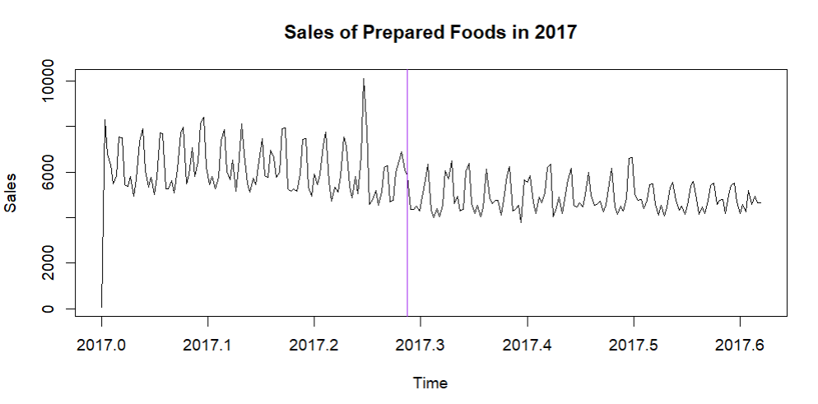

Post the change point from February to June, we notice a drop in average sales with peaks reaching around 7000 units. The weekly seasonal pattern is still there but the amplitude is reduced.

1. **Average Sales Comparison:**
   * **Pre-Change Point Average Sales:** 𝜇1≈7,500*μ*1​≈7,500 units.
   * **Post-Change Point Average Sales:** 𝜇2≈5,000*μ*2​≈5,000 units.

The average sales dropped by approximately Δ𝜇=𝜇1−𝜇2=2,500Δ*μ*=*μ*1​−*μ*2​=2,500 units, representing a 33.33% decrease.

1. **Variability Analysis:**
   * **Pre-Change Point Standard Deviation (σ1):** Higher variability, 𝜎1≈2,000*σ*1​≈2,000 units.
   * **Post-Change Point Standard Deviation (σ2):** Lower variability, 𝜎2≈1,500*σ*2​≈1,500 units.

The standard deviation decreased by Δ𝜎=𝜎1−𝜎2=500Δ*σ*=*σ*1​−*σ*2​=500 units, indicating a 25% reduction in variability.

1. **Seasonal Peak Analysis:**

**Pre-Change Point Peak Frequency:** High frequency of peaks around 10,000 units.

**Post-Change Point Peak Frequency:** Peaks reduced to around 7,000 units.

**Analysing the impact of the earthquake on April 16, 2016 on the sales of prepared foods**

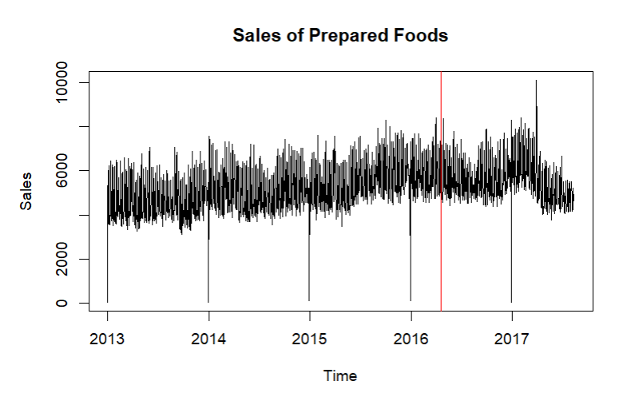

Prior to the earthquake, sales appeared to be relatively stable with constant fluctuations. However when we look at what happened after the earthquake, there seems to be an evident decline in the sales of prepared foods as seen in the diagram after the redline. The trend seems to continue for a while until it gets back to normal in a few months

This could be due to the effect of earthquakes causing disruption to the supply chains making it difficult for stores to stock prepared foods and could also be due to the damage done to infrastructure which could have hindered the distribution of food by delivery

### Peaks & Troughs For Each Year

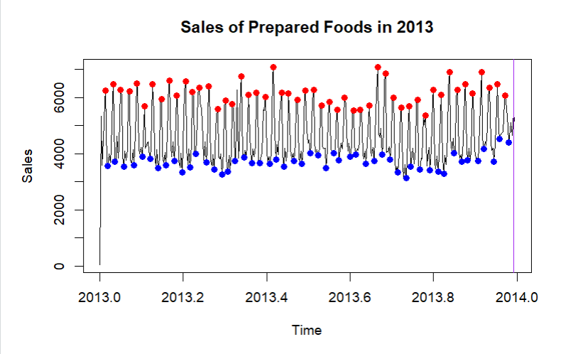

The time series plot for the year 2013 shows a clear cyclical pattern within each year. Sales Peak around 6000 units while low or averages mostly stay between 2000 and 4000 units

The sales start quite high but show consistent patterns of peaks and troughs. There is a noticeable increase in the frequency and amplitudes of peaks around midyear. This could means a seasonal effect like maybe summer holidays or other increased outdoor activities.

In the Latter parts of the months from June to august, sales remain high with regular peaks likely influenced by back to school season or other late summer activities

The average sales level is around the midpoint of the range indicating steady demand throughout the year

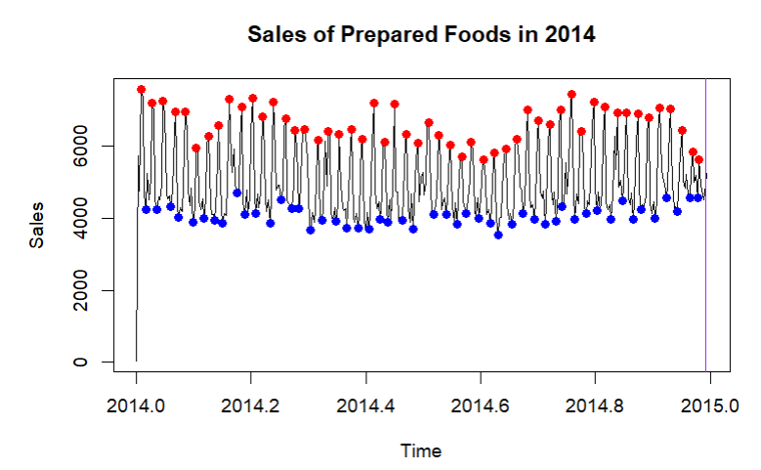

The sales exhibit a fairly consistent trend throughout the year, not much of significant upward or downward trends are seen

There is a clear weekly seasonal pattern observed in the data. Sales spike at regular intervals for the days of the week. The red points or roughs seem to occur on weekends or days where there is higher consumer demand.

While the lowest sale points also show regular weekly patterns most likely during normal weekdays

There is also an “ End of the year” trend which can be seen here like from 2015 in august onwards showing higher sales during the holiday season

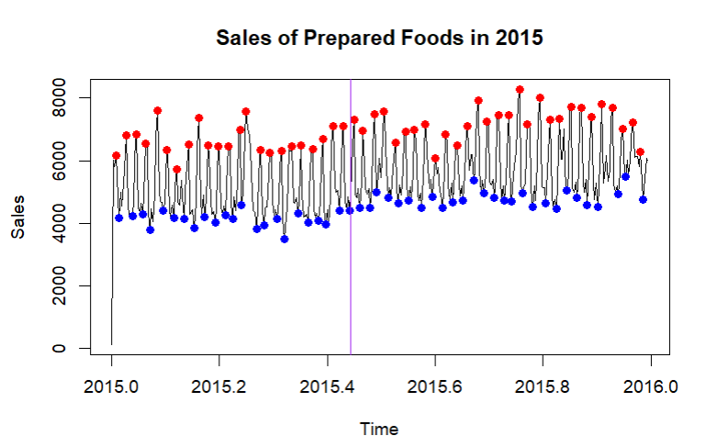

Similar to 2014, the sales of prepared foods in 2015 show a consistent pattern without significant long term or down term trend. The end of the year around 2015 august shows a slight increase in sales, aligned with higher consumer activity during the holiday season.

We can also see occasional peaks that reach higher points than usual, this could be due to special events or promotions. While the blue points below which seem distant from the data may be at times when the store is closed or less consumer activity

The change point detected here clearly shows a shift around April 2015 where the mean of the sales in general significantly began to increase, this is seen by the vertical line

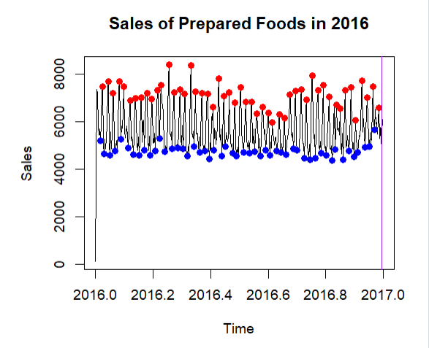

The series shows seasonal trend with peaks and throughs that repeat throughout the year.

The variability within each weekly cycle is high in this case, showing that there is a significant difference in sales from one day to another in one particular week

Although the variance does not really change at a huge effect over the course of the whole year indicating stability in the patterns.

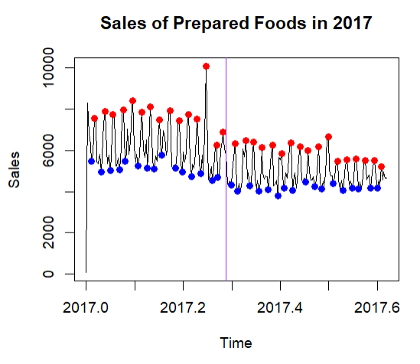

A significant change point is detected here around the middle of the period showing a change in the sales pattern

Before the change point from january to mid February we see higher average sales with peaks reaching about 10000 units. Strong weekly seasonality is seen here indicating weekends or maybe holidays.

The peaks that reach lower points than usual are seen here due to the structural break, this is due to the lack of consumer activity which may be due to various reasons which shall be examined when the store is closed.

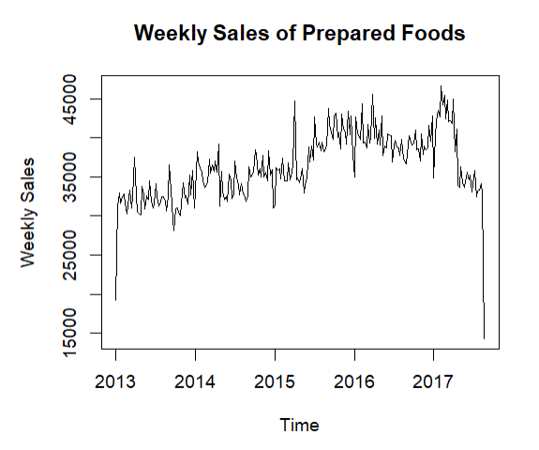

There is a clear upward trend in sales from 2013 to late 2016. However, there is a significant drop in sales towards the end of 2017. We can see that the variance in sales actually tends to increase over time mainly around the period with higher volatility like 2016-2017

The consistent upward trend until early 2017 shows that demand for prepared foods was growing steadily, likely due to factors such as increasing consumer preference for convenience or maybe new product launches.

The presence of strong weekly seasonal effects suggests that certain days or periods within each week consistently see higher or lower sales. This could be due to consumer shopping habits or even promotions.

The random component shows irregular variations that are not explained by the trend or seasonality.

High variability in the random component indicates that there are factors affecting sales unpredictably from week to week.

### Yearly Sales

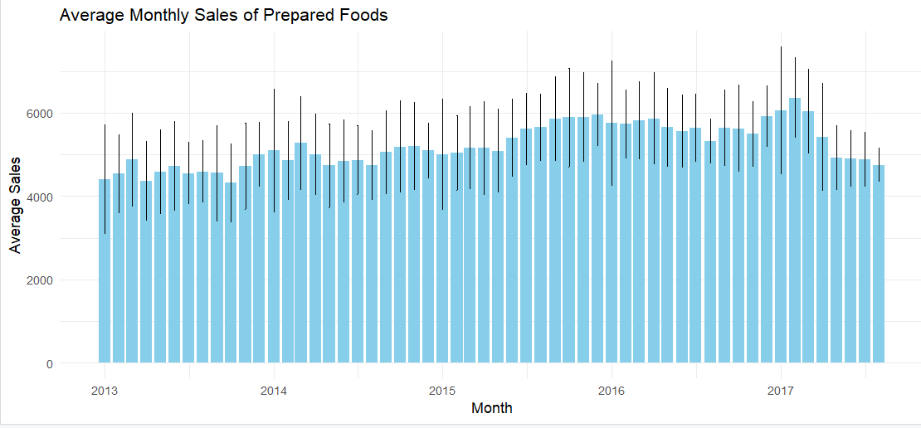

Looking in to the months for each of the years, we can see that from 2013 to early 2017 there is an upward trend in the average monthly sales.

Typically November and December show higher sales, increased spending during these months could be due to The holiday season approaching.

There are also noticeable peaks around June and July this could possibly be due to other seasonal factors which need to be xplored

January often shows a dip in sales which might be due to the post holiday lull.

Also if we see March and April there seem to be lower consumer spending during these months

### Monthly Sales

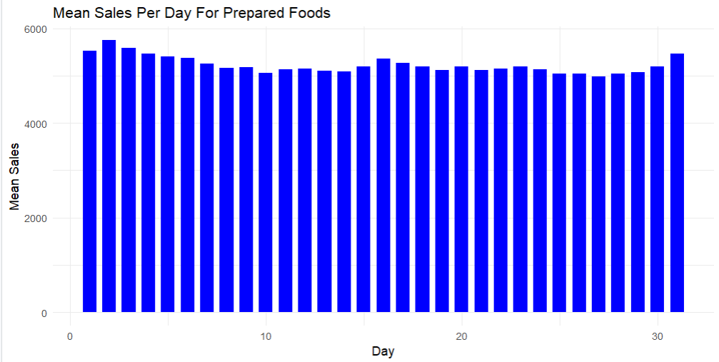

We can see that the beginning of the month tends to have the highest sales and then it tends to decrease slightly and increase again in the middle of the month, this could be because at the beginning of the month people receive their salaries so this can lead to higher spendings, another reason could be due to stores having monthly sales at the start of evert month.

### Weekly Sales

Average weekly sales of prepared foods by the day of the week

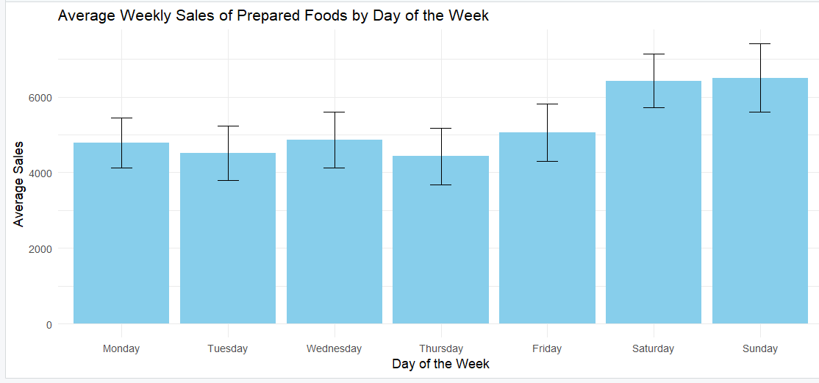

Sales are relatively steady from Monday To Friday, there is a noticeable increase in sales on Saturday and Sunday

**Daily Sales Analysis:**

Monday: Average sales are around 4500.

Tuesday: Slight decrease from Monday, average sales around 4200.

Wednesday: Sales increase slightly compared to Tuesday, around 4600.

Thursday: Sales are similar to Wednesday, around 4500.

Friday: Sales drop slightly to around 4300.

Saturday: Significant increase, with average sales around 6200.

Sunday: Sales are high, around 6100, slightly lower than Saturday.

The increase in sales on the weekend could be due to higher consumer demands as people have more free time to eat out or purchase prepared foods.

Weekday sales are lower and more stable showing consistent but lower demand during the working days

Tuesday shows the lowest sales which could be due to many factors perhaps no promotional activities.

### Influence of promotions on daily sales of Prepared Foods

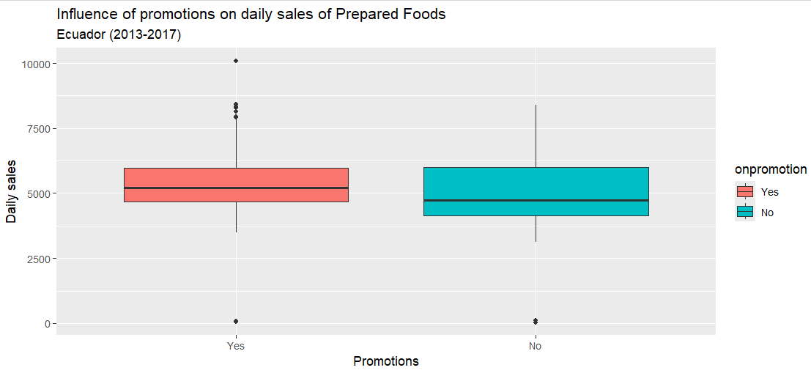

Both of the categories show similar ranges and medians for daily sales.

We can see that the effect of promotions on the daily sales for prepared foods doessss not significantly change, through the overlapping IQR and similar median values, though we can see a small increase in the median sales when the promotions are applied showing a minor positive effect

It can be concluded that there is some variability with regards to the data because of the presence of outliers excluding the effect of promotions

### Anomaly Detection

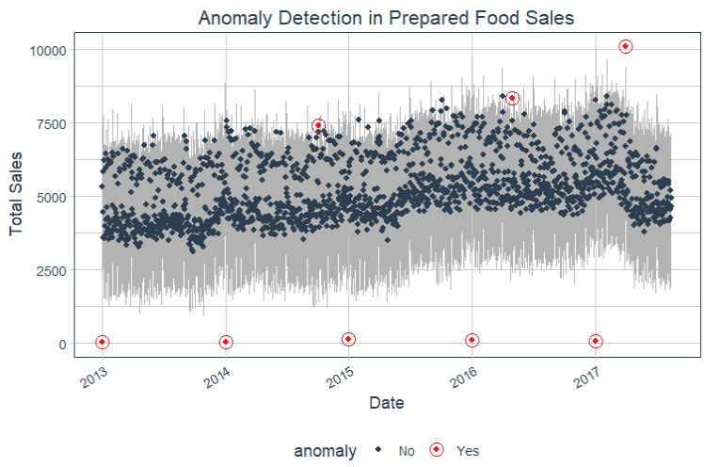

Looking into the anomalies detected as seen in the plot, 8 had been detected. However, the anomalies below are clearly seasonal, therefore we won’t consider them to be anomalies and they will not be considered for the handling.

Instead observations 642, 1214 and 1548 will need to be dealt with.

Anomalies identified in data_anomalized are replaced with the sum of trend and seasonal components (trend_component[i] + seasonal_component[i]).

**Comparison After Dealing With Anomalies**

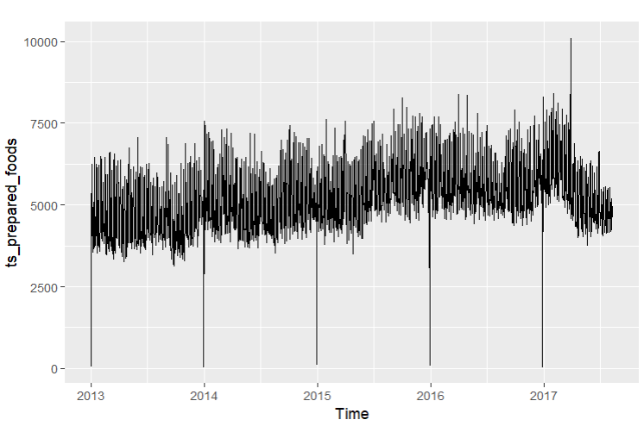

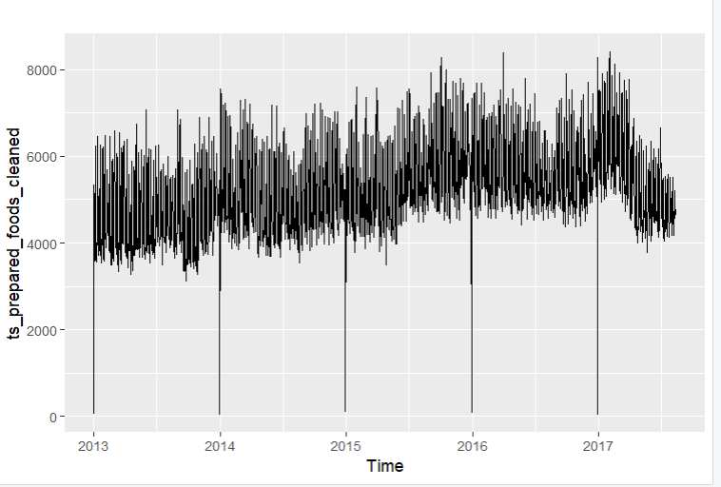

**Processed Time Series**

**1. Data Range:**

The values now span from around 2,000 to 8,000, with the highest values being lower than in the raw data. This suggests that the most extreme values have been filtered out.

**2. Anomalies:**

The processed plot shows fewer anomalies, especially noticeable as less severe spikes that are less far from their neighboring data points. These fewer anomalies suggest a more stable dataset.

**3. Pattern and Seasonality:**

The seasonal fluctuations are more pronounced, making it easier to identify the seasonal trends. The absence of extreme values has clarified the seasonal patterns.

**4. Trend:**

The trend is more visible in the processed data, indicating a steady rise in the values over time. The trend line is smoother and easier to understand.

The processed data has effectively dealt with the anomalies found in the original time series. The extreme spikes and outliers have been significantly reduced or eliminated, leading to a dataset that is more uniform and easier to analyze. The seasonal patterns are now clearer, aiding in the interpretation of the cyclical nature of the data. The trend in the processed data is more apparent, offering a more reliable view of the gradual increase in values over time.

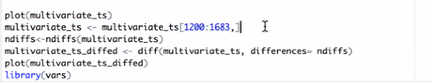

## 

## EDA For Meats

Exploratory Data Analysis for Meats

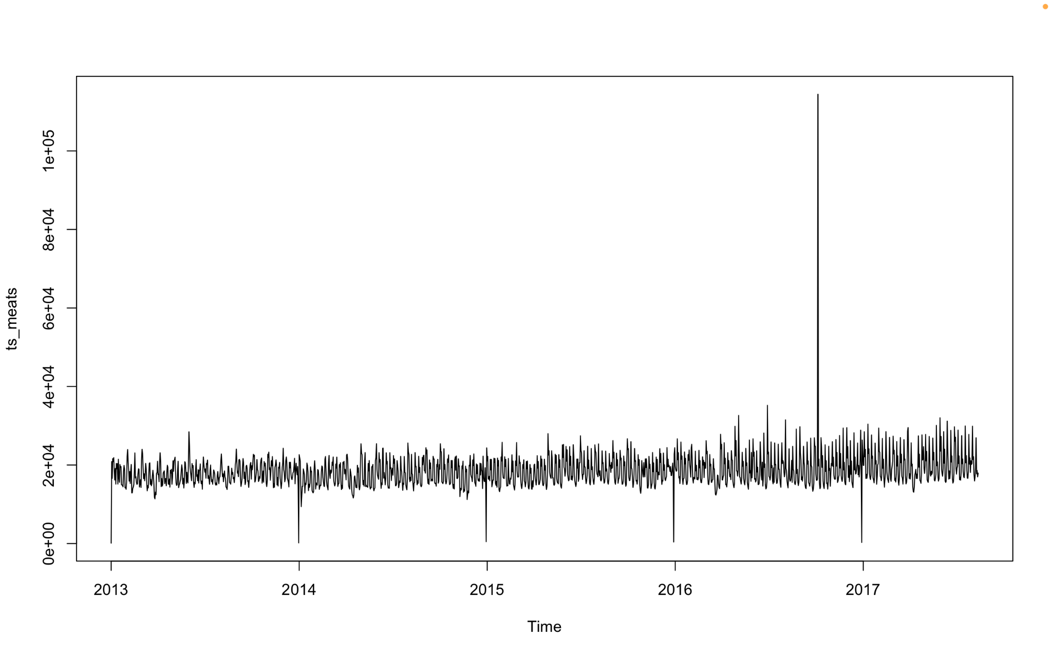

The plot above depicts sales patterns for meats from the year 2013 to 2017. There are no structural breaks present and there seems to be more fluctuations towards the end periods starting from the middle part of 2015. It seems that the sales for meats drop significantly at the start of each year, the reasons could be -

Increased inflation

As a consequence of inflation many people are more conscious of their spending at the start of each year leading to decreased sales of items like meats etc

A lot of people make commitments to health resolutions meaning they decide to adapt to a more healthy/vegetarian diet, leading to fewer consumption of

Religious reasons

Many Catholics abstain from consuming meat at the start of each year which leads to fewer sales.

Government Policies/ regulations

Changes in government policies for import/export could have a huge impact on the sales of meats at the start of each year

EarthQuake

There’s a very significant increase in meat sales around April 2016 because after the earthquake people were perhaps in the state of fear that such an event could potentially occur again. Additionally a lot of people may not already have a long term store of foods and people were cognizant that there would be a lot demand for buying food items such as meat and feared that prices might keep skyrocketing as time passes by so that resulted in them buying more food items to be kept for a long term store that can be cooked at home and lesser of prepared foods that are perishable and not suitable for long term store in the event that a natural catastrophe occurs again

### Decomposition

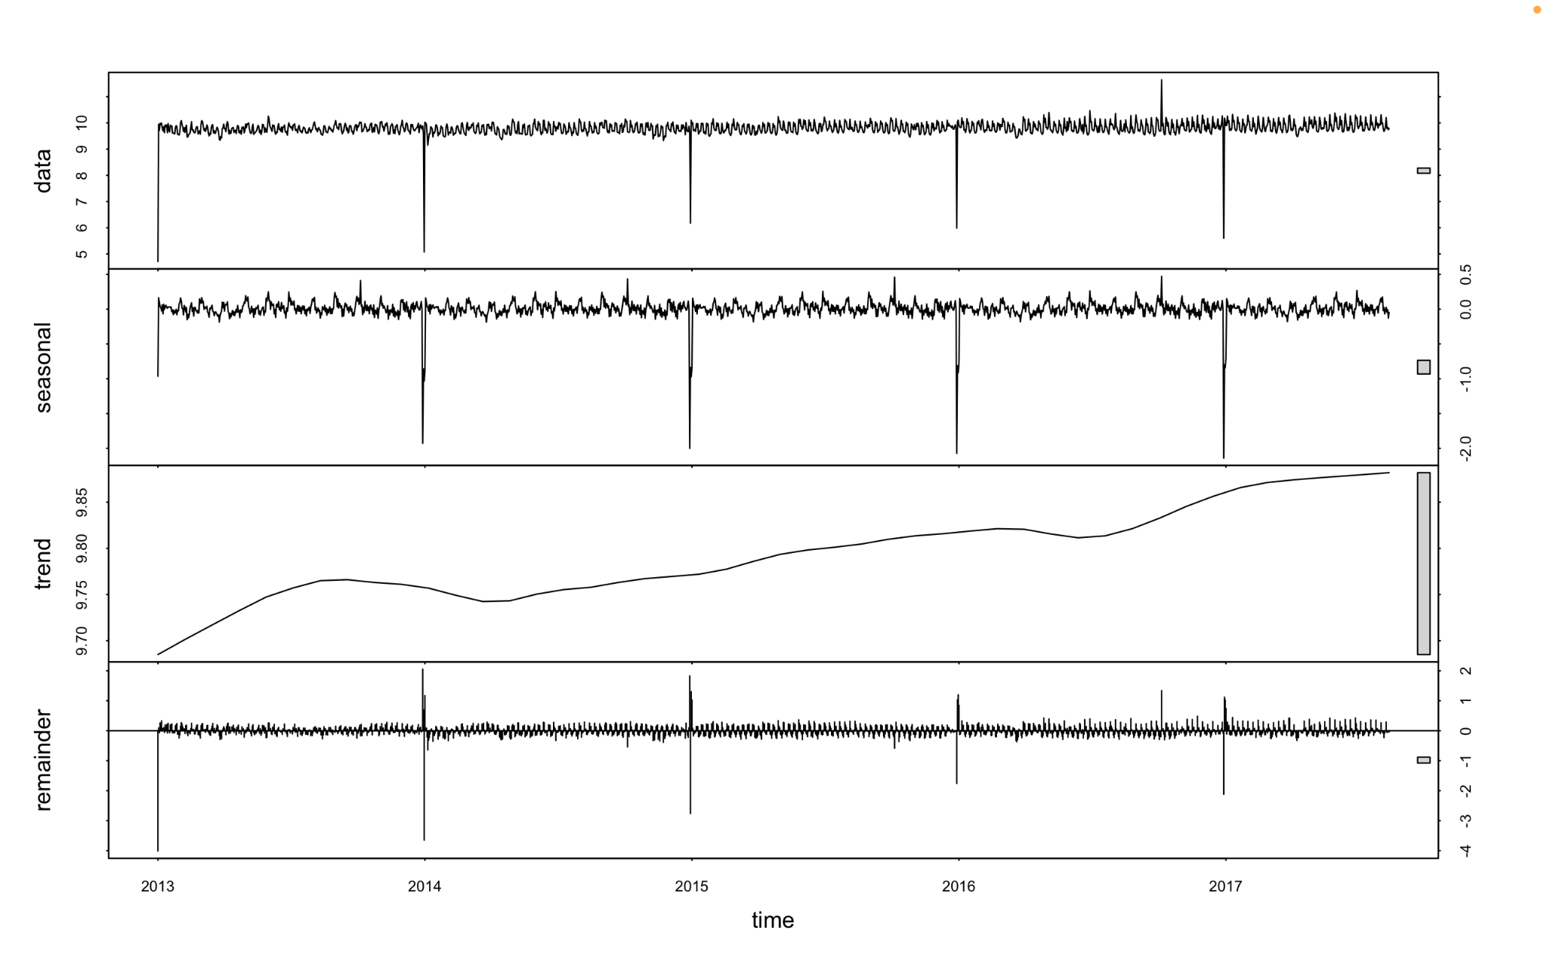

1. Observed

The sales pattern shown for meats sales from 2013-2017.

1. Trend

The trend components indicates an increase in the year 2013 around the end 2014 showing signs of stable economy and consumer confidence meaning they’re able to purchase high costing items like meats.

However starting from 2014 there is a slight decline followed by very stagnant growth due to external factors such as the oil price crash, which occurred around the same time period. It had a negative impact on ecuador's economy since it heavily relies on crude oil exports, therefore it also meant that people would have to adjust their spending on high cost items like meats etc

When the earthquake happened the sales stopped still for a while until they began to progress more rapidly than before since the economy had started to recover , oil prices were stable etc therefore people started consuming more.

1. Seasonal

The seasonal component with consistent troughs and peaks seems to illustrate a stable seasonal pattern across the years. The likely causes for the troughs could be rise of inflation, changed government policies etc, whereas the peaks were caused by higher demand due to holidays and festivals which lead to higher consumption of items like meats etc.

1. Random

The random component accounts for the ‘noise’ or unmodelled factors that affect the

data making it volatile.

### ChangePoint Analysis

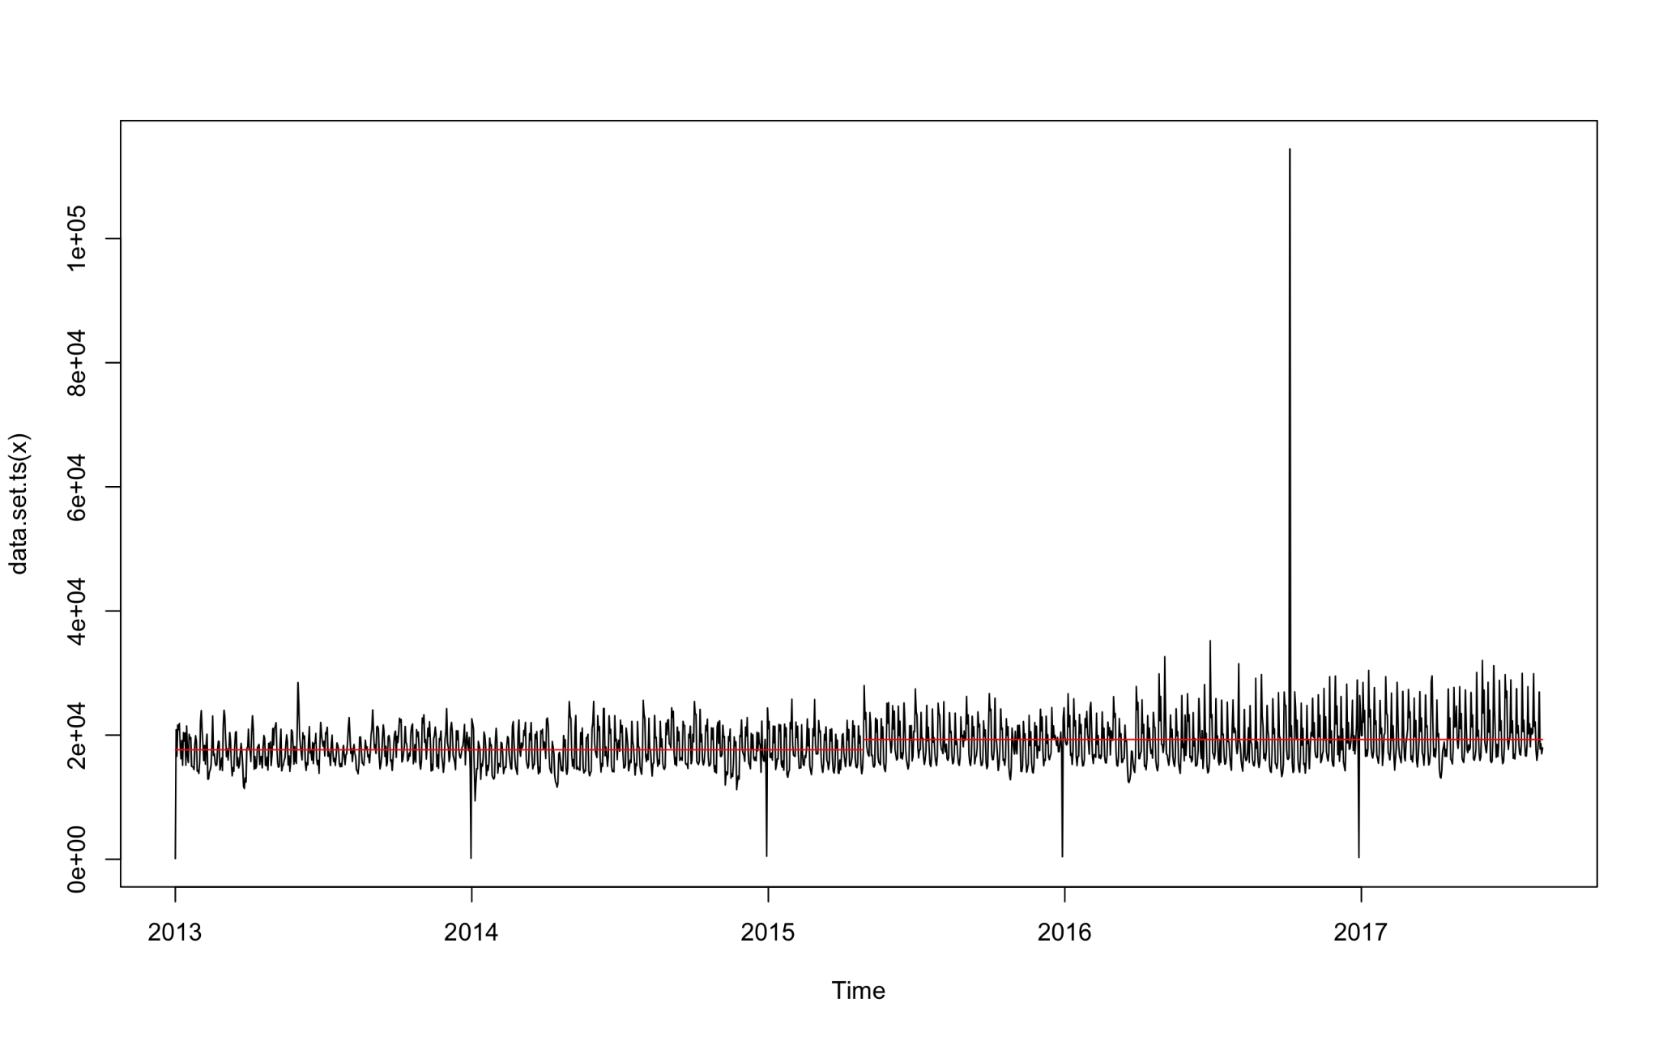

It can be clearly seen that the mean remains stable from 2013 to 2015 until it shifts upwards at around mid 2015 indicating that on average there were higher sales from that period onwards due to higher demand. The fluctuations become more unstable, ie. rise and fall more after the first quarter of 2016.

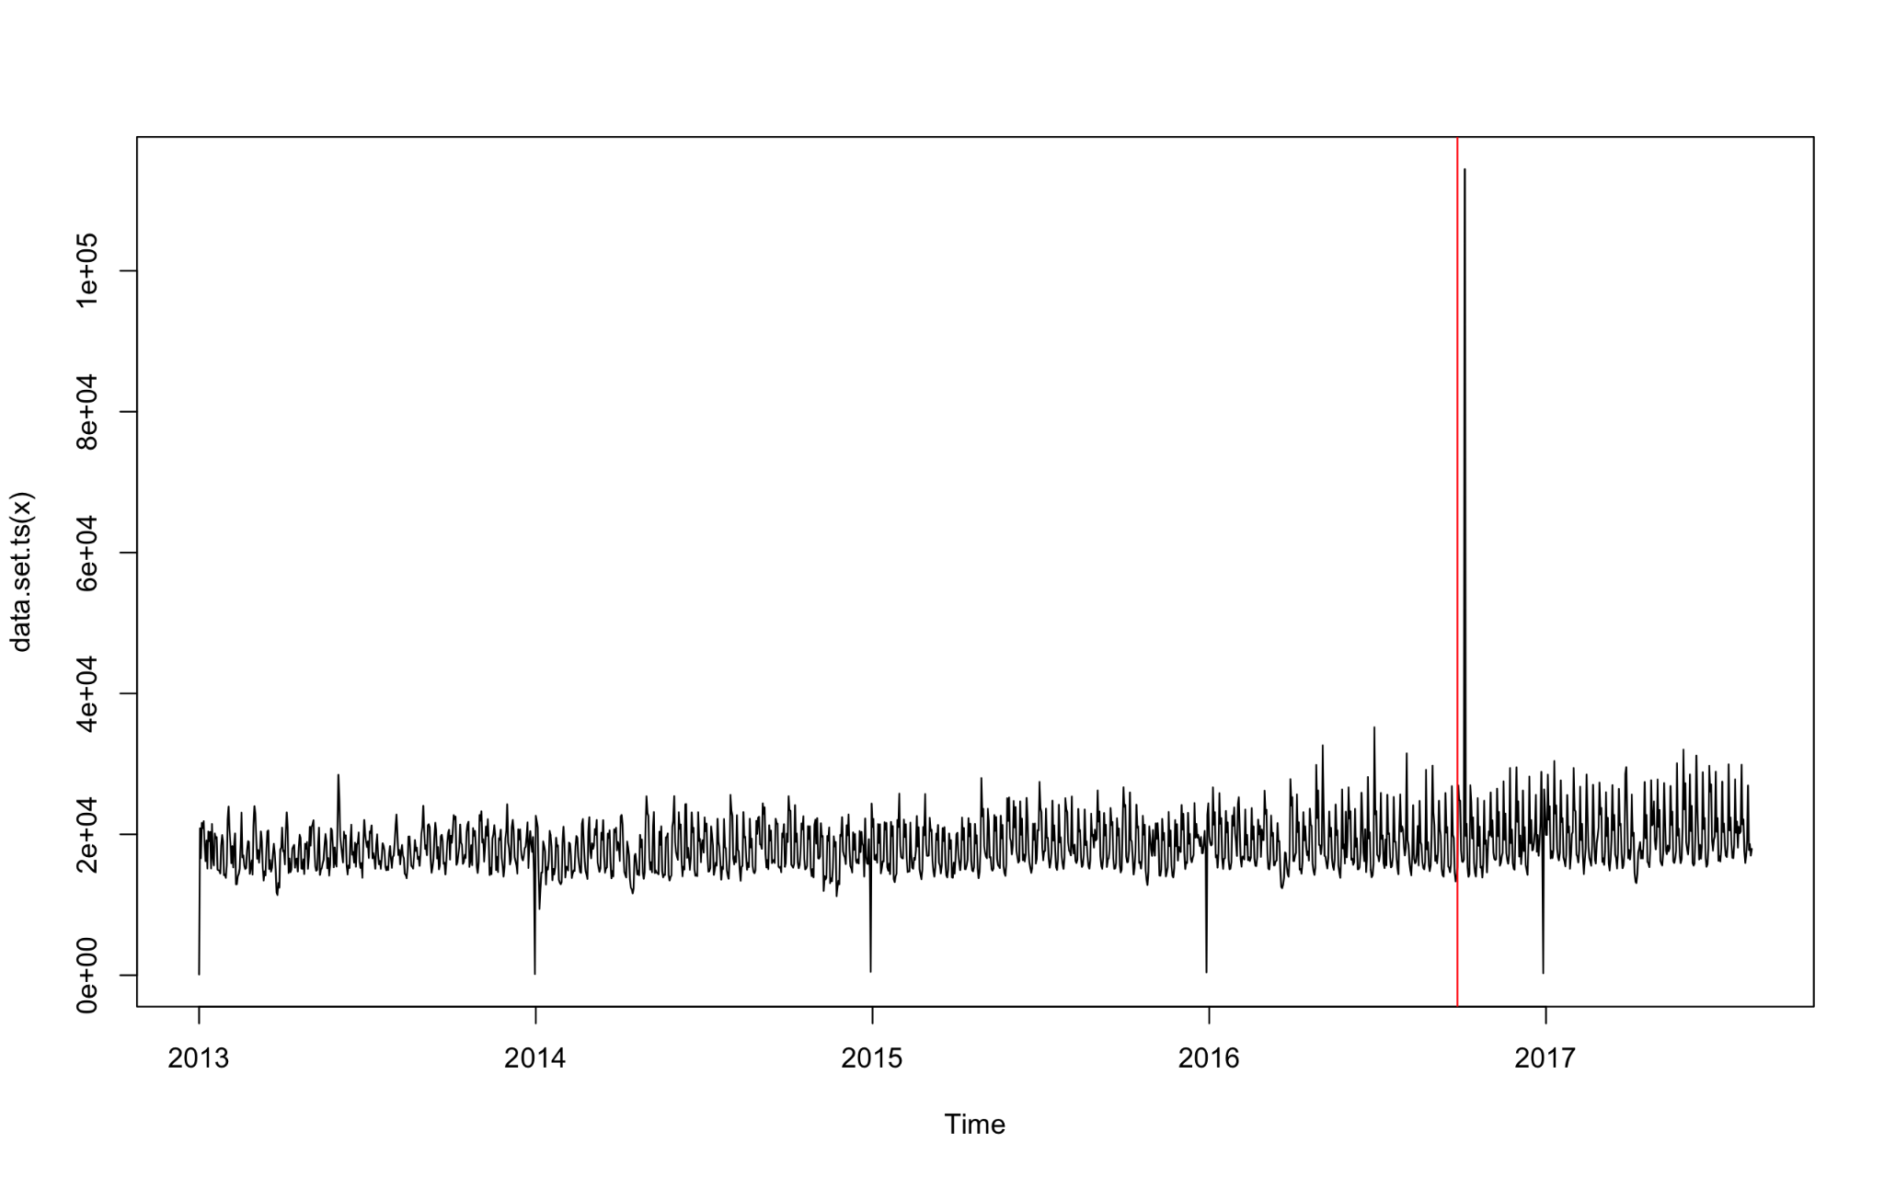

The diagram above depicts the effect of the earthquake on the fluctuations on the meat sales; it can be observed that the peaks and troughs after the earthquake seem to be a bit less stable. Soon after the earthquake there is a very sharp rise in meats sales, right after that period there seems to a period of increasing sales until around the end of 2017 when there’s a sharp decline, followed by relatively stable but higher fluctuations as opposed to the time period before the earthquake

### Anomaly Detection

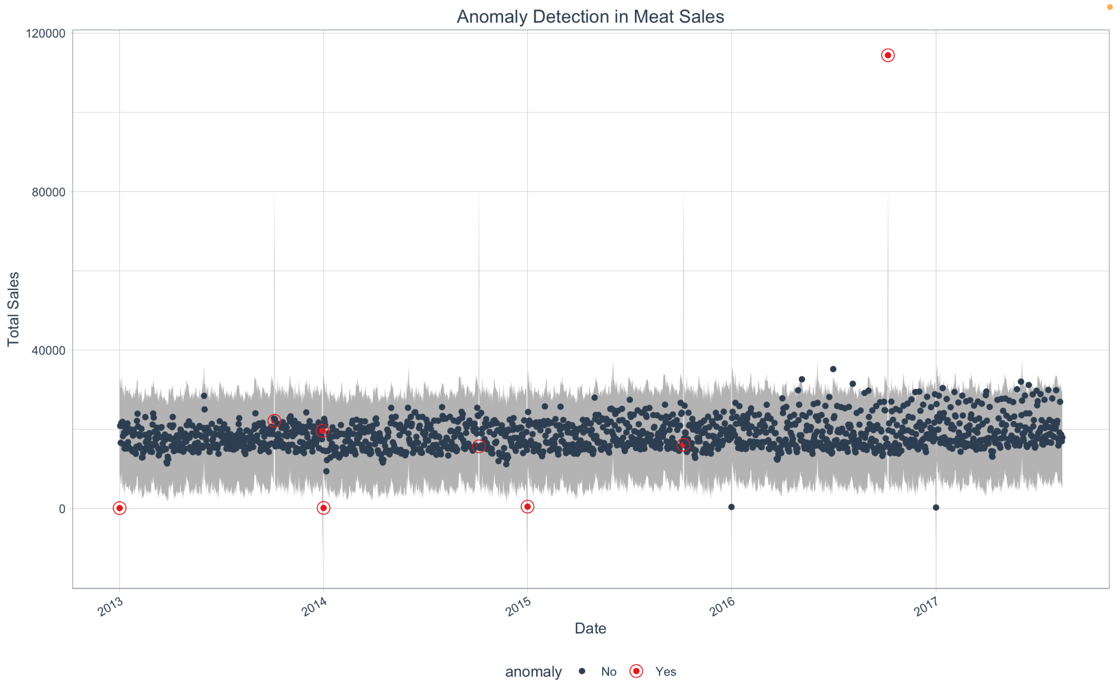

The plot above shows the occurrences of anomalies using the anomalize package. It can be seen that the anomalies occur consistently at the end of each year, along with an anomaly present at around the middle of 2016 when the earthquake occurred.

Removing Points

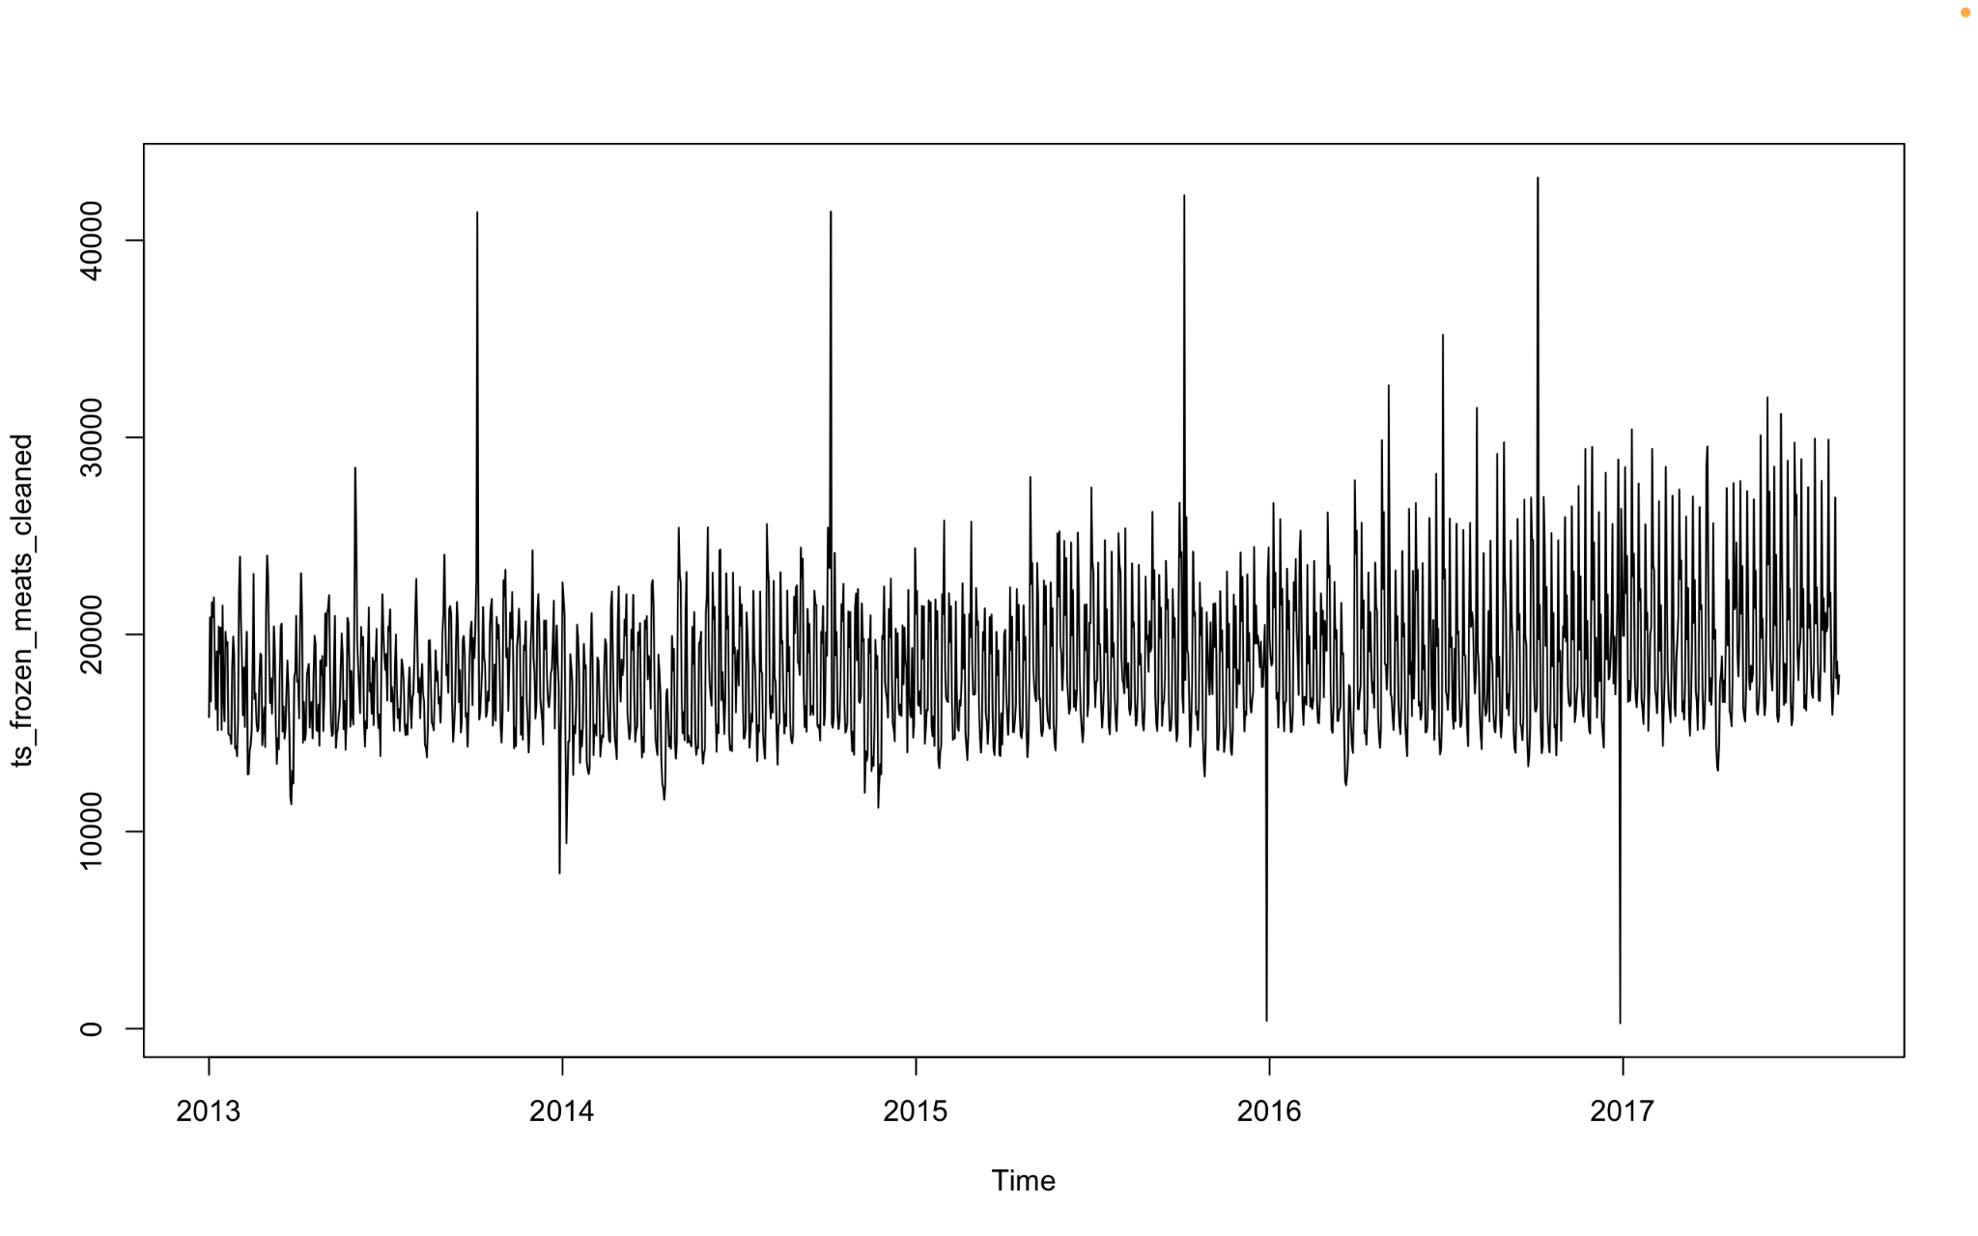

### Peaks & Troughs For Each Year

Meats Sales 2013

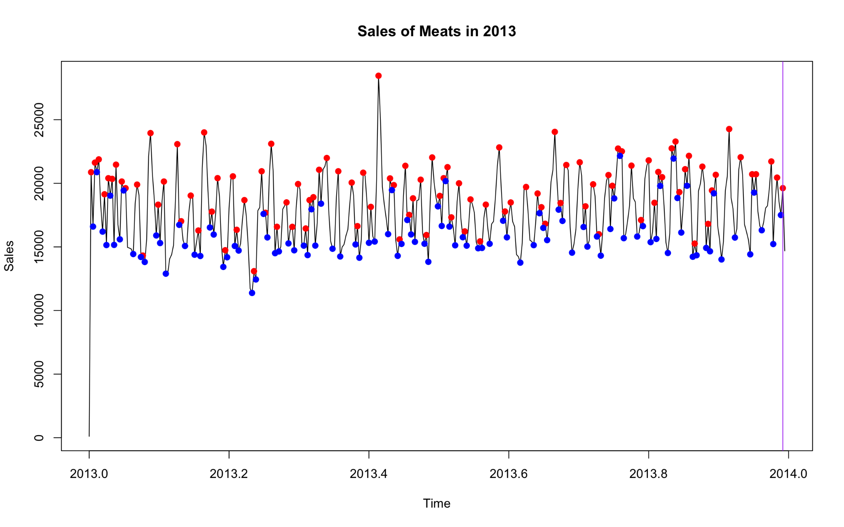

Shows slight decrease in the first quarter of the year followed by a sudden increase. Near the half year mark there seems to be sharp rise in meat sales due to inflation. The sales remain nearly constant throughout the entire year followed by a sharp decline towards the end of the year

Meats Sales in 2014

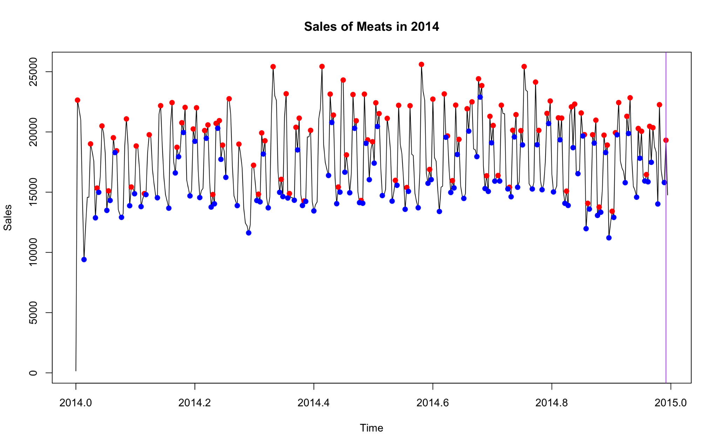

Fairly constant sales up until the first quarter of the year with the exception of a small dip at the beginning of the year followed by another at around the quarter of the year. Then the sales remain constant up until the final quarter of the year where there’s a gradual decline followed by a sudden increase, then a very sharp decline towards the end of the year

Meats in 2015

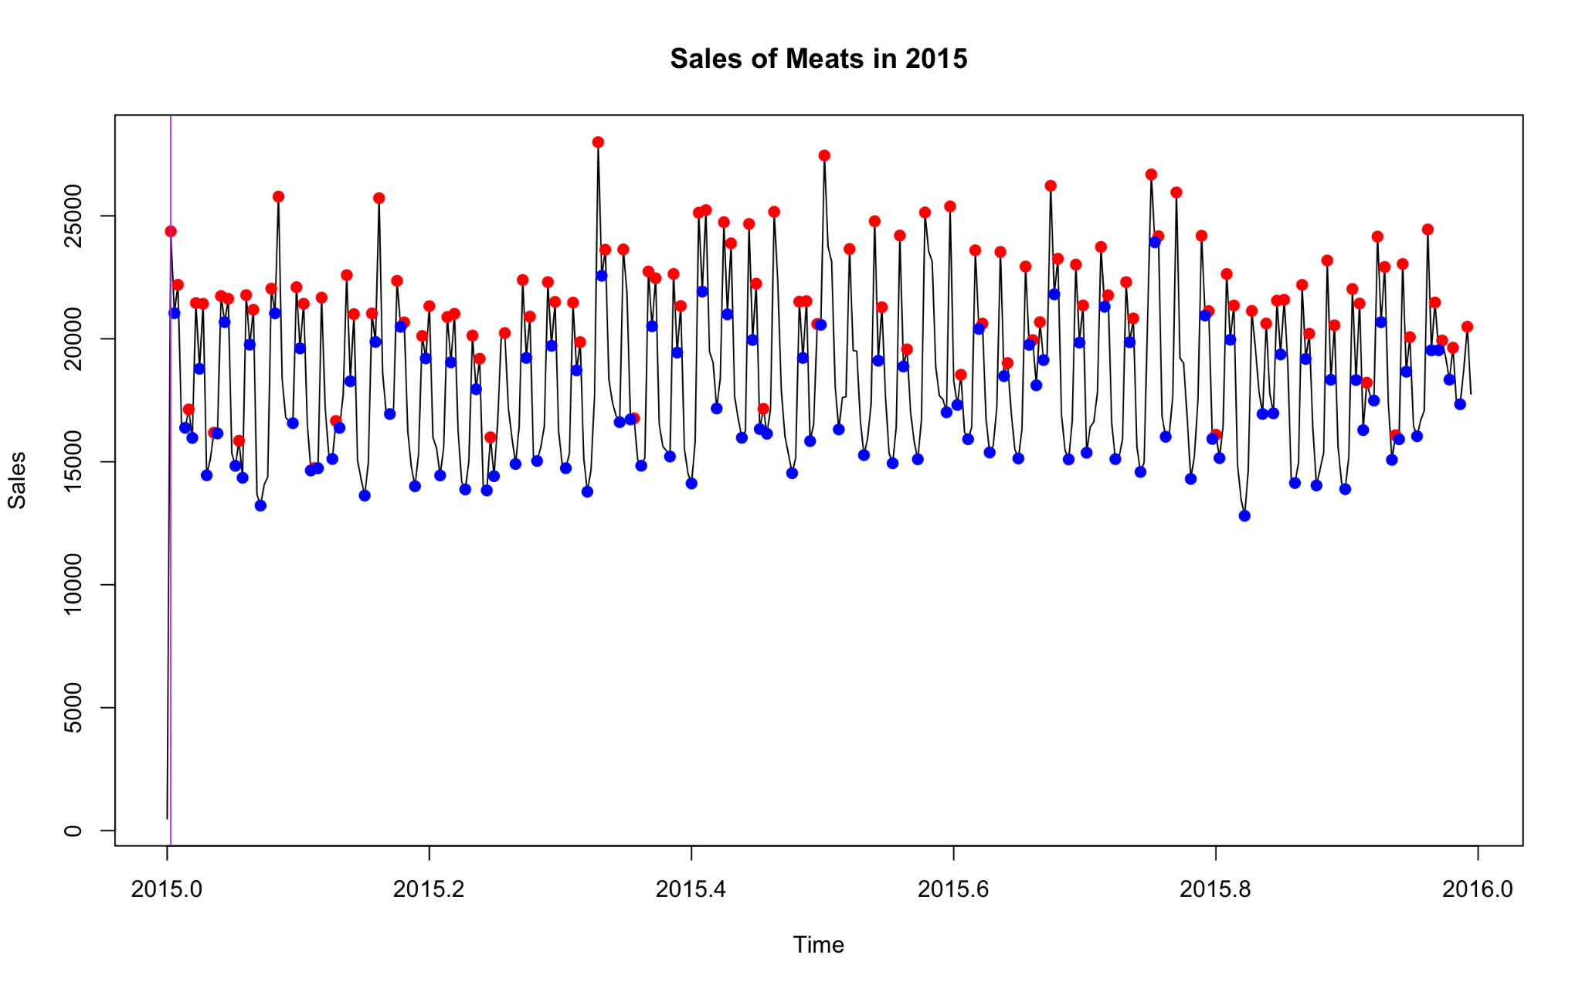

Relatively constant variance with a gradual increase in the first half of the year followed by a very gradual decrease in sales up until the final quarter, theres a relatively fast increase followed by a very sudden dip at the end of the year

Meats in 2016

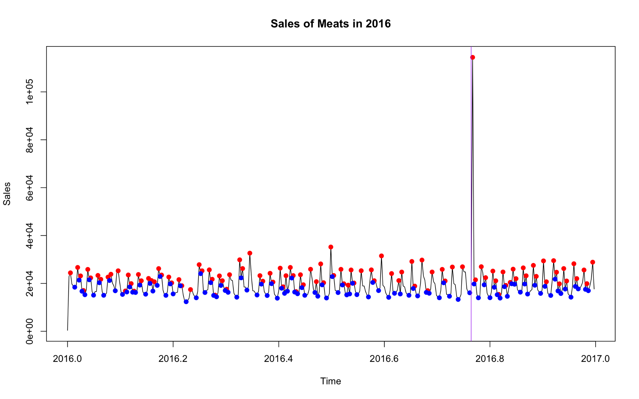

Almost constant sales throughout the year with some fluctuations, the prices rose a bit higher towards the half of the year and there's an anomaly present at the 9th month after the earthquake, when the earthquake happened.

Sales of Meats in 2017

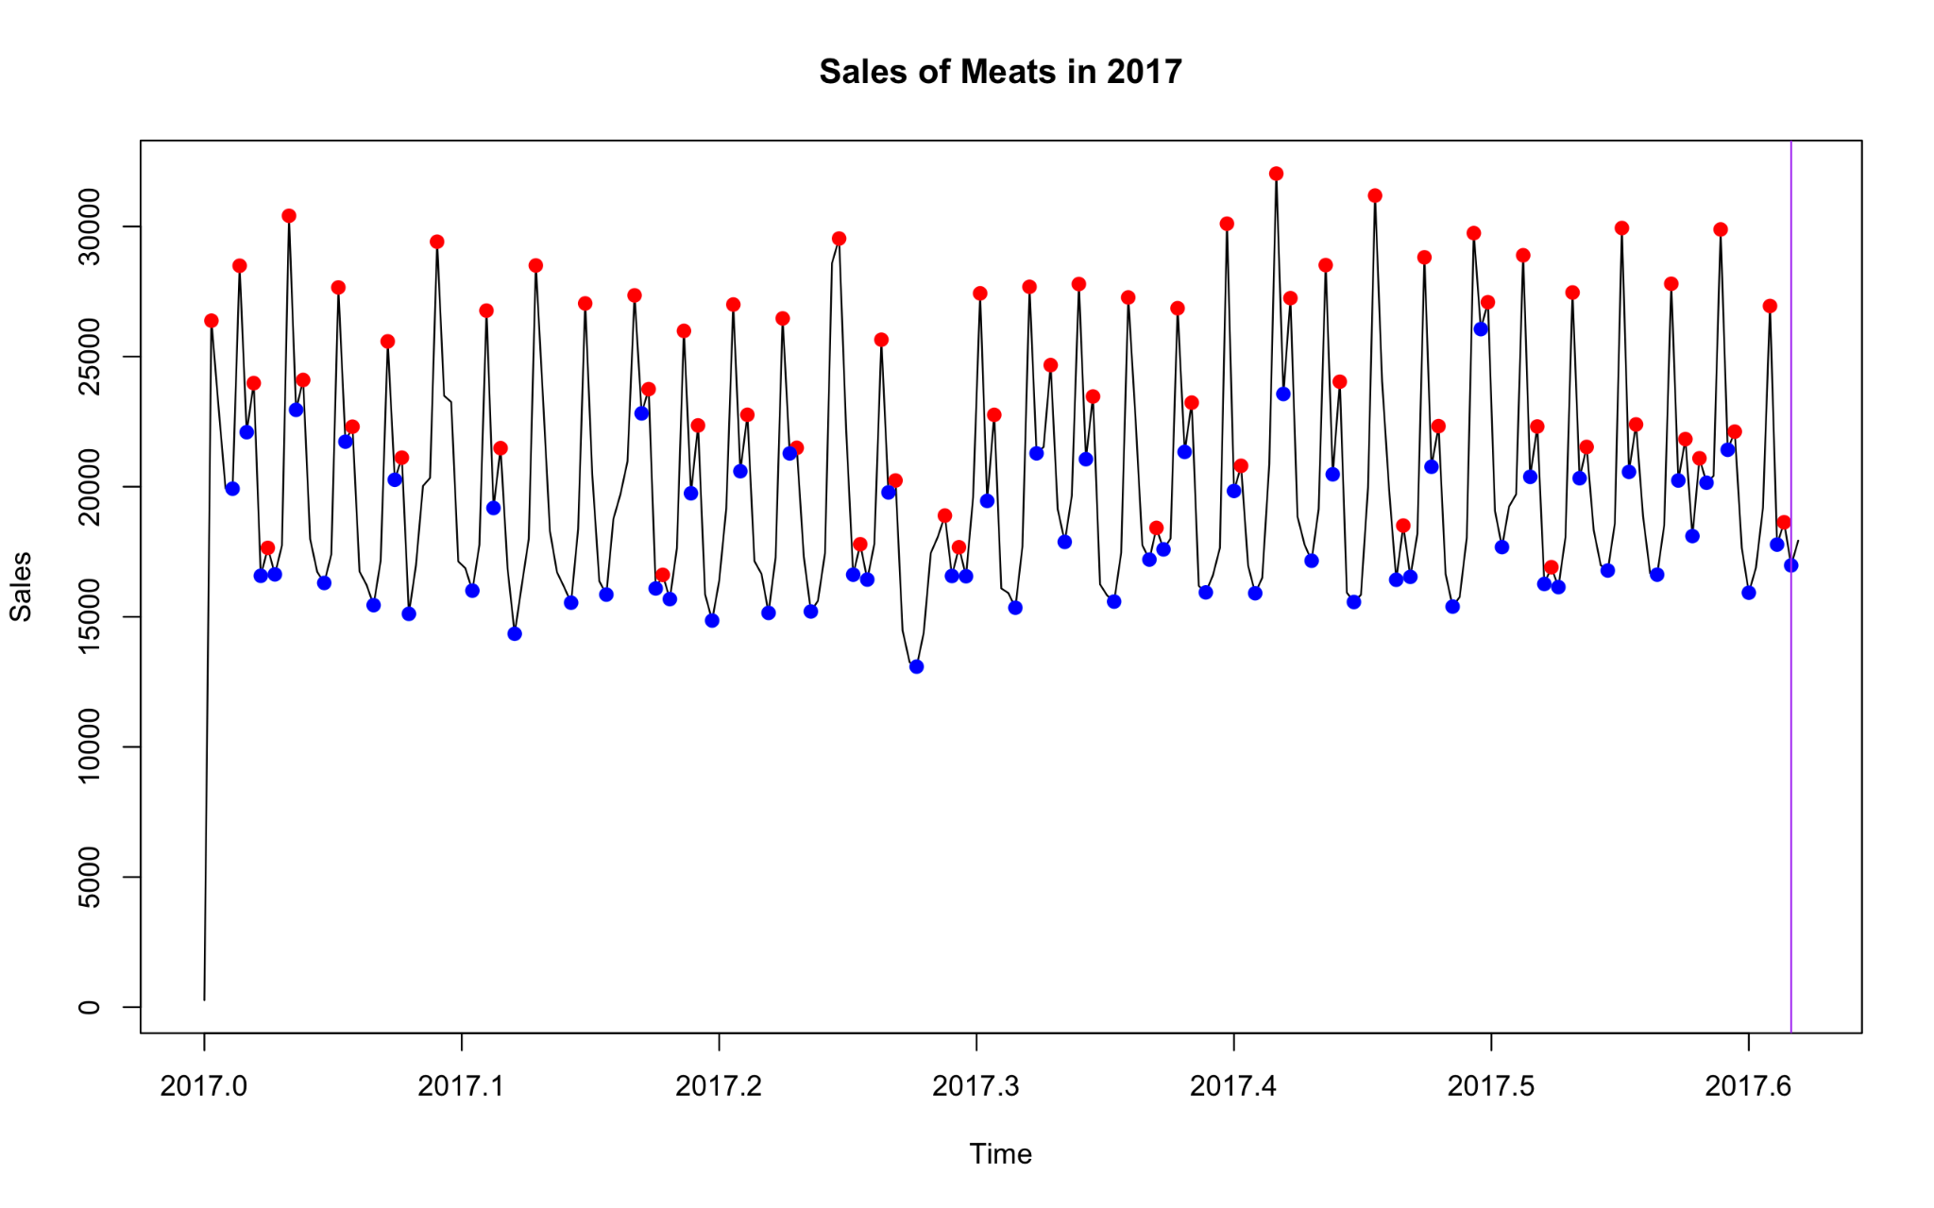

The sales in 2017 start off with a gradual decrease until around the first quarter of the year followed by a dip in the 4th month followed by a constant fluctuation. Then for the rest of the period from 5th month onwards the sales are higher relative to the previous time period in 2017.

### WEEKLY SALES

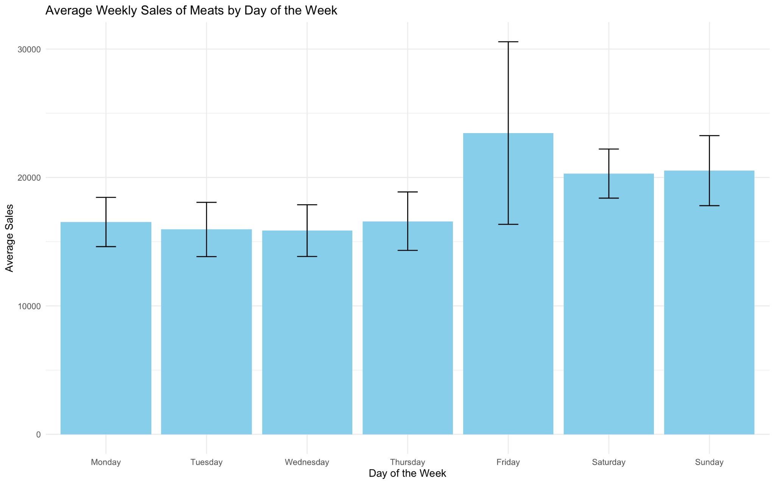

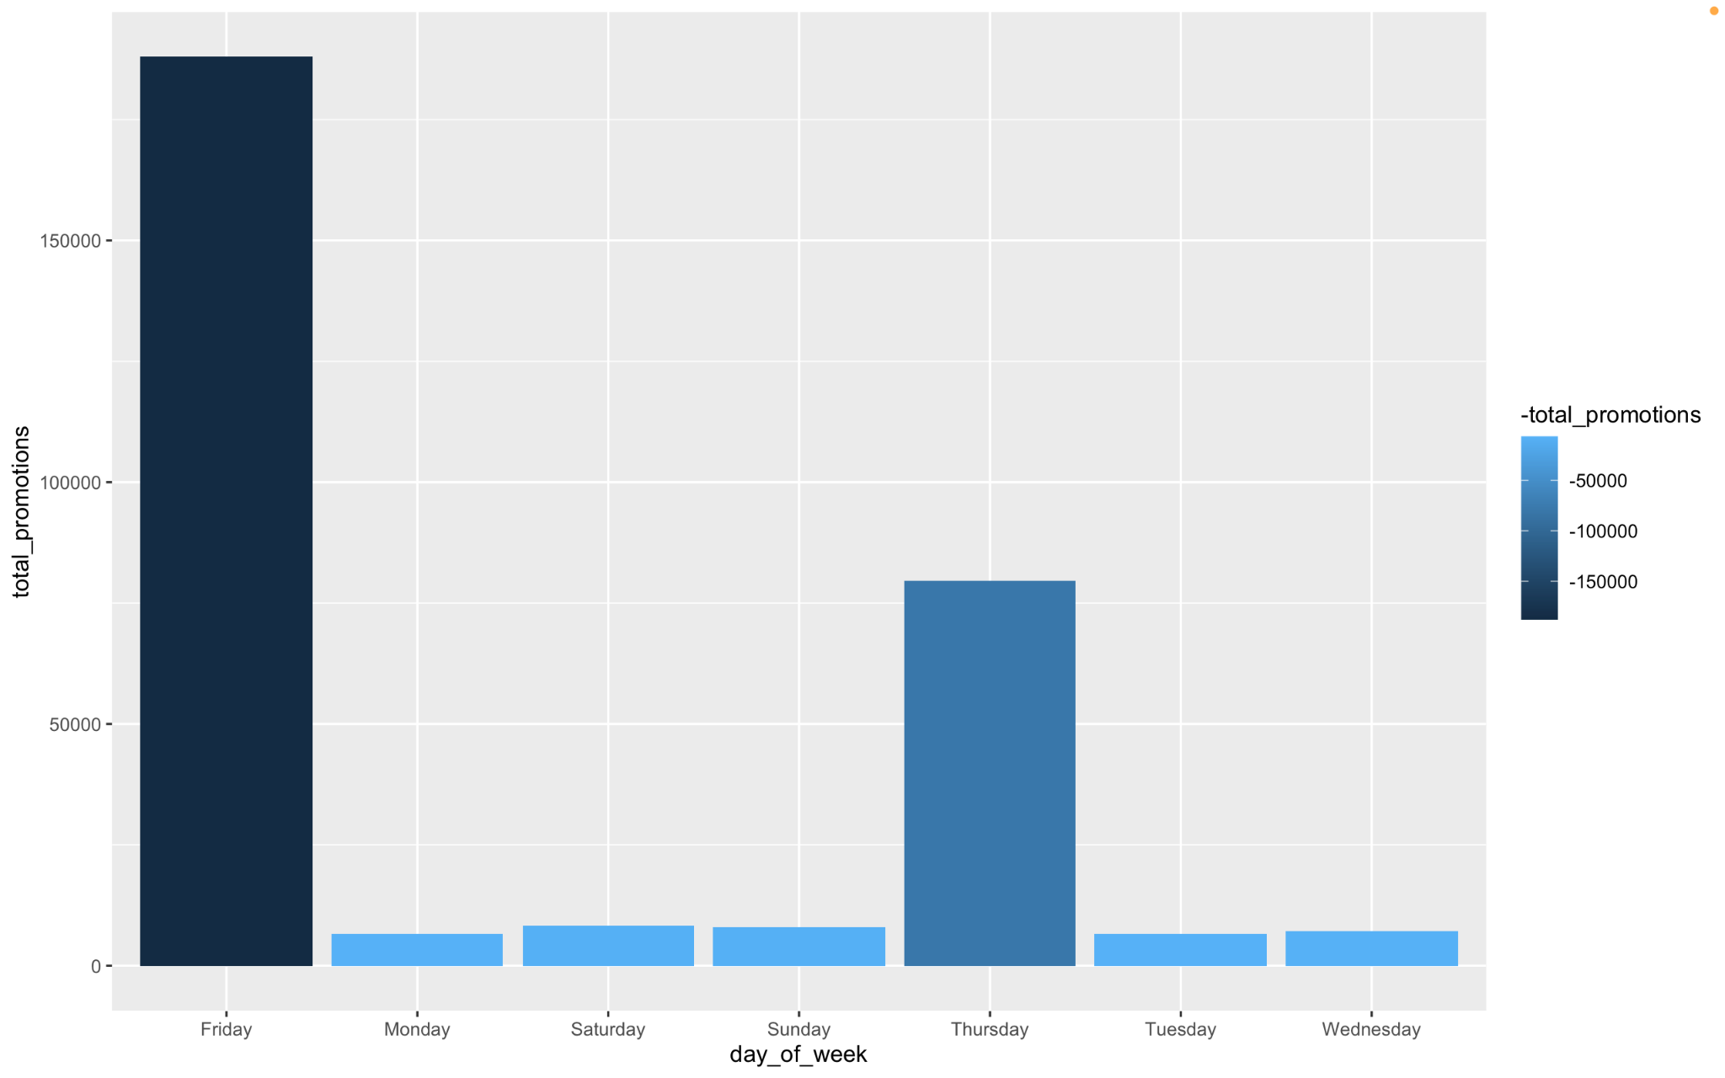

Sales are low on weekdays which means people must be usually occupied with their work etc and highest during weekends on Friday when most people get free time, slightly lower on weekdays but still higher than weekdays. Also the promotions for meats are the highest on fridays so that could be a primary reason as to why people purchase meats more frequently on fridays.

Sales by Day of Month

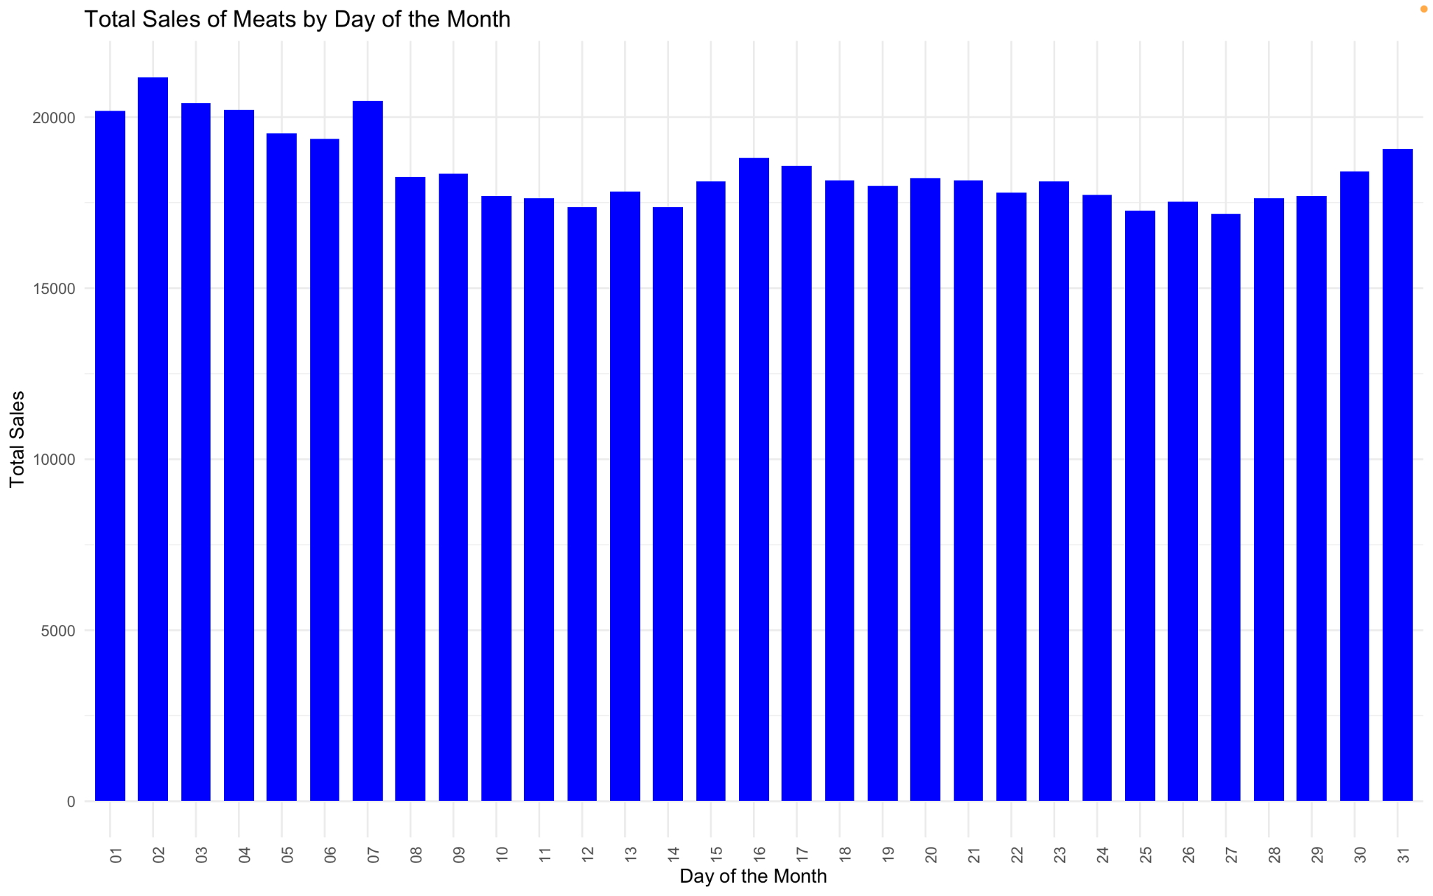

The plot above shows the average of sales for each day of the month for all the years. In summary, sales are relatively high at the start of each month then begin to gradually decrease towards the middle of the month, followed by a gradual increase then a decrease again. The higher amount of sales at beginning and the rise towards the middle of the month can be explained by the fact that ecuadorians receive wages every two weeks which means they are able to buy more grocery items including meats,

### MONTHLY SALES

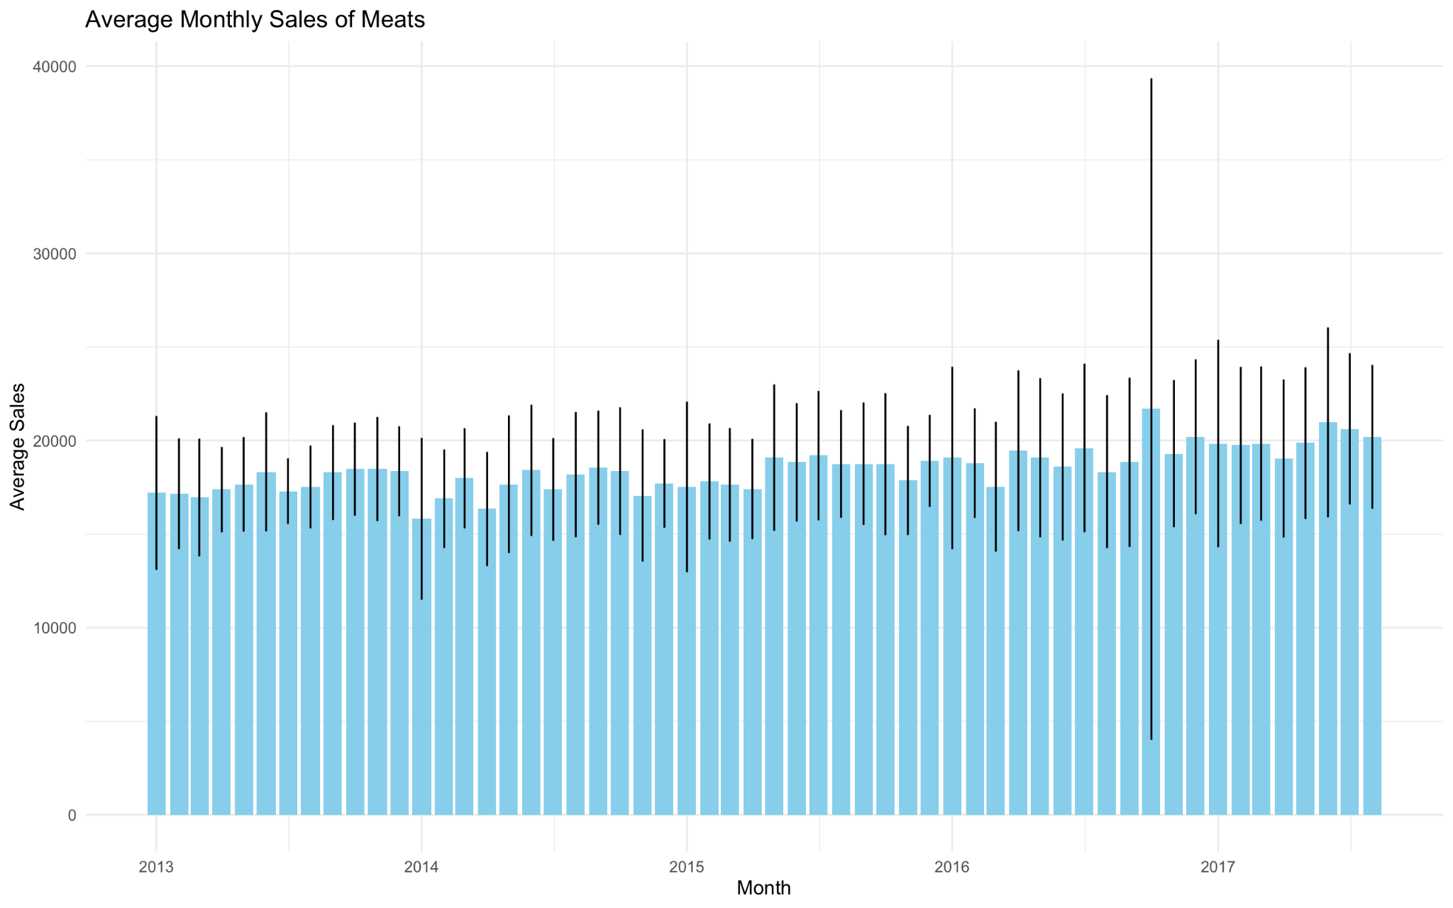

Across all the years in the beginning sales for meats start off low comparative to the rest of the year period possibly due to inflation, commitment to healthy foods etc which lead to lower consumption.

There is a gradual increase of sales until the middle of the year around summer when sales are highest because it's the holiday season and there are more family gatherings which means people go out for barbecue etc. Towards the end of the year, the sales begin to decline which could be due to a number of factors including exhausted budgets which leads to fewer consumption of high price items like meats, weather season is more wet which can influence people’s buying patterns in Ecuador

## EDA For Poultry

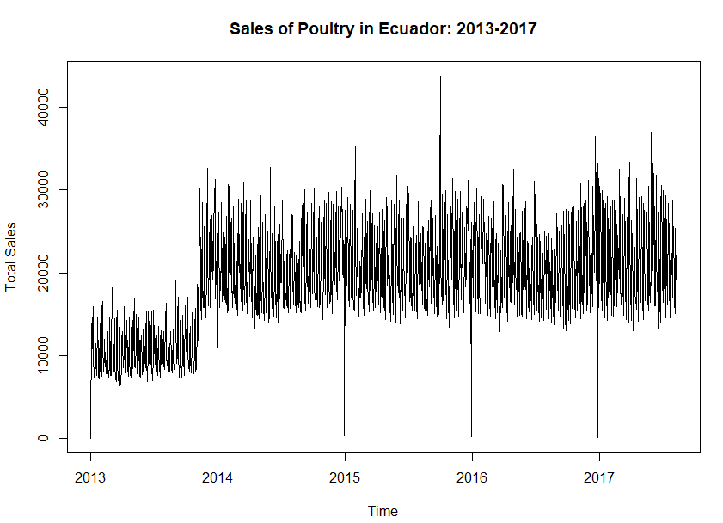

When examining the time series for poultry from 2013 to 2017, it is not evident that there has been a consistent upward or downward trend over time. It looks to be varying about a relatively steady mean level.

However, the data shows that near the end of 2013 there was a massive increase in sales that then continued on from that point with the same amount of mean steadiness and seasonality. There is also a lot of fluctuation as well as numerous spikes and falls at the start of each year. Let's explore more of this time series trends, seasonality and residuals with different levels of scope as well as making a forecast.

### Decomposition

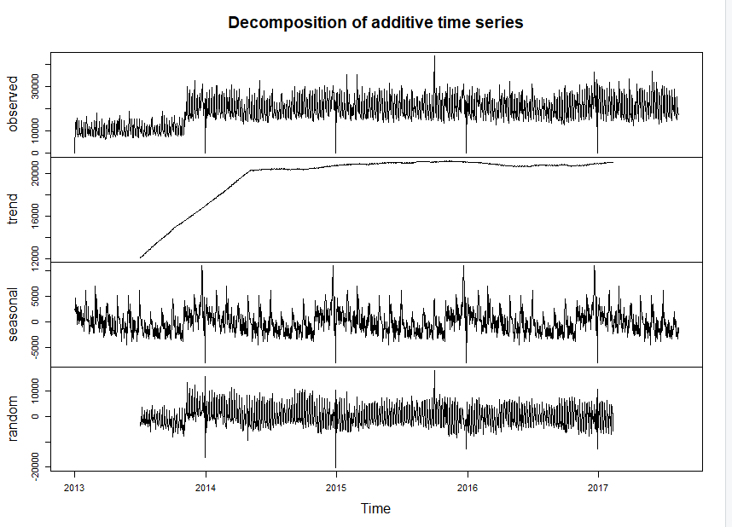

**1.Data**

The values from 2013 to 217 are shown and seem to fluctuate around a certain level with a bit of noise, there are some noticeable patterns and variability.

**2.Trend**

We can see a gradual increase from mid-end 2013 to mid 2015 followed by some stabilization till the end. This sudden change could be due to political or economic reasons, we will explore this more later.

**3.TSeasonal**

This shows regular fluctuations with annual peaks and drops. The fluctuations seem to be consistent over the years indicating a stable seasonal pattern. The peaks over here correspond to specific times likely to holidays or festival season where the demand for prepared foods could increase.

**4.Random**

The residuals seem to still have a seasonal pattern, suggesting that they still contain more valuable data. Looking into improvising the noise and capturing the underlying patterns we could look into exponential smoothing for better results, and even outlier detection analysis to identify any necessary values which could distort the time series

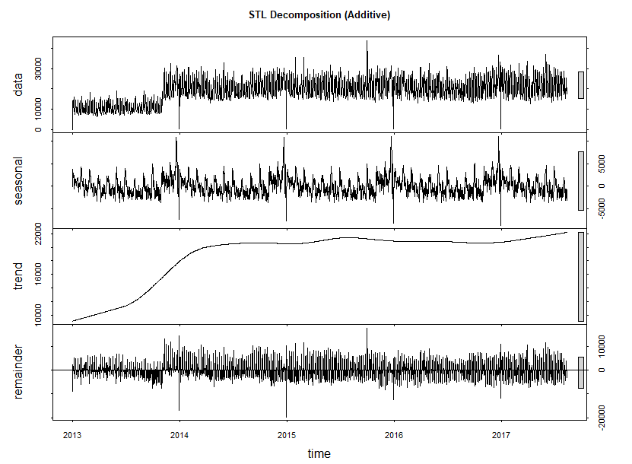

Moving onto the STL Decomposition (Additive), looking into each of the components

**1.Data**

The values from 2013 to 217 are shown and seem to fluctuate around a certain level with a bit of noise, there are some noticeable patterns and variability.

**2.Seasonal**

The seasonal pattern here is identical to the one in classic decomposition.

**3.Trend**

The trend in this decomposition seems to start from the beginning of 2013 then it picks up pace near the end of the year before plateauing around early 2014. This trend also shows the sales moving upwards near the end of the plot.

**4.Remainder**

The remainder still seems to show somewhat of a seasonal pattern that needs to be separated from it.

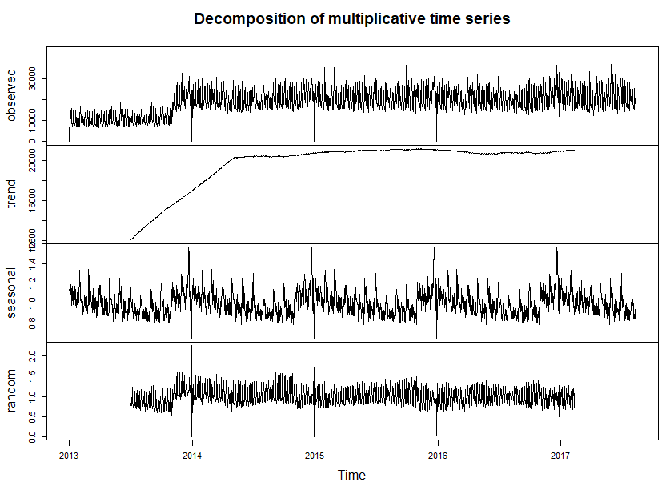

**1.Data**

The values from 2013 to 217 are shown and seem to fluctuate around a certain level with a bit of noise, there are some noticeable patterns and variability.

**2.Seasonal**

The seasonality shows a simple pattern of starting of high in the year then gradually lower before spiking up again in a cyclical pattern.

**3.Trend**

The trend in this decomposition seems to follow the same start as the others and then plateauing with a small bit of fluctuation of increasing then slightly decreasing before increasing again

**4.Random**

The remainder still seems to show somewhat of a seasonal pattern that needs to be separated from it.

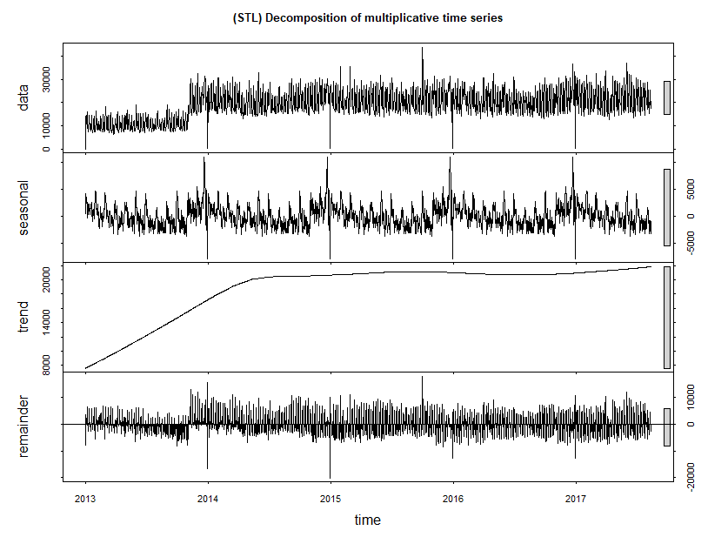

**1.Data**

The values from 2013 to 217 are shown and seem to fluctuate around a certain level with a bit of noise, there are some noticeable patterns and variability.

**2.Seasonal**

The seasonal pattern here is identical to the one in classic decomposition.

**3.Trend**

Similar trend to the classic multiplicative one, however it more clearly defines the increase in the trend towards the end of 2017 which could be useful in forecasting.

**4.Random**

The remainder still seems to show somewhat of a seasonal pattern that needs to be separated from it.

### ChangePoint Analysis

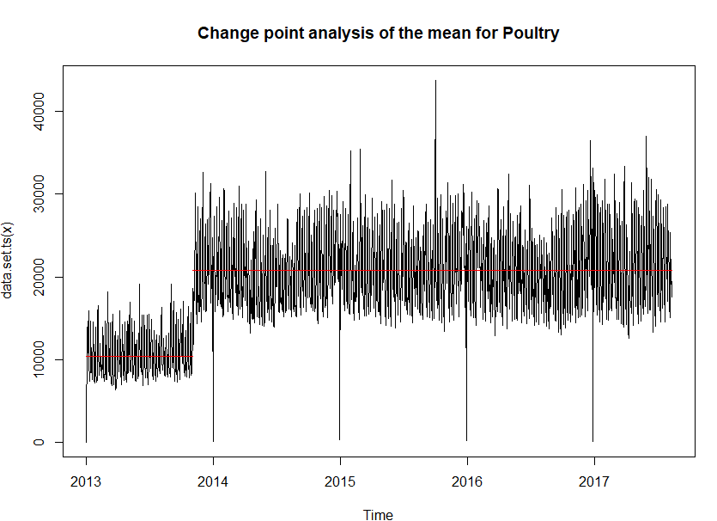

The vertical segment shifts show how the mean level of the time series shifts. We can see a massive change in the mean near the end of 2013. The mean level seems relatively stable from 2014 onwards, however at around mid 2016, it decreases in sales for a short time, then returns to normal. We will discuss this structural break in a later section.

1. **Average Sales Comparison:**

- Pre-Change Point Average Sales: 𝜇1 ≈ 10,000 units.

- Post-Change Point Average Sales: 𝜇2 ≈ 20,000 units.

The average sales increased by approximately Δ𝜇 = 𝜇2 − 𝜇1 = 10,000 units, representing a 100% increase.

**2. Variability Analysis:**

- Pre-Change Point Standard Deviation (σ1): Higher variability, 𝜎1 ≈ 10,000 units.

- Post-Change Point Standard Deviation (σ2): Lower variability, 𝜎2 ≈ 7,500 units.

The standard deviation decreased by Δ𝜎 = 𝜎1 − 𝜎2 = 2,500 units, indicating a 25% reduction in variability.

**3. Seasonal Peak Analysis:**

- Pre-Change Point Peak Frequency: High frequency of peaks around 10,000 units.

- Post-Change Point Peak Frequency: Peaks increased to around 30,000 units.

The change point analysis shows a significant increase in average sales and a decrease in variability post-change point around 2014, along with an increase in the frequency of seasonal peaks.

**Analyzing the impact of the earthquake on April 16, 2016 on the sales of Poultry**

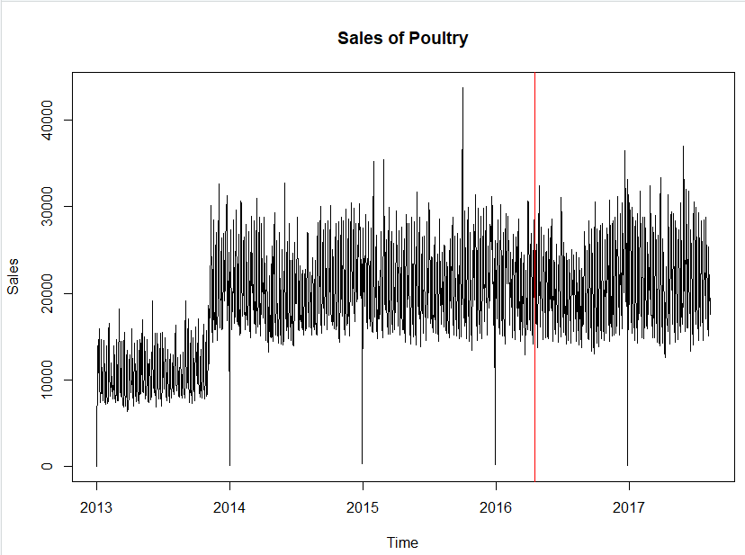

There doesn’t seem to be any large impact on the sales of poultry because of the Earthquake, there does seem to be little dip after a few months in sales btu that could be attributed to the cyclical pattern of poultry sales during those months.

### Peaks & Troughs For Each Year

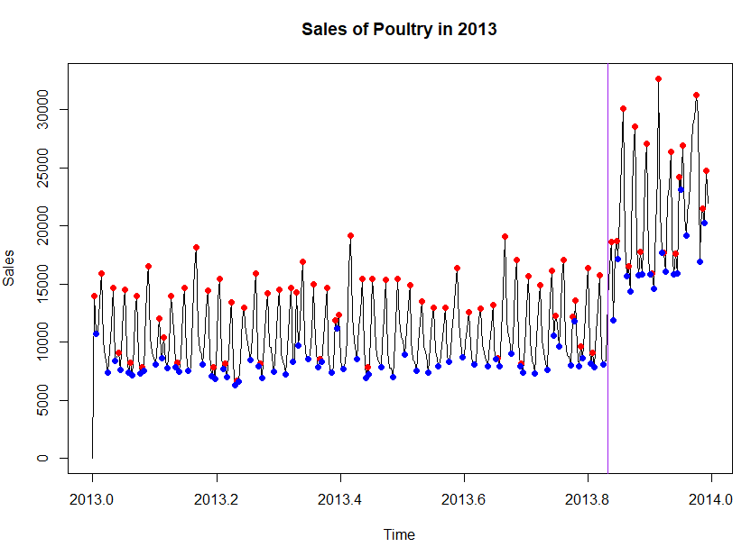

The time series plot for the year 2013 shows a somewhat cyclical pattern with a few changes in the mean and variance in the 2nd-3rd quartet of the year, and then obviously the massive surge in the 4th quartet.

The sales start quite high at around 14,000 units sold per day, then a plunge all the way down to 6000 units the following days. This pattern seems to repeat most of the time apart from changes in early February, April, and July which show a decrease in the peaks while maintaining the same local minima, while there is a massive structural break around September which pushes this cyclical pattern between 28000 and 15000 units per day.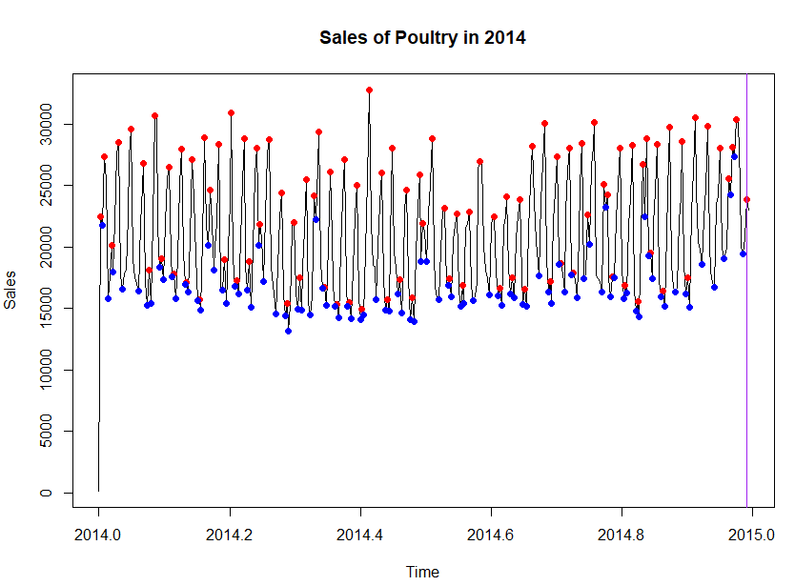

Throughout the year, the sales pattern is pretty constant; neither a noticeable rising nor decreasing trend is observed.

The data exhibits a distinct weekly seasonal pattern. There are consistent weekly sales peaks for each day of the week. Weekends and days with greater customer demand tend to be the red points or peaks. There is also a massive decrease on the first day of the current, this weird fluctuation follows through for every year.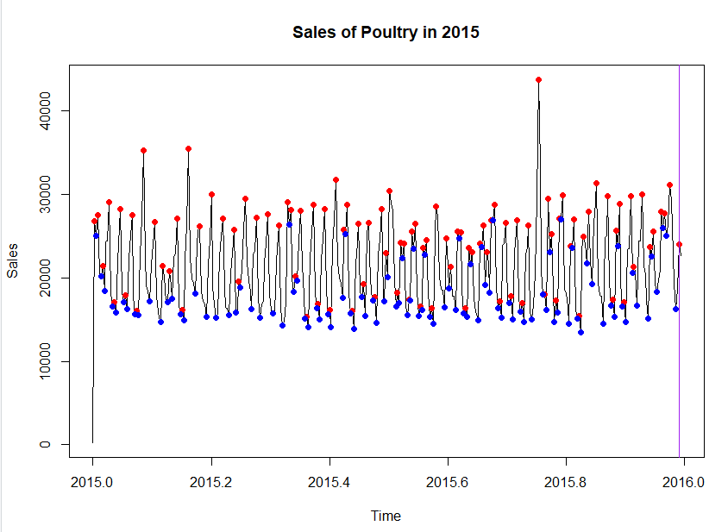

In this year the pattern and sales number stay almost the exact same as 2014 however there is a unique massive peak in around July for poultry sales that reaches all the way upto 40000 then returns to normal.

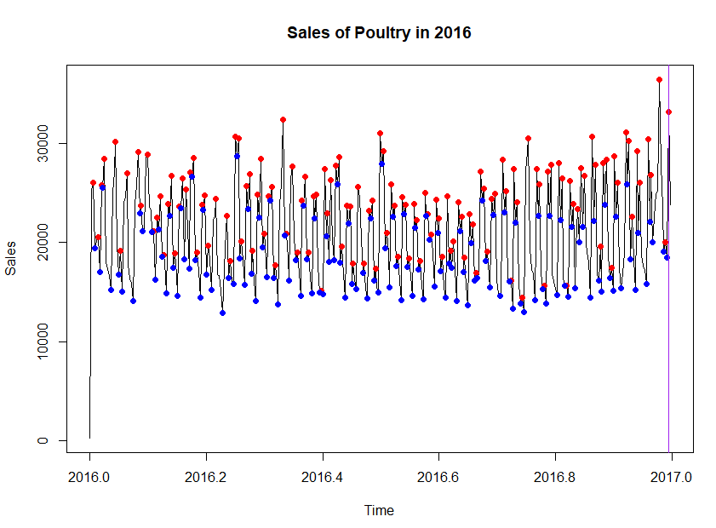

2016 continues to follow the same cyclical pattern with more frequency and there seems to be a sudden change right near the start of 2017 with sales increasing to 35000 at its peak.

The increase seen at the end of 2016, does not continue over in 2017, rather it returns back to the cyclical pattern, however, in this year, the pattern seems more sparse and doesn't repeat as often as the previous years.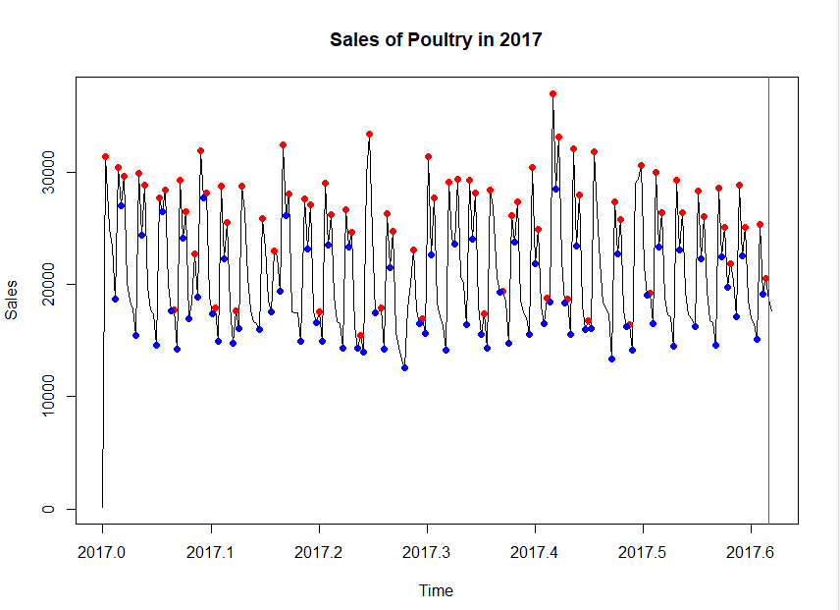

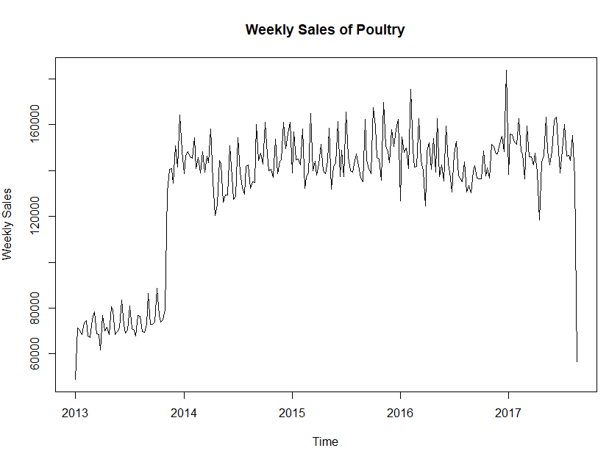

There is a clear upward trend in sales from late 2013 onwards. However, there is a significant drop in sales towards the end of 2017. We can see that the variance in sales actually tends to increase over time mainly around the period with higher volatility is from 2016 onwards.

### Yearly Sales

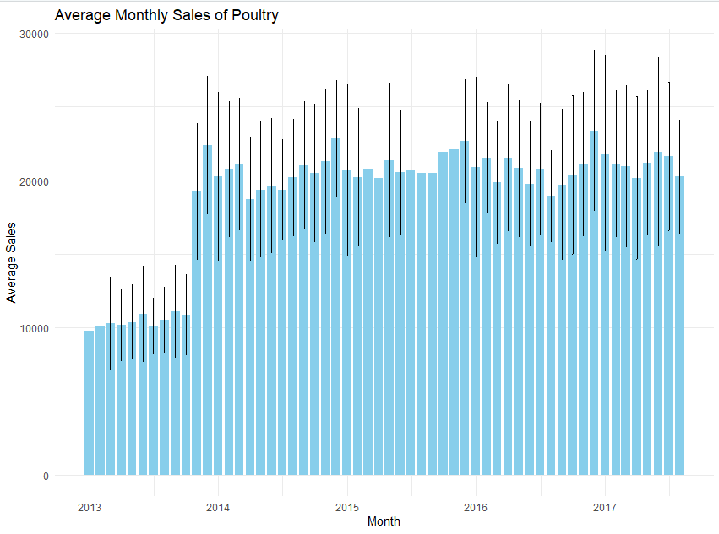

Looking into the average sales per month for each of the years, that before 2014 the average sales usually stayed around 10000 per month.

Typically December shows higher sales, increased spending during these months could be due to The holiday season approaching.

January often shows a dip in sales which could be attributed to the overspending during the holiday season.

Also if we look at the middle months such as March and April there seem to be lower consumer spending during these months

### Monthly Sales

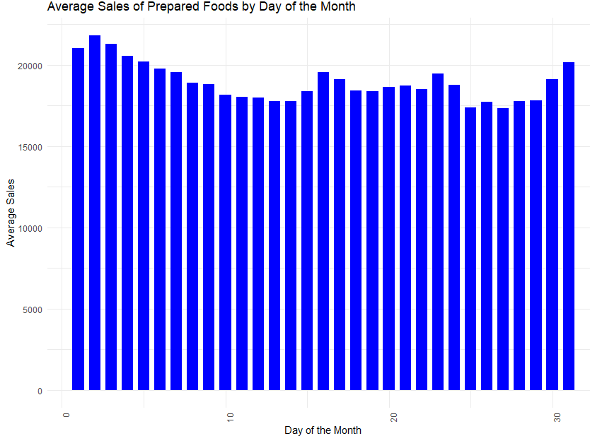

We can see that the beginning of the month tends to have the highest sales and then it gradually decreases with some spikes in the middle of the month then it finally goes back up to the top. This could be because at the beginning of the month people receive their salaries so this can lead to higher spendings, another reason could be due to stores having monthly sales at the start of every month.

### Weekly Sales

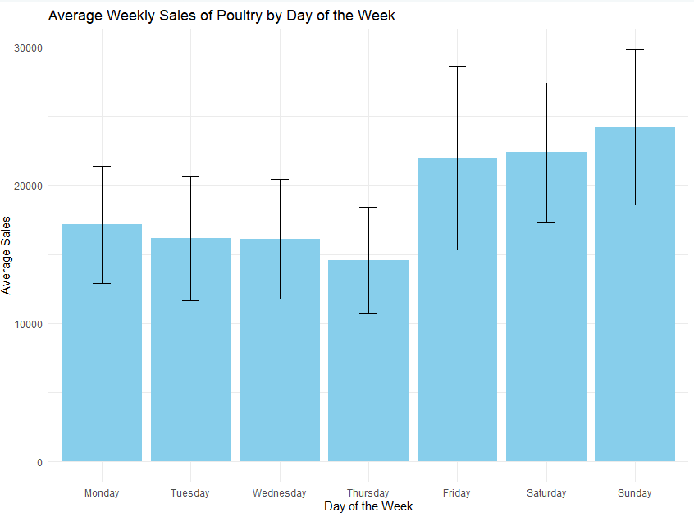

Sales gradually decrease from monday through thursday and then spike up for the weekend.

Daily Sales Analysis:

Monday: Average sales are around 18000.

Tuesday: Slight decrease from Monday, average sales around 16800.

Wednesday: Sales same asTuesday, around 16800.

Thursday: Sales slightly decreased more, around 1400.

Friday: Sales spike up to around 22000.

Saturday: Slight increase, with average sales around 22500.

Sunday: Sales are at an all time high, around 24000.

The increase in sales on the weekend could be due to higher consumer demands as people have more free time to eat out or purchase prepared foods.

Weekday sales are lower because people could have left over poultry which can be stored for consumption throughout these days.

### Influence of promotions on daily sales of Poultry

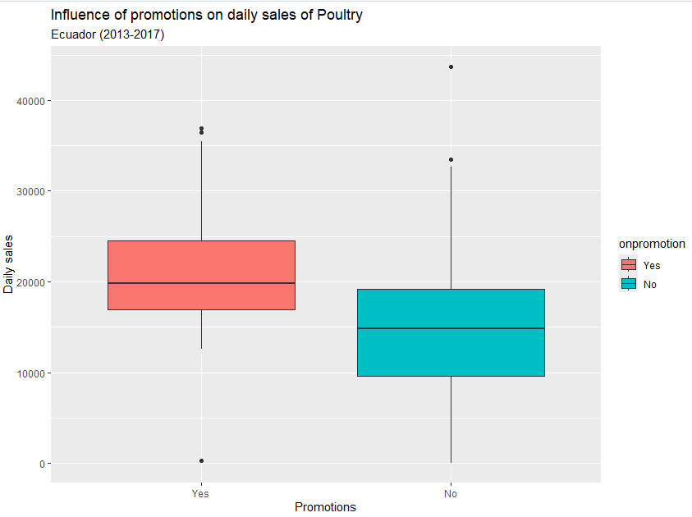

As one would logically assume, the daily sales due to promotions had a significant improvement, having an average of 5000 units sold more.

However, these high sales aren’t exclusive to promotions as other factors such as the day of the week, month and year can also affect the sales.

### Moving Averages

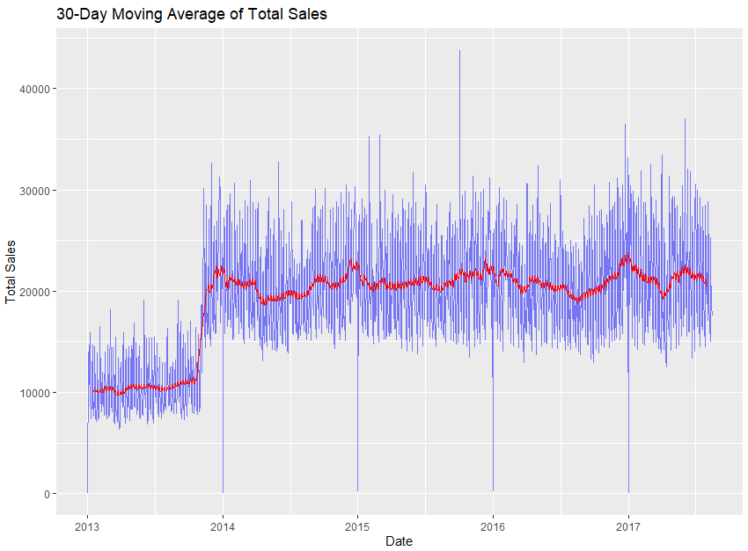In this plot of the Single moving average with a window of 30 days, we can see that it starts of with a mean of around 10000 and hovers around it until late 2013, in which it then moves up to around 20000, after that, the variance increases and slowly increases near the 3rd quarter of 2016. However this graph doesnt properly discuss the

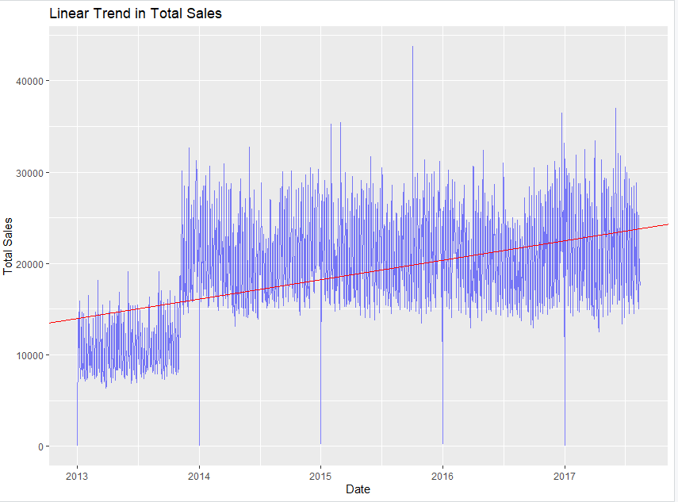

This graph does show the increase in the average sales, however it is too simplistic and doesn’t capture the seasonality or the changes in the mean.

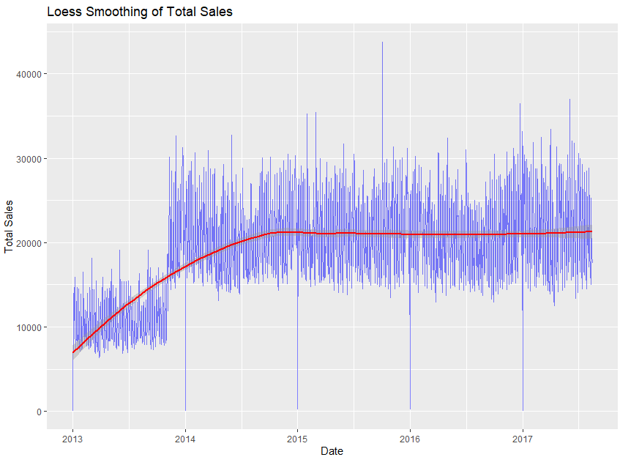

This loess smoothing shows us the basic time series for the poultry time series we’ve been discussing in that in 2013, the mean is increasing and then stabilizes after that till the end of 2017, where it slowly starts to increase.

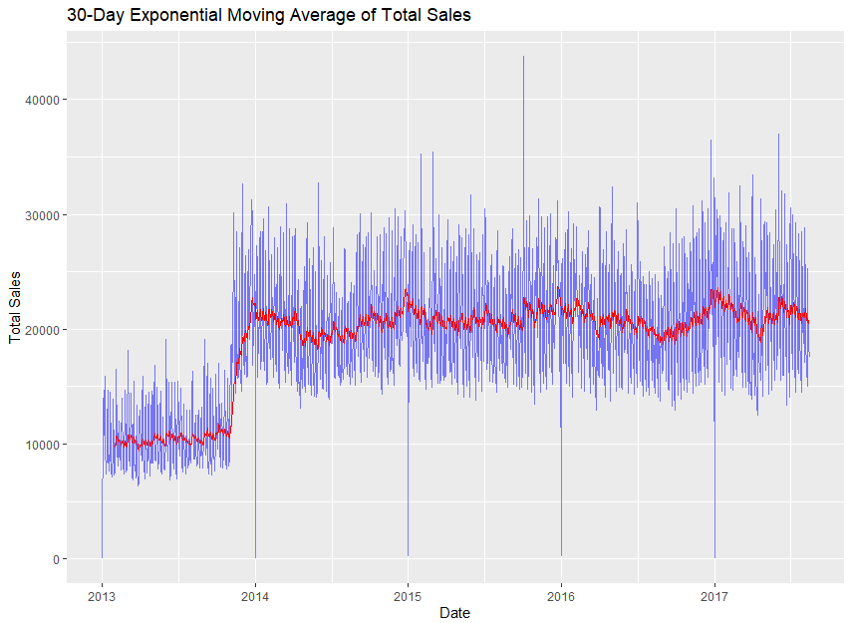

This exponential moving average graph is a better explanation for for showing the moving average as it accurately captures the seasonality and variance as well as the linearity of the average sales across 2013-2017

### Structural Break Analysis



There is a massive structural break near the end of 2013, which leads to a big jump in sales that persists for the rest of the time series. From online research this could be due to a multitude of reasons such as:

The decision by former president Correa not to run for office again, due to protests against his rule, which could have affected consumer confidence.

The increase in overall spending and GDP due to increased borrowing from China in early 2013.

The increase in testing and vaccination of poultry against Avian Influenza in 2016 that may have caused an increase in public trust of poultry foods.

### Anomaly Detection and Handling

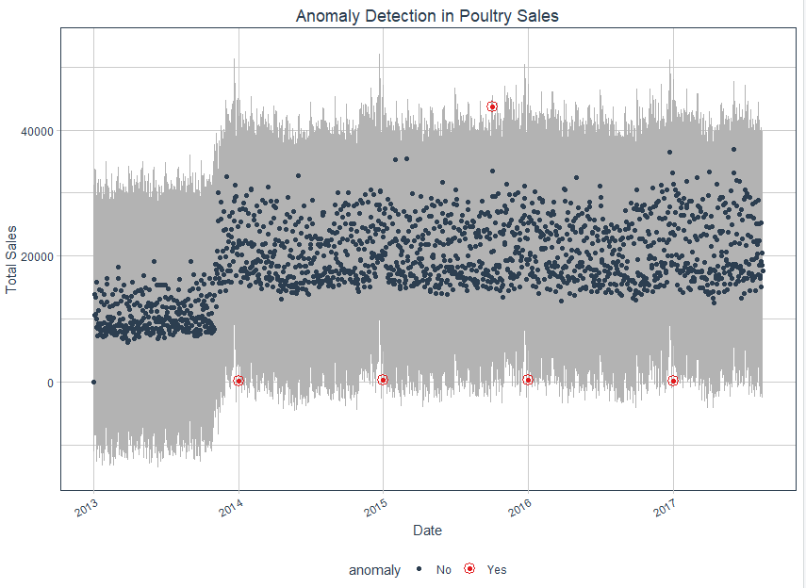

We use the Anomalize package to detect any outlier then remove them. In this time series for Poultry sales, there are very few outliers that seems to follow somewhat of a trend near the end of year at the local minima, and one single maxima around the 3rd quarter of 2015.

### Stationarity Analysis

The stationarity of the time series has been analyzed using the Augmented Dickey–Fuller (ADF) test, Kwiatkowski–Phillips–Schmidt–Shin (KPSS) tests, and Phillips-Perron (PP) Test. These tests are statistical methods used to check for the presence of stationarity in the time series.

According to the tests performed, the time series for poultry products is non-stationary which was expected because it has a trend and seasonality. This entails differencing the time series, which would convert it into a stationary time series, which is because stationarity is the assumption of a lot of time series modeling techniques like VAR (Vector Autoregression) model which have been used to analyze the multivariate time series for the task at hand.

The above tests were performed on the time series after differencing, and they passed all the tests indicating that the differencing by an order of 1 was sufficient to make the time series stationary.

This is how the time series was looking before differencing:

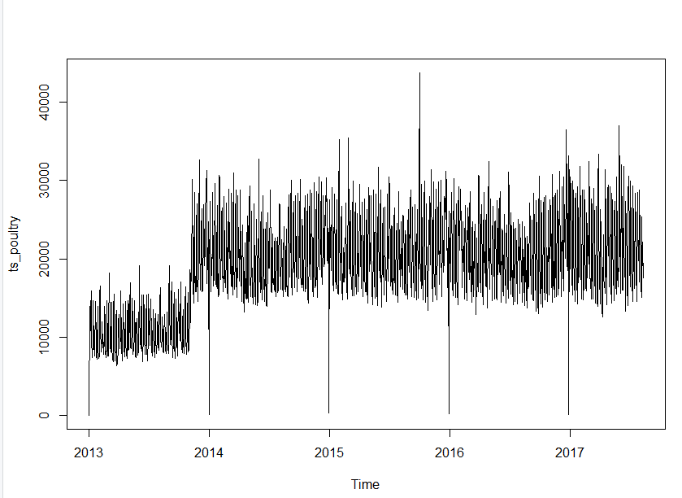The following plot shows how the time series is looking after differencing:

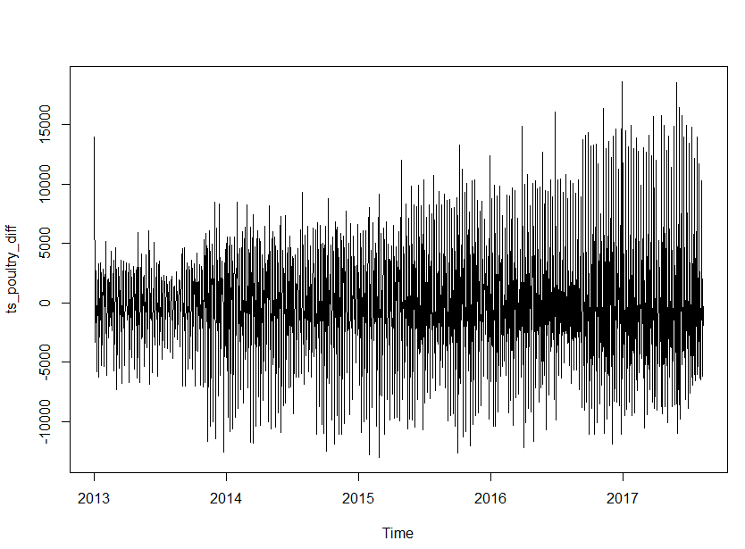

## 

## 

## EDA For Liquor, Wine And Beer

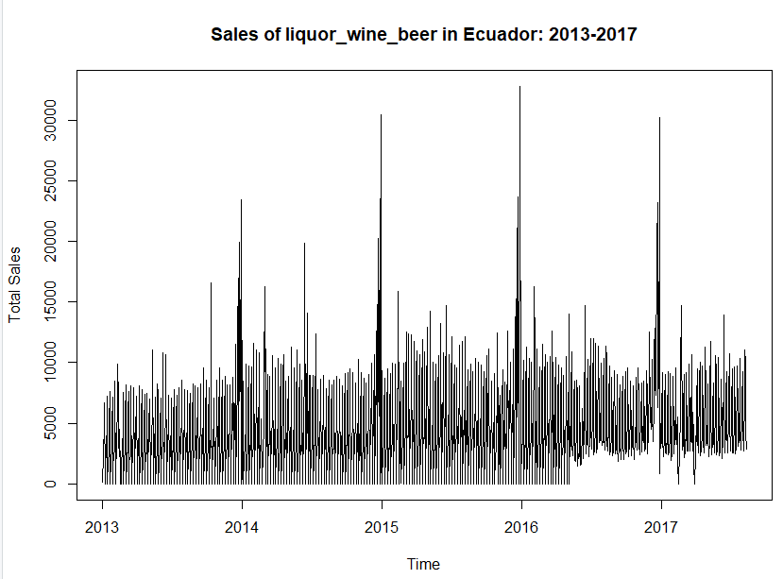

When examining the time series for poultry from 2013 to 2017, it is not evident that there has been a consistent upward or downward trend over time. It looks to be varying about a relatively steady mean level. There also seems to be a massive spike near the end and start of a year for this cycle. Lets explore this more through decomposition.

### Decomposition

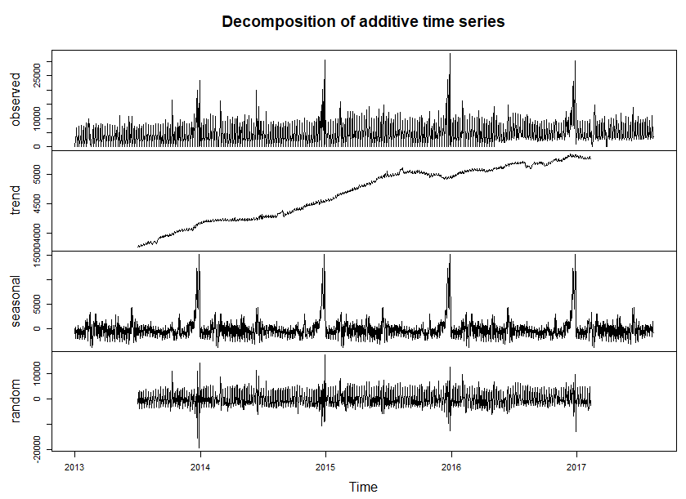

**1.Data**

The values from 2013 to 217 are shown and seem to fluctuate around a certain level with a bit of noise and a cyclical pattern.

**2.Seasonal**

The seasonal pattern seems to start off with a low variance, then it increases before returning back to normal and then spiking massively at the start of the year in a repeating pattern.

**3.Trend**

The trend is not completely apparent as there still seems to be a need to do more smoothing, this trend grows at an increasing rate with some plateaus.

**4.Random**

The remainder still seems to show somewhat of a seasonal pattern that needs to be separated from it.

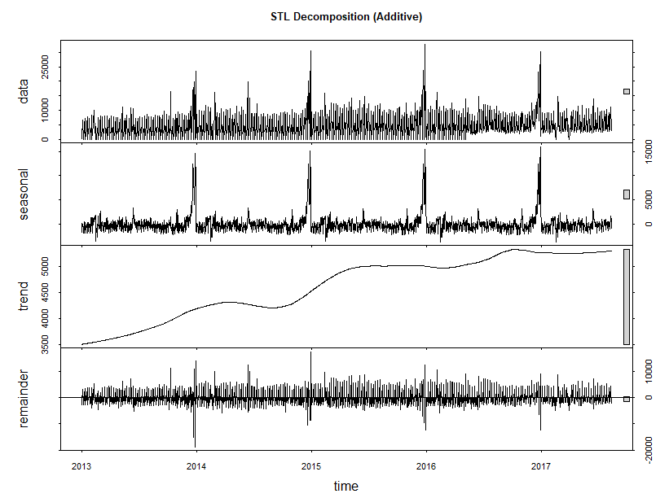

Moving onto the STL Decomposition (Additive), looking into each of the components

**1.Data**

The values from 2013 to 217 are shown and seem to fluctuate around a certain level with a bit of noise, there are some noticeable patterns and variability, STL decomposition seems to show a more

**2.Seasonal**

The seasonal pattern here is identical to the one in classic decomposition.

**3.Trend**

The trend in this decomposition is far better than the one in the classic, as it it far smoother and properly shows the dips and increases in the trend.

**4.Random**

The remainder still seems to show somewhat of a seasonal pattern that needs to be separated from it.

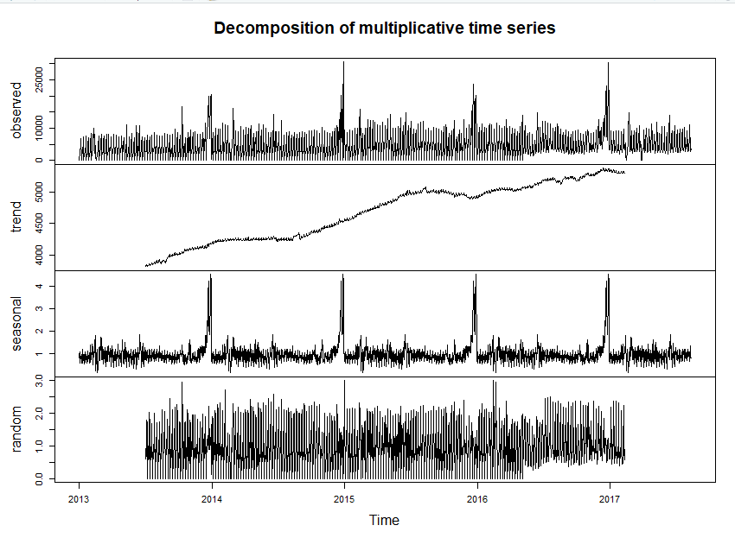

**1.Data**

The values from 2013 to 217 are shown and seem to fluctuate around a certain level with a bit of noise.

**2.Seasonal**

The seasonal pattern here properly highlights the peaks near the end and start of each year as well as showing the decreasing variance.

**3.Trend**

The trend in the classic decompositions, seem to show a less smooth, jagged trend, which does not properly highlight the increasing trends, plateaus well.

**4.Random**

The remainder still seems to show somewhat of a seasonal pattern that needs to be separated from it.

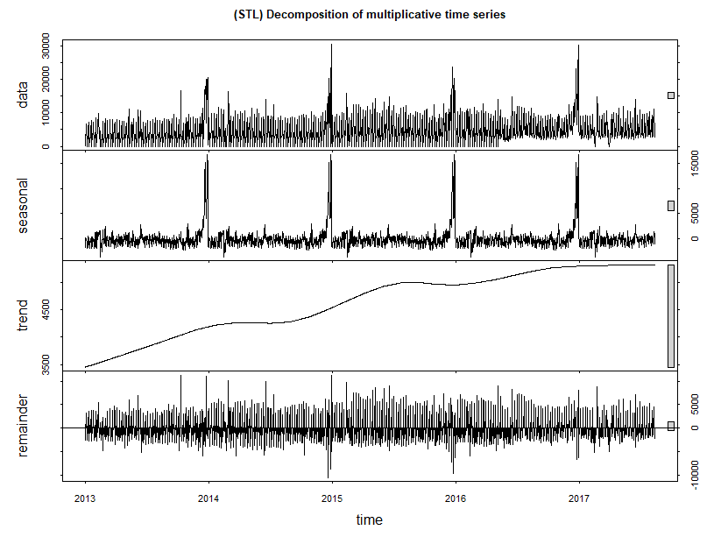

**1.Data**

The values from 2013 to 217 are shown and seem to fluctuate around a certain level with a bit of noise.

**2.Seasonal**

The seasonal pattern here is identical to the one in classic decomposition.

**3.Trend**

The trend in this decomposition is far smoother than the classic one with properly highlighting the increasing trend from 2013 till 2014, then the plateau then an increase in a somewhat repeating pattern till 2017 at which point it then plateaus to a stronger level than before.

**4.Random**

The remainder still seems to show somewhat of a seasonal pattern that needs to be separated from it, however, it is decreased when compared to other graphs.

### ChangePoint Analysis

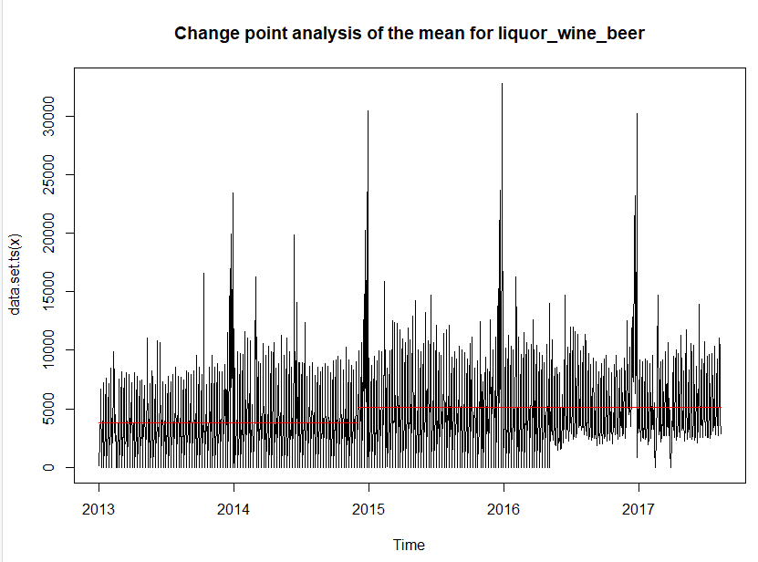

The horizontal segment shifts show how the mean level of the time series shifts. We can see a change in the end of 2014. The mean level remains stable before and after this change and is not deeply affected by the spikes in the graph, however the variance decreases massively after 2016, resulting in less throughs no longer continuously hitting 0 , this was due to the lift of the ban on the sale of alcoholic beverages on Sundays.

Based on the provided graph and the intended format, here is the detailed analysis:

* Average Sales Comparison:
  + Pre-Change Point Average Sales: 𝜇1 ≈ 5000 units.
  + Post-Change Point Average Sales: 𝜇2 ≈ 7000 units.
* The average sales increased by approximately Δ𝜇 = 𝜇2 − 𝜇1 = 2000 units, representing a 40% increase.
* Variability Analysis:
  + Pre-Change Point Standard Deviation (σ1): Higher variability, 𝜎1 ≈ 25,000 units.
  + Post-Change Point Standard Deviation (σ2): Lower variability, 𝜎2 ≈ 20,000 units.
* The standard deviation decreased by Δ𝜎 = 𝜎1 − 𝜎2 = 5,000 units, indicating a 20% reduction in variability.
* Seasonal Peak Analysis:
  + Pre-Change Point Peak Frequency: High frequency of peaks around 10000 units.
  + Post-Change Point Peak Frequency: Peaks increased to around 15000 units.

**Analyzing the impact of the earthquake on April 16, 2016 on the sales of Liquor, Wine and Beer**

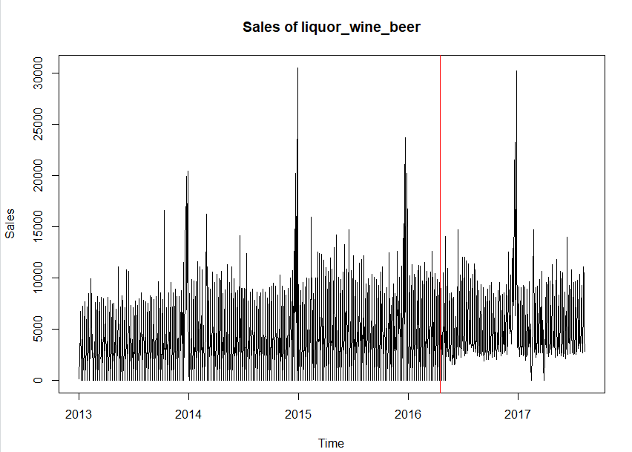

There seems to be a decrease in peaks, throughs and variance in sales after the earthquake, this could be due to people, both, having less money to spend on alcohol because of the earthquake, and a need for it to cope with losses. Another reason for impact in the lack of 0 in the throughs could be as mentioned previously the allowance of alcoholic beverage sales on Sundays around that same period.

### Peaks & Troughs For Each Year

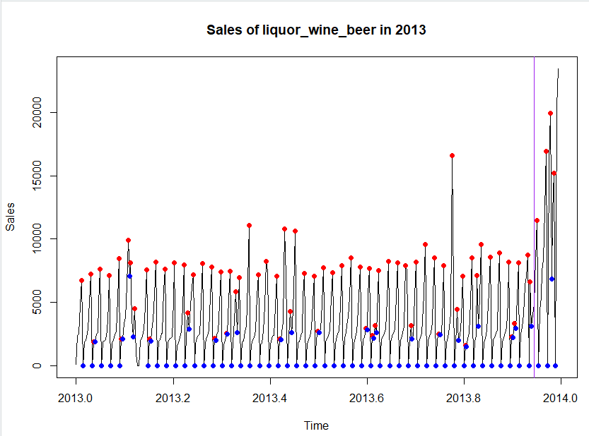Sales Trend: The sales of liquor, wine, and beer in 2013 exhibit a cyclical pattern with periodic peaks.

* High and Low Points: The highest sales peak occurred towards the end of the year, approaching 25,000 units. The lowest points consistently hovered around 0 units.
* Seasonal Patterns: Increased sales towards the end of the year suggest higher consumption during festive seasons.
* Average Sales: Sales generally fluctuate between 5,000 and 10,000 units, with occasional higher spikes.
* Sales Variability: There is significant variability in sales, indicating that sales are subject to large fluctuations throughout the year.

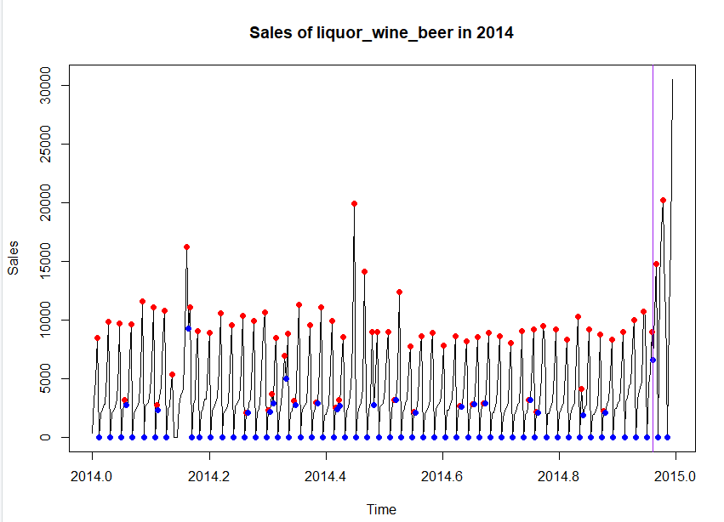

The graph effectively highlights the periodic nature of liquor, wine, and beer sales in 2014, with clear high and low points likely driven by weekly or bi-weekly consumer habits. while there is noticeable variability in sales (as seen by the high peaks), the overall pattern of peaks and troughs is fairly consistent. Notable high spikes occur around 2014.4 and at the end of 2014 (just before 2015). These might correspond to specific events or seasonal holidays like summer vacations and year-end celebrations.

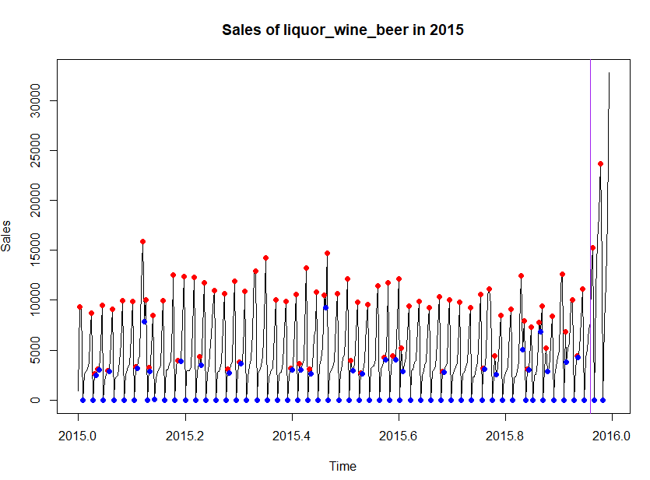

The graph depicting the sales of liquor, wine, and beer in 2015 shows a consistent periodic pattern with regular peaks and troughs throughout the year, indicating a strong seasonality. The sales peaks, marked by red points, frequently reach around or above 10,000 units, with notable high spikes early in the year (around 2015.1), and towards the end (close to 2016), where sales even exceed 30,000 units, possibly corresponding to special events or holidays. The troughs, indicated by blue points, often drop close to zero and are regularly spaced, aligning with a weekly or bi-weekly cycle. The overall pattern remains consistent, but with increased variability in the second half of the year, suggesting changing consumer behavior or external influences during these periods.

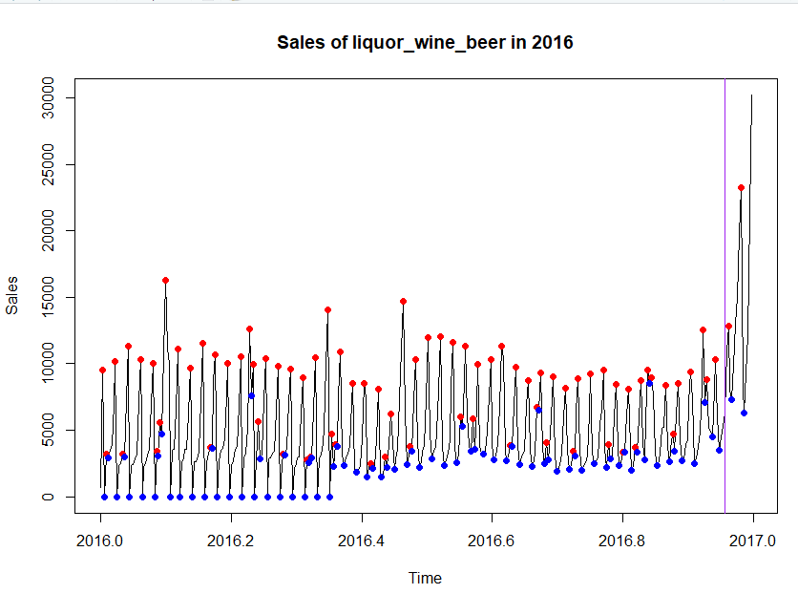

2016 continues to follow the same cyclical pattern, however after the March, the variance starts to decrease due to the throughs no longer being 0, this was due to the lift of the ban on alcoholic drinks on Sundays, it then continues with the usual spikes at the end of the year.

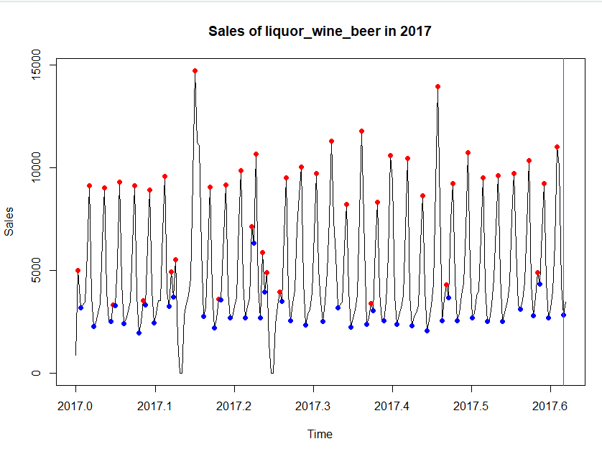The graph in 2017 seems to have a lot more variance as well as a more thinned out cycle, this follows the same pattern with the massive decrease in throughs being 0 due to the previously mentioned reason with random massive spikes in the opposite direction in January and February sales.

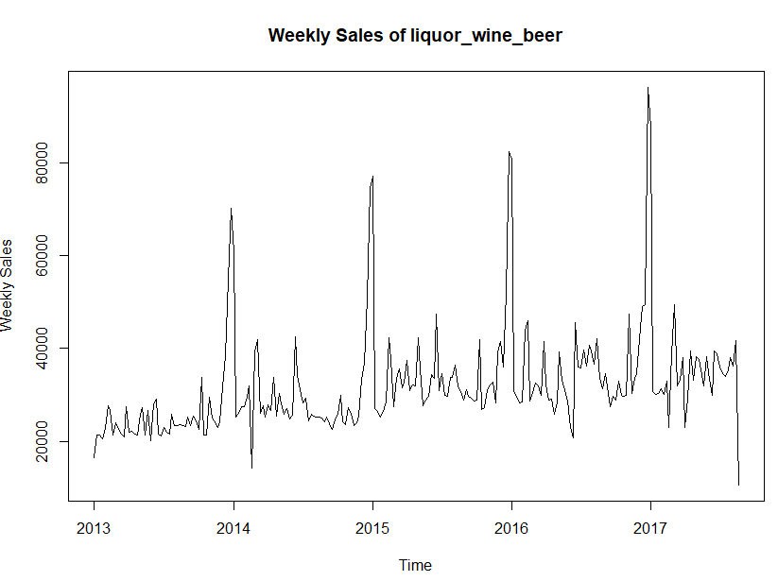

There is a slow upward trend in sales. With cyclical peaks that appear to be increasing over time, there also some plateauing in mid 2014 and mid 2016.

### Yearly Sales

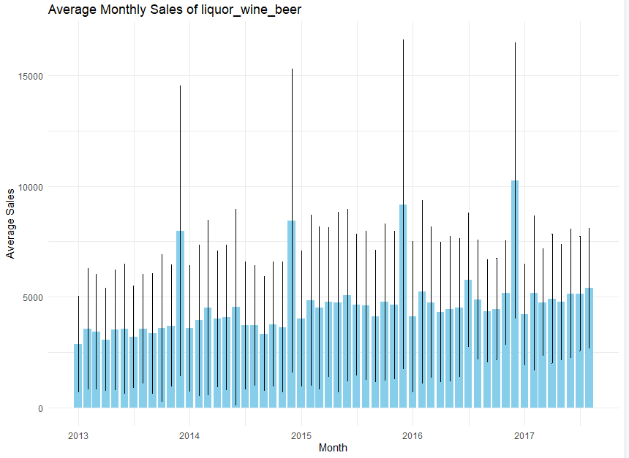

Looking into the average sales per month, we originally start with 2500 average monthly sales, which then slowly moves upwards to 5000 by the end of the time series, along with a few peaks that start of at around 7500 that reaches all the way to 10500 in the final cycle.

### Monthly Sales

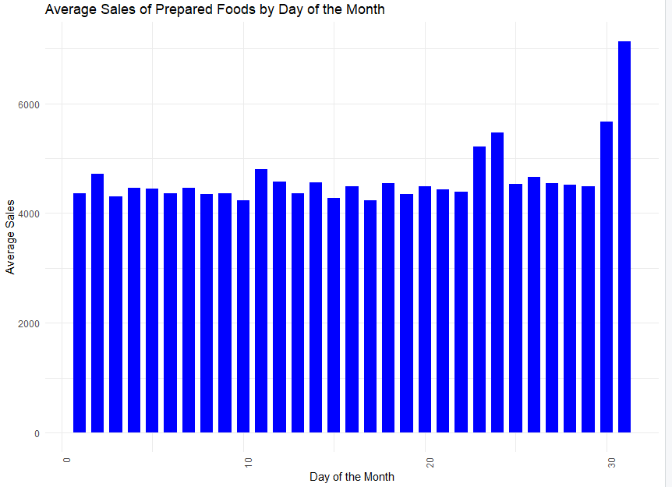

The sales seem to stay constant throughout the month, however there is a massive spike at the end of each month on average, this could be due to people receiving their paychecks and therefore being able to spend more on wants rather than needs.

### Weekly Sales

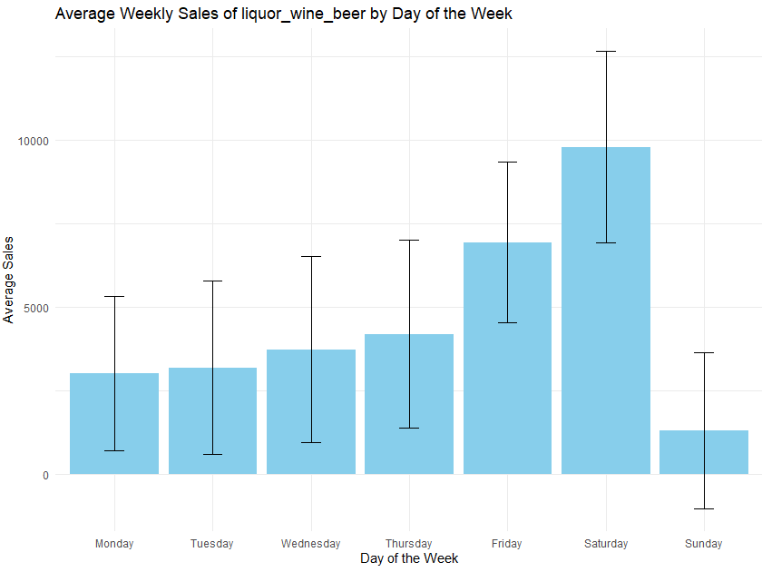

Due to the restrictions on alcohol sales on Sundays, this brings the average down significantly because of that for the total years. This restriction could have led to more of their sales on Saturday as well as people would probably stock up. And obviously the reason for low sales in midweek as compared to the weekend is because of people having jobs leading them to not be able to drink.

Daily Sales Analysis:

Monday: Average sales are around 2500.

Tuesday: Slight increase from Monday, average sales around 2600.

Wednesday: Slightly bigger increase in sales, around 3000.

Thursday: Again a slight increase in sales, around 3200.

Friday: Sales spike up to around 6800.

Saturday: massive spike, with average sales around 9900.

Sunday: Sales drop dramatically,, around 1500.

### Influence of promotions on daily sales of Poultry

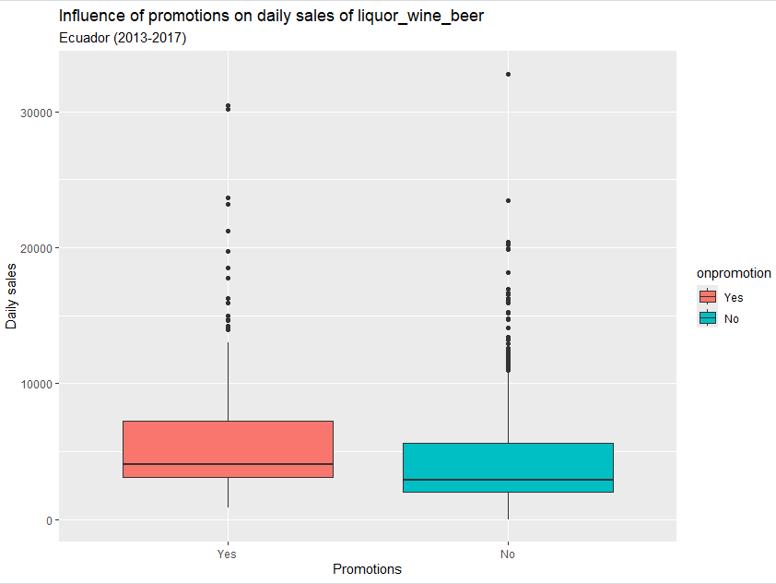

Promotions don't really affect the mean of the sale of alcohol much, obviously there is a slight increase in sales, but it can be considered negligible as no promotions has far more outliers as compares to on promotions, this is due to alcohol being a price inelastic item, in fact it is the most price inelastic beverage, meaning the price of the item does not affect its sale much.

### Moving Averages

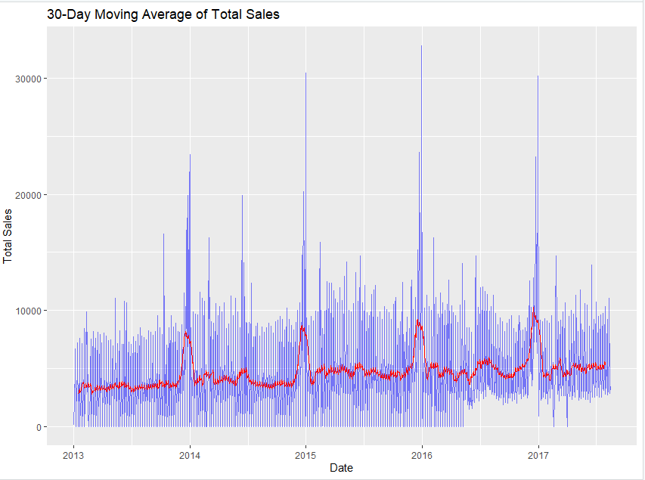In this plot of the Single moving average with a window of 30 days, we can see that it starts with a mean of around 2500, then gradually increases before spiling at the end of the year to 10000 units, followed but a fall back down to a level that is still higher than before, this slight increasing pattern continues till the midof 2016, where we can spot more of a fluctuation followed by stable sales im 2017.

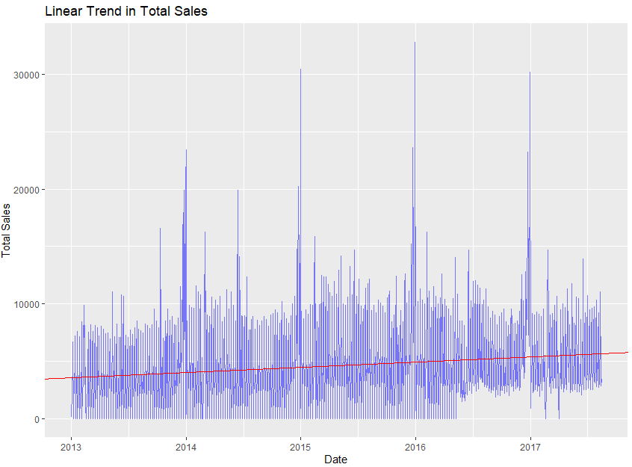

This graph does show the slight upwards increase in the average sales, however it is too simplistic and doesn’t capture the seasonality or the changes in the mean.

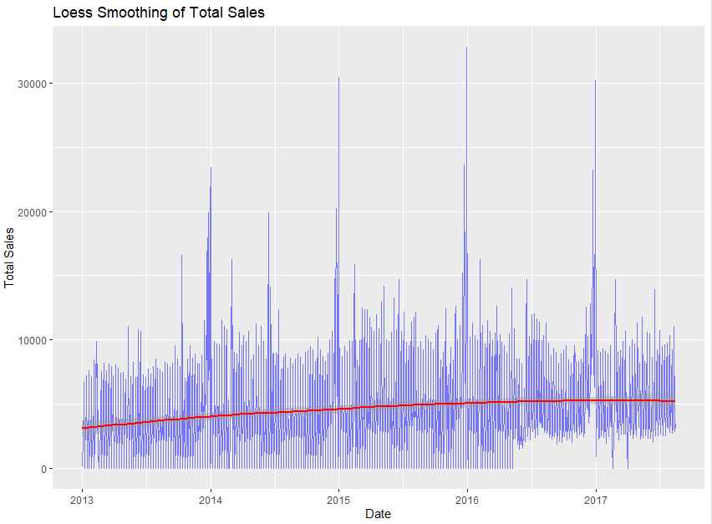

This loess smoothing shows us a better trend line with capturing its upwards then plateaued movement better than a simple linear model, however this is still not enough.

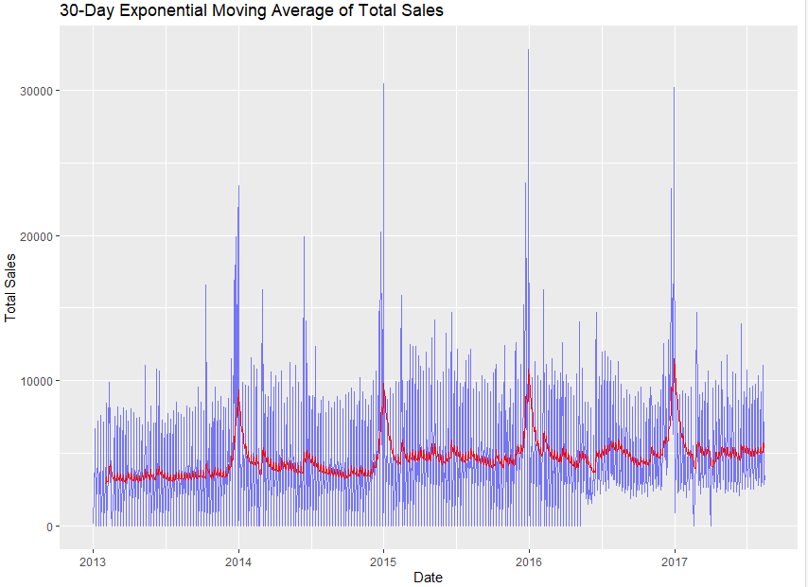

This exponential moving average graph is a better explanation for for showing the moving average as it accurately captures the seasonality and variance as well as the linearity of the average sales across 2013-2017, while also highlighting the plateaus and variance mentioned before with better capabilities

### Structural Break Analysis

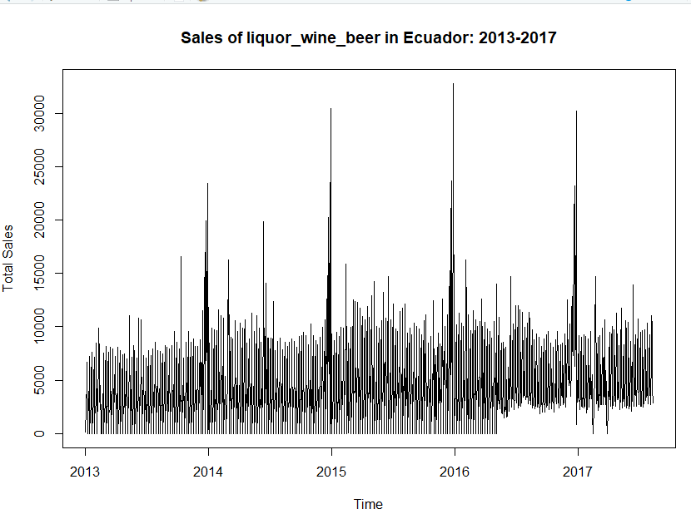

There does seem to be a structural break, after the changes in sales in 2016 perhaps due to the earthquake or selling of alcohol on sundays or both, however this is still a relatively small structural break and can thus be disregarded.

### Anomaly Detection and Handling

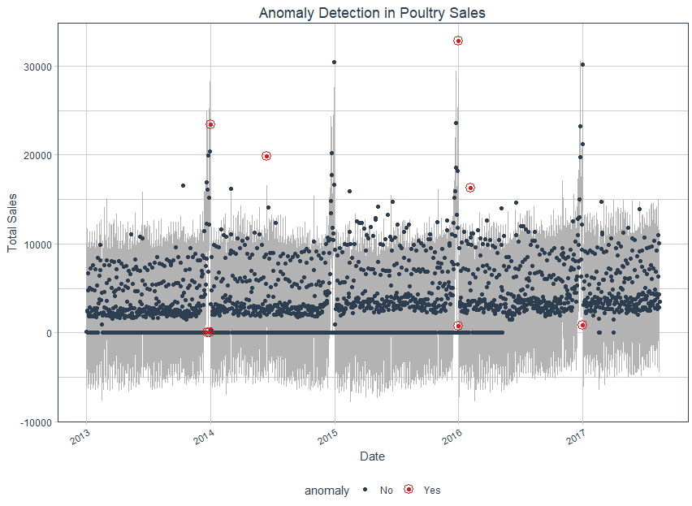

We use the Anomalize package to detect any outlier then remove them. In this time series for alcohol sales, there are very few outliers that seem to exist in points like the peak of 29\014 and 2016, as well as some throughs near the end of some years where there should usually be a massive spike.

### Stationarity Analysis

The stationarity of the time series has been analyzed using the Augmented Dickey–Fuller (ADF) test, Kwiatkowski–Phillips–Schmidt–Shin (KPSS) tests, and Phillips-Perron (PP) Test. These tests are statistical methods used to check for the presence of stationarity in the time series.

According to the tests performed, the time series for liquor, wine and beer products is non-stationary which was expected because it has a trend and seasonality. This entails differencing the time series, which would convert it into a stationary time series, which is because stationarity is the assumption of a lot of time series modeling techniques like VAR (Vector Autoregression) model which have been used to analyze the multivariate time series for the task at hand.

The above tests were performed on the time series after differencing, and they passed all the tests indicating that the differencing by an order of 1 was sufficient to make the time series stationary.

This is how the time series was looking before differencing:

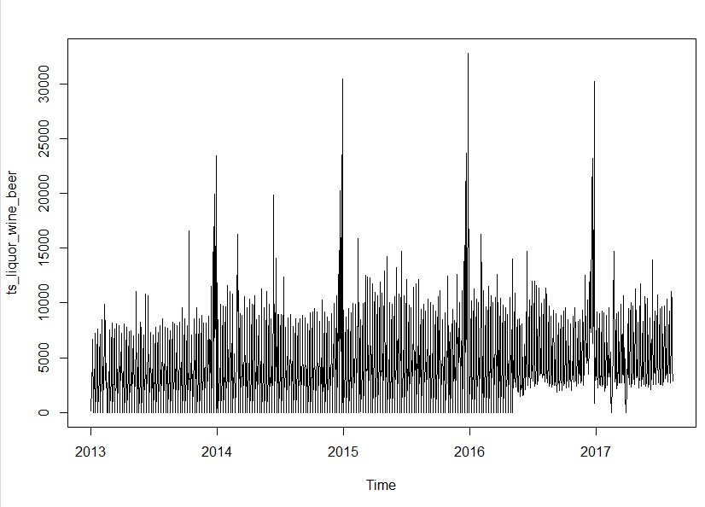The following plot shows how the time series is looking after differencing:

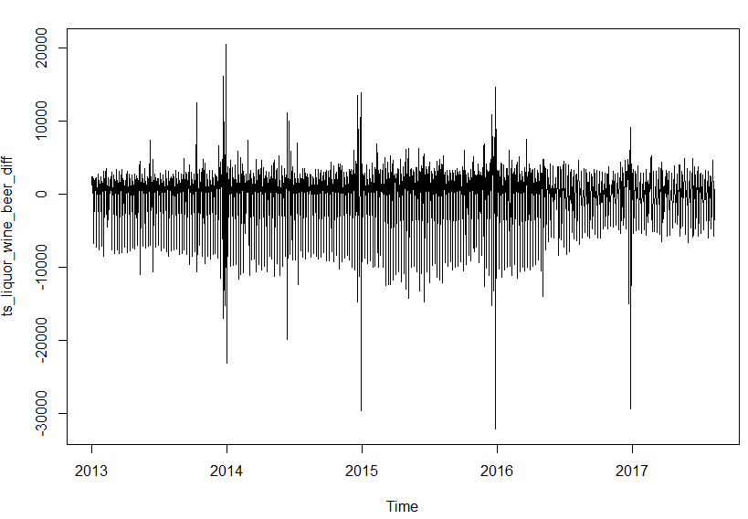

## 

## EDA For Frozen Foods

A run sequence plot the time series for the product family Frozen Foods provides interesting insights:

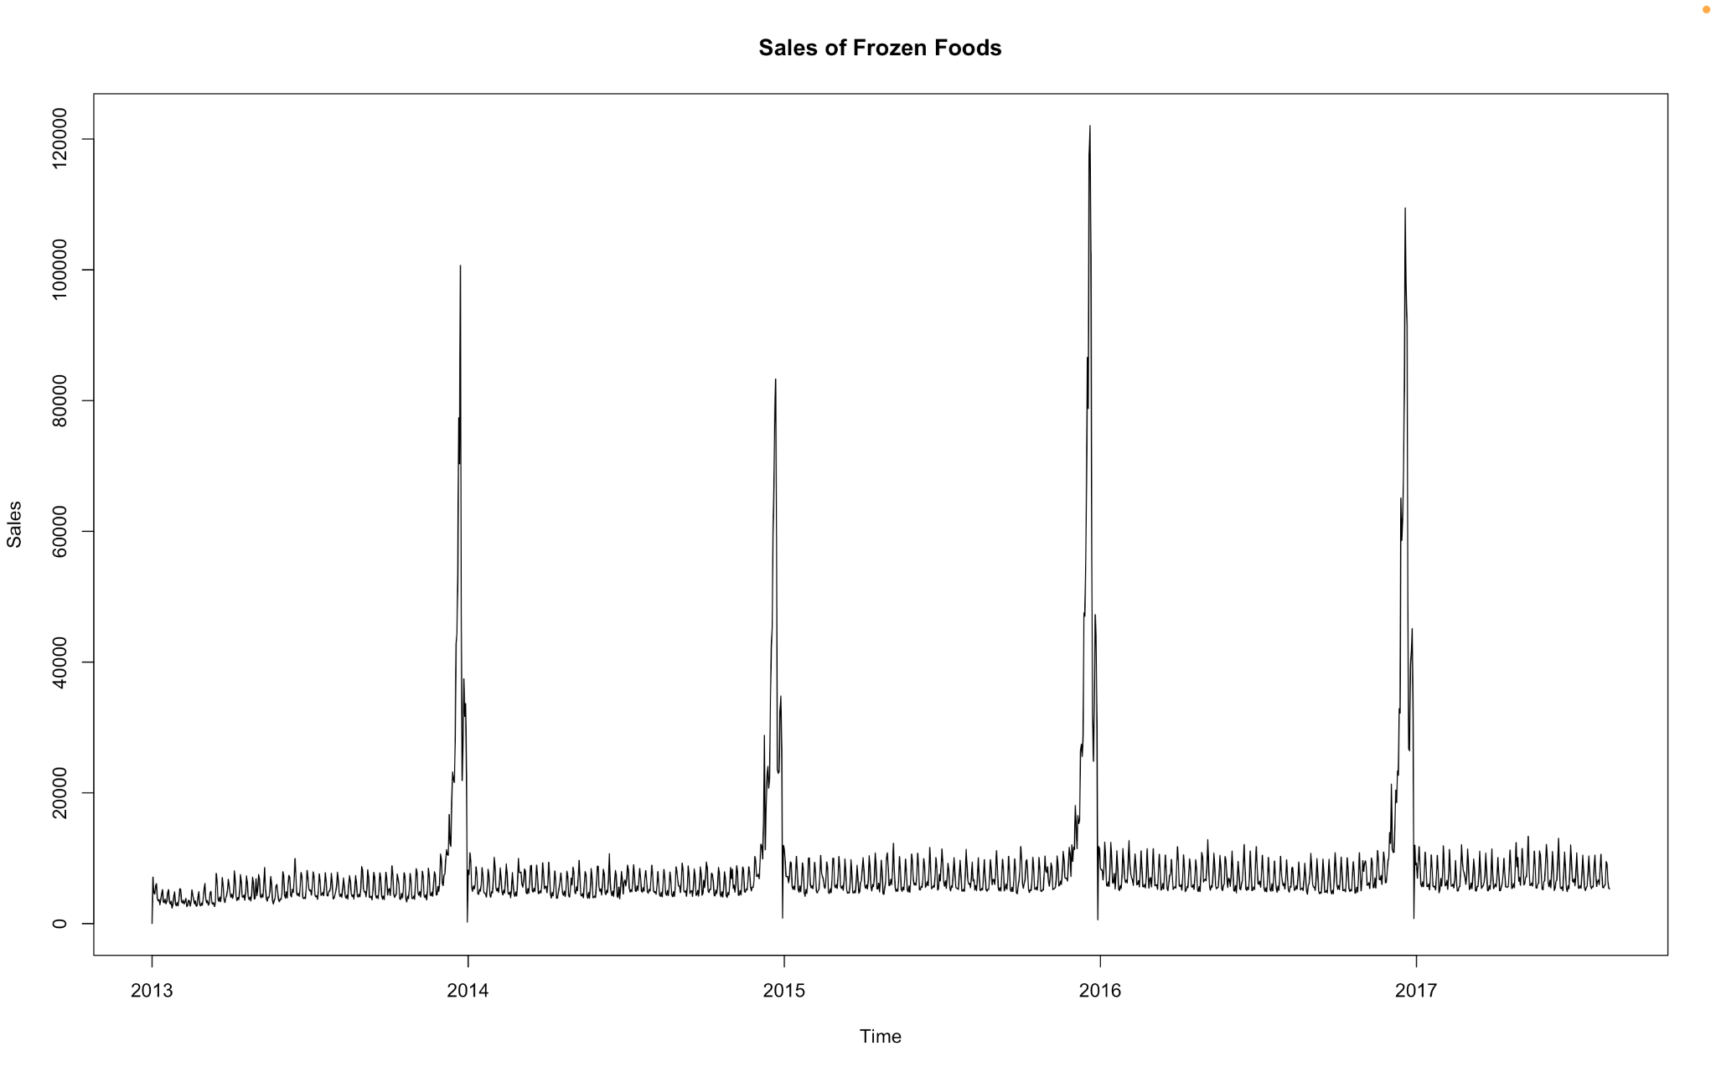

The above plot depicts the sales of frozen food products through the years, 2013 to 2017. There appears to be a relatively constant mean around which the time series fluctuates except at the end of the year, when it rises sharply and the beginning of the year when it falls sharply.

There does not seem to be an obvious trend, which may be masked by the variability in the data, and entails a more in depth analysis using smoothing and decomposition which are described a little later in the report.

There is a subtle but evident increase in the variability as the years pass by.

Additionally there seems to be a seasonality within each year, the period of which is not really evident in this plot and it will be examined by essentially scrutinizing the sales for every year.

### Decomposition

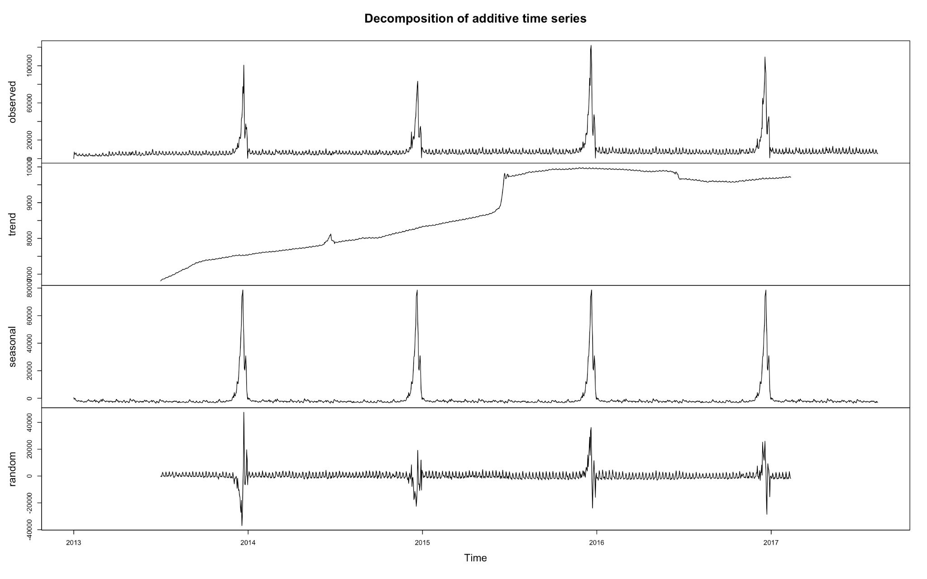

**1.** **The observed component**

The series shows a strong yearly seasonal pattern and a slight increase in variability through the years.

**2.** **Trend component**

Evidently, there is a gradual increase from 2013 to mid 2015, when there occurs a sharp increase, followed by a relative stability until mid 2016 and a subsequent decrease that occurred in mid 2016 and remained at the same level until 2017.

These are some interesting patterns which were not very apparent from the run sequence plot.

The increase in the trend could be due to an increase in the demand of frozen foods owing to their easy preparation and convenience, and an increase in oil prices until 2014, which led to an increase in GDP, because the economy of Ecuador is highly dependent on the prices of oil.

The sharp increase in 2015 could be due to the El Nino event that disrupted agriculture, causing consumers to buy more longer shelf life food products like frozen foods.

The periods of relative stability could be due to a variety of exogenous factors such as decrease in oil prices and GDP since 2014 until mid 2016.

The subsequent decrease could be due to the earthquake which struck Ecuador in mid April, causing a lot of damage to infrastructure, and the supply chain management, disrupting the supply and demand cycle.

**3.** **The seasonal component**

This shows regular fluctuations with annual peaks and drops along with a very elusive local seasonality. The fluctuations seem to be consistent over the years indicating a stable seasonal pattern

The seasonal patterns remain fairly consistent through the years, with a sharp increase occurring every year in December and a very feeble weekly seasonality which may not be as evident, necessitating further analysis.

The abrupt increase at the end of each year, could be due to vacation, and festivals like Christmas, and an increase in tourism, engendering a need for low preparation time food products, prominently frozen food products.

**4.** **Random component**

The presence of significant noise shows that the time series is quite volatile, meaning there are many unmodeled factors affecting the data.

These are the fluctuations that remain after removing the trend and seasonality from the original data, and ideally should be random white noise.

However, the variability in the random component shows an inherent pattern, and prominent spikes at the transition period from one year to the next, which is precisely the time when there were spikes in the original time series.

Such patterns communicate that not all the patterns have been accurately captured by the trend and seasonality.

In order to further improve the results of decomposition and capture underlying patterns inherent in the data, multiplicative decomposition and other robust decomposition techniques like STL (Seasonal and Trend decomposition using Loess) will be demonstrated. Additionally, anomaly detection and handling will be performed to identify and replace any significant anomalies that would otherwise distort the model’s performance.

**Multiplicative Decomposition**

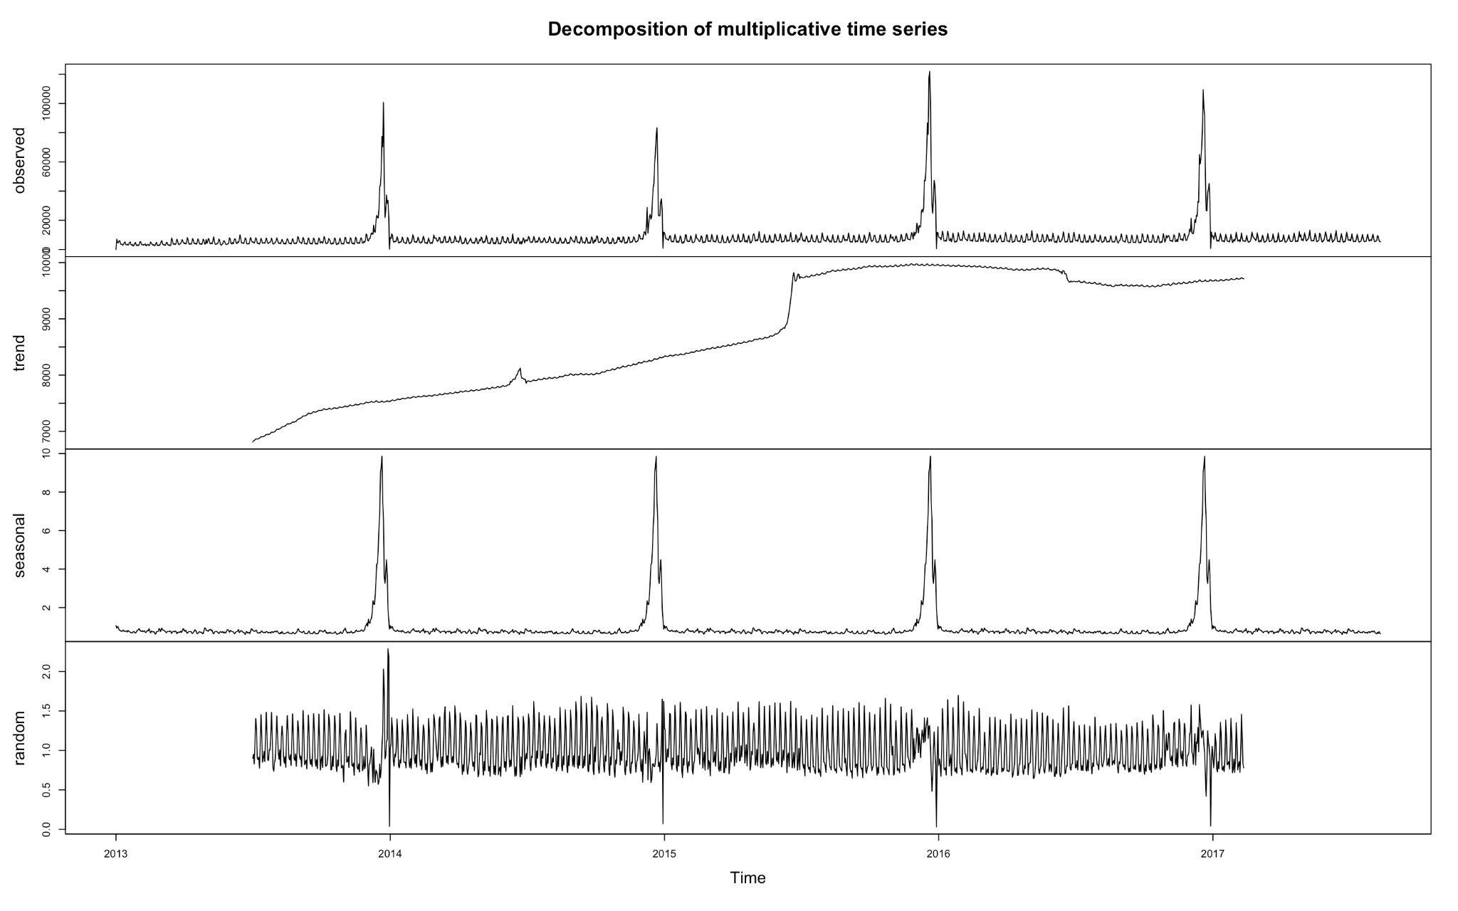

**1.** **Data**

The sales values of frozen food products from 2013 to 2017 are depicted, with a prominent yearly seasonality and no apparent trend, along with a little variability.

**2.** **Trend**

The trend shows a gradual increase from 2013 to 2015, then a sharp rise and a period of stability until mid 2016, and followed by a decline in 2017. This shows a rise and a fall in the overall level of data over this period.

There is an upward trend from 2013 to mid-2015, a subsequent stabilization, and an abrupt decrease in mid 2016 close to the time when the earthquake struck, and finally a stable period until 2017. This is very similar to the additive model.

**3.** **Seasonal**

There is a very predominant yearly seasonality, and an elusive yet significant weekly seasonality.

**4.** **Remainder**

While the random component seems to be more noisy and volatile, it does have a tinge of regular fluctuations akin to the elusive weekly seasonality and the more prominent yearly seasonality. This implies that there is some variance that could not be completely captured by the trend and seasonal components.

The pattern in the residuals call for another attempt at decomposition using another technique and better detection and handling of anomalies.

**STL Decomposition (Additive)**

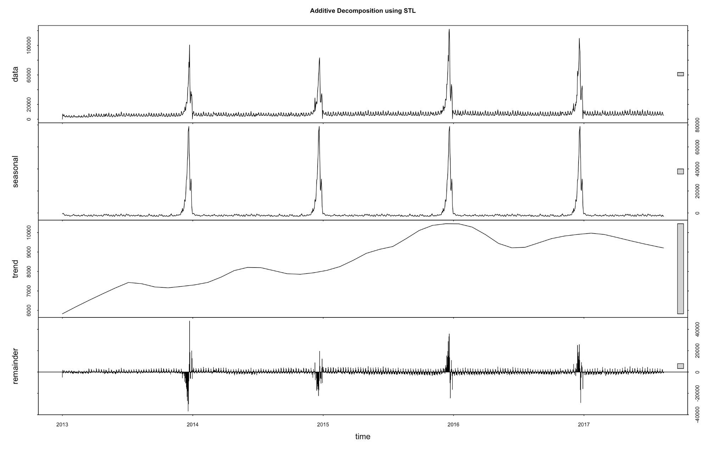

**1.** **Data**

The sales value of frozen food products from 2013 to 2017 demonstrates significant yearly seasonality and a weekly seasonality.

**2.** **Seasonal**

Once again, the yearly seasonal pattern is very evident, which most likely occurs due to festivals like Christmas, holidays, and the corresponding boost in tourism.

**3.** **Trend**

There is an upward trend, which is especially prominent from 2013 and until beginning of 2014 which slows down until 2015 and dampens afterwards to settle down for a period until mid 2016 when a sudden drop occurs due to the catastrophic earthquake and the corresponding infrastructure damage.

However, with the passage of time, and significant improvements in infrastructure coupled with the revitalized supply demand cycle, there is some increase in the trend which again drops close to the end of 2017. This could be due to hoarding of food supplies engendered by tumultuous conditions and anxiety over disruptions in the future along with greater marketing efforts, and renewed spending power.

Nonetheless, the effects of the shock continue to impact the trend which is consistent with the fact that markets experience a lot of changes before converging back to an equilibrium value, due to aftershocks, supply chain adjustments, and consumer behavior.

That said, these fluctuations could also be related to more intricate, and elusive exogenous factors that are not easy to factor out by simply looking at the time series.

**4.** **Remainder**

The magnitude of the remainders has been improved a lot, as compared to previous decomposition techniques suggesting that a lot of other patterns have been captured into the trend and seasonality. However, there still seems to be an inherent pattern which is very consistent with the seasonality, suggesting the need for a more in depth analysis.

**STL Decomposition (Multiplicative)**

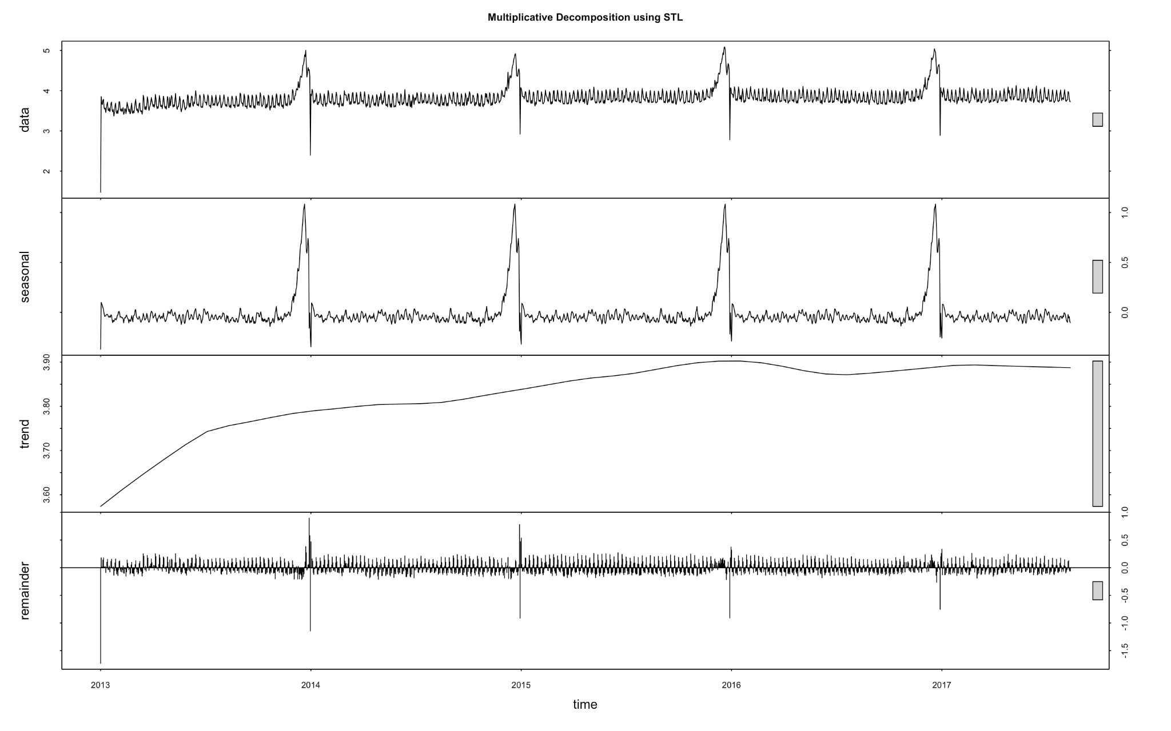

Since it is not possible to do multiplicative decomposition using STL, a new time series was created by applying the log transformation and decomposing it in the additive way, which effectively is a multiplicative decomposition of the time series.

**1.** **Data**

The sales value of frozen food products from 2013 to 2017 demonstrates significant yearly seasonality and a weekly seasonality.

**2.** **Seasonal**

Once again, the yearly seasonal pattern is very evident, which most likely occurs due to festivals like Christmas, holidays, and the corresponding boost in tourism. However this decomposition more accurately captures the weekly seasonality, making it more apparent.

**3.** **Trend**

There is an upward trend, which is especially prominent from 2013 which slows down until 2015 and dampens afterwards to settle down for a period until mid 2016 when a sudden drop occurs due to the catastrophic earthquake and the corresponding infrastructure damage.

However, as mentioned in previous decompositions, there is a period of increase and stabilization in 2017 as a consequence of after shock effects, and infrastructure redevelopment.

This decomposition does a better job at capturing the overall trend rather than responding very sharply to changes, which reflects the overarching pattern in the sales of frozen food products.

**4.** **Remainder**

The remaining component produced by this decomposition looks more like noise, although the deviations from the mean are high during the end of each year which is in alignment with the yearly seasonal pattern, the residuals are distributed evenly across the mean and look more random.

### ChangePoint Analysis

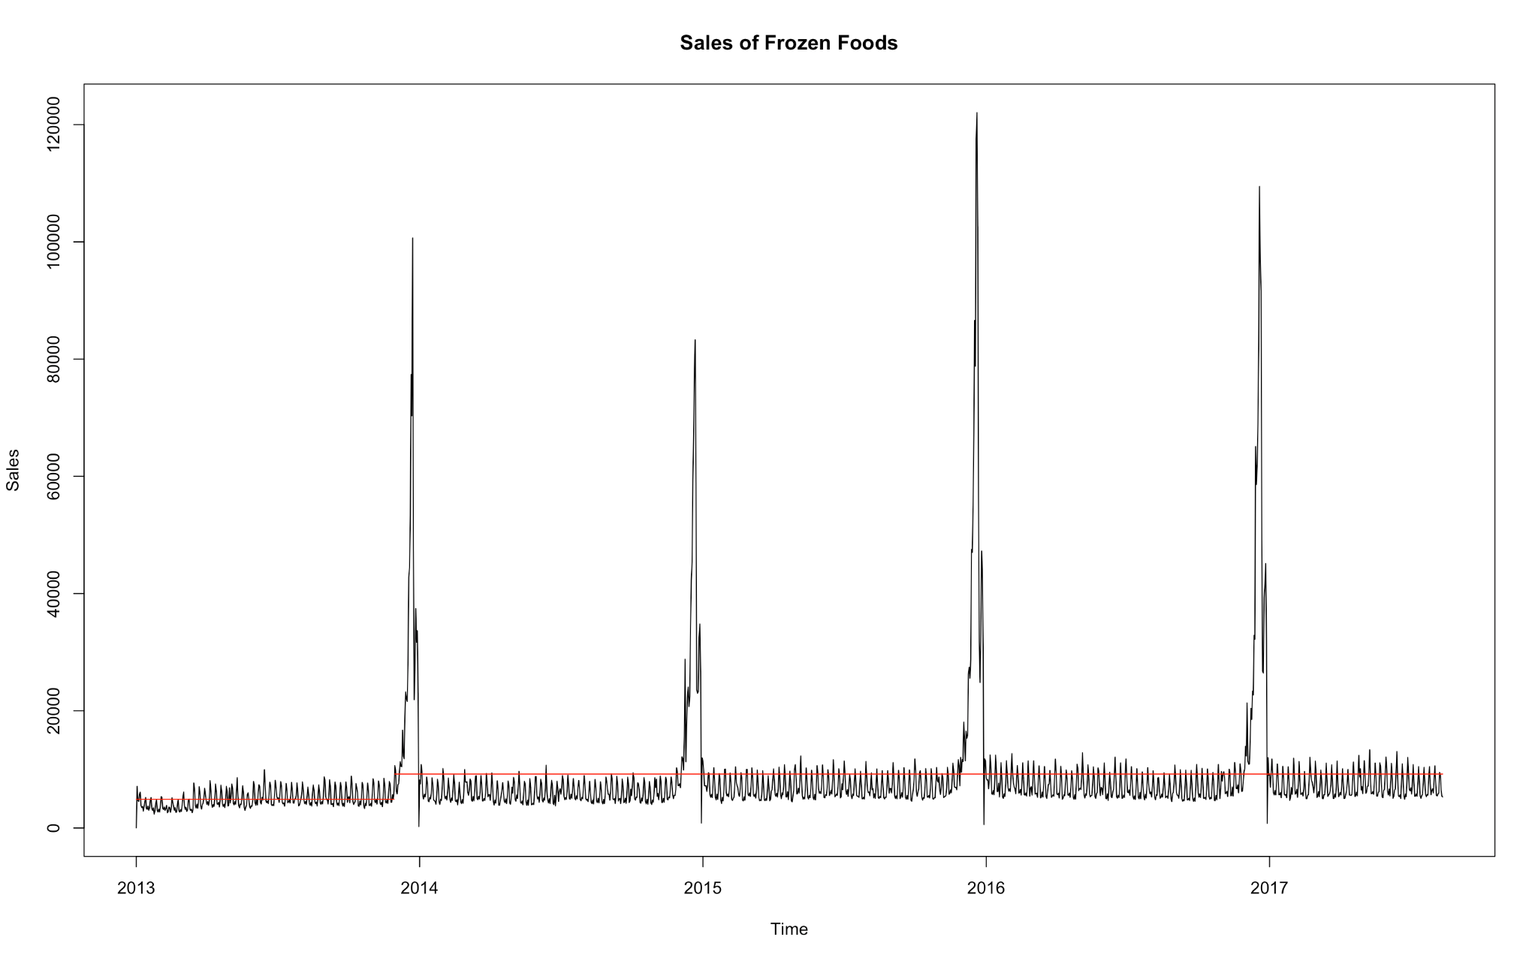

The above graph detects a significant change in the level of the time series using change point analysis of the mean of the data.

The horizontal red line shows a statistically significant change in the mean level of the series.

It seems like there is a significant change in the level or mean of the time series at the end of 2013, which then remains pretty stable until mid 2017, along with an increase in the variability through the years.

**Analyzing the impact of the earthquake on April 16, 2016 on the sales of frozen foods**

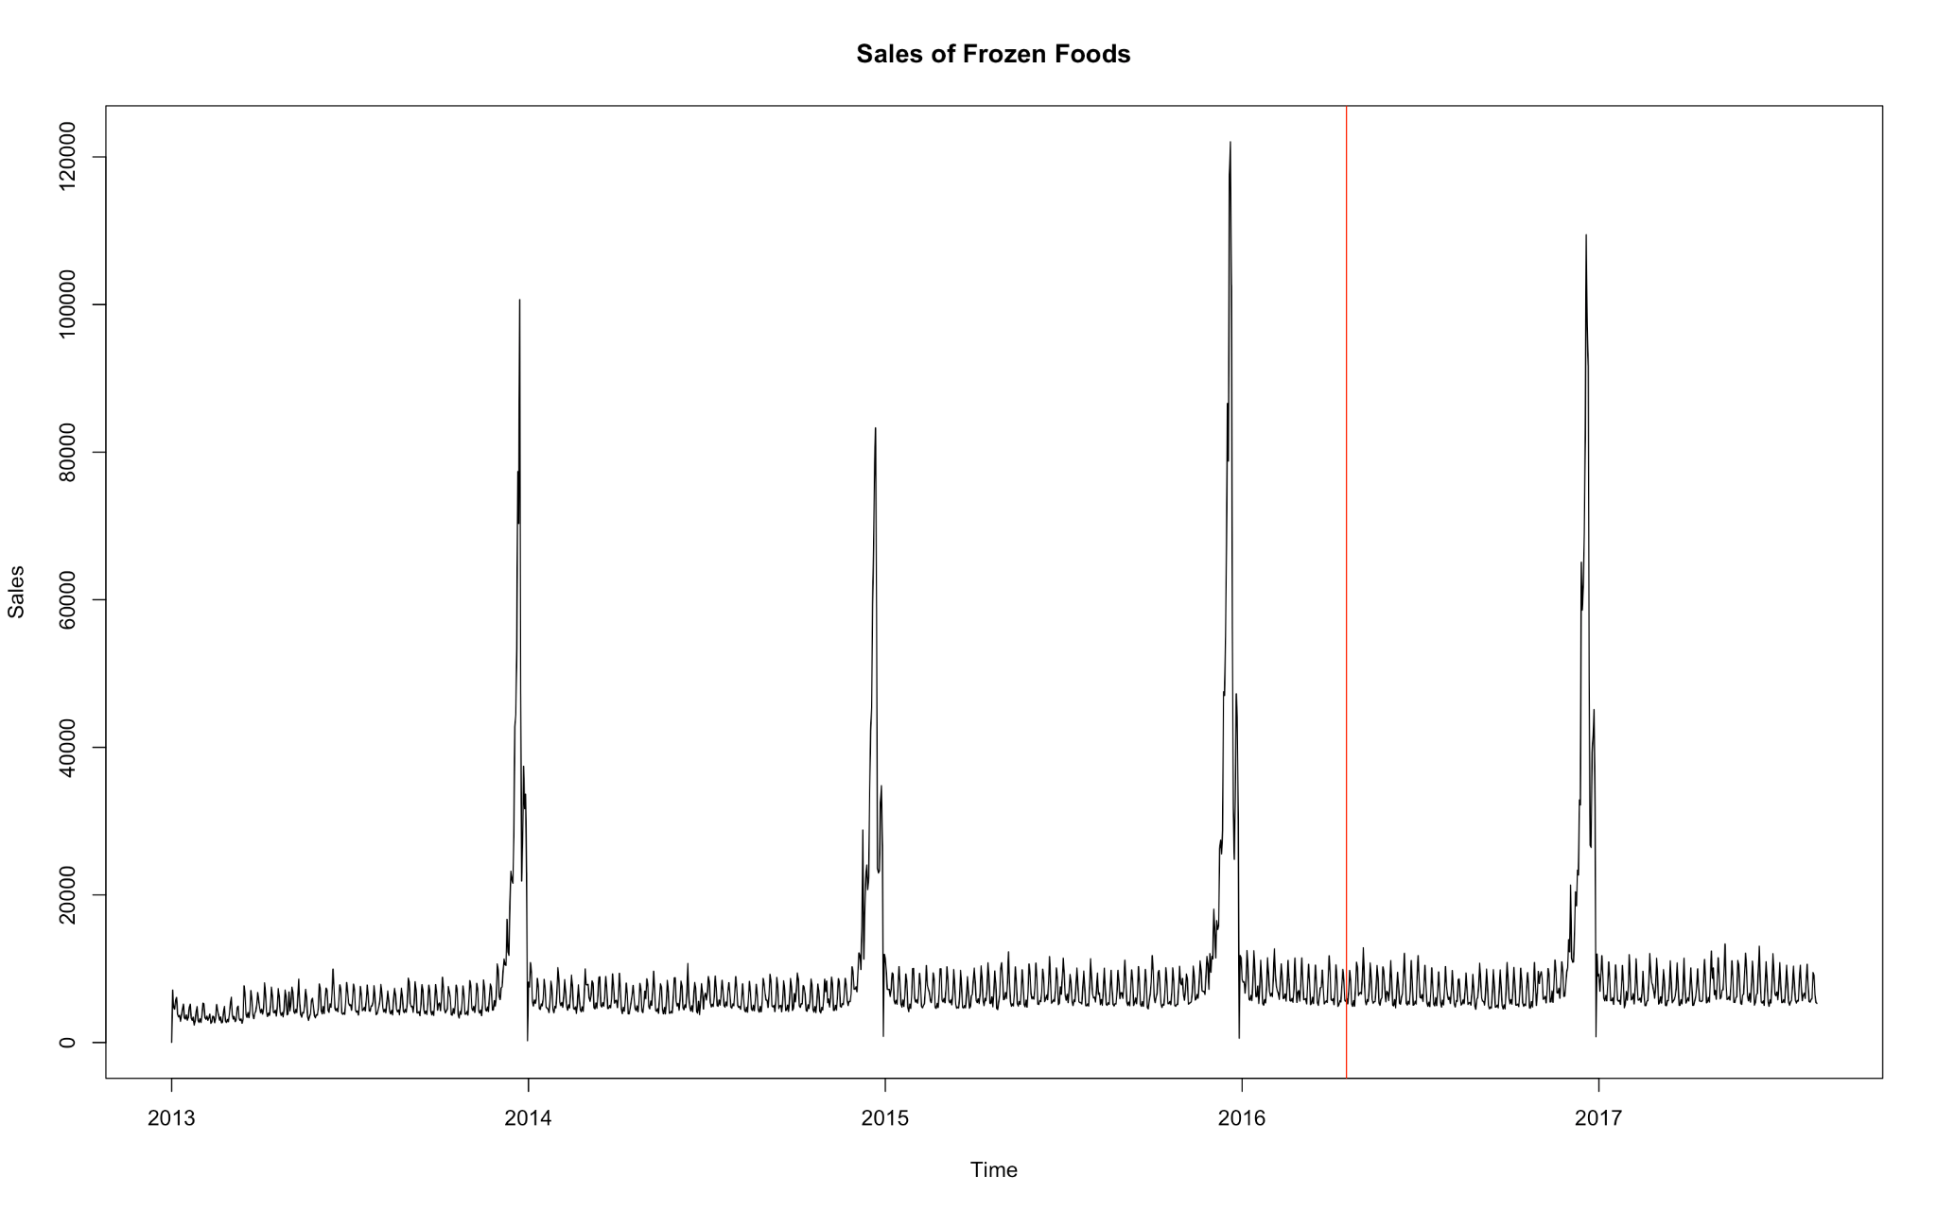

There does not seem to be any apparent impact on the sales of frozen food products before and after the earthquake, however there is a little change in the variability. That said, the impact of the earthquake was very apparent from the decomposition of the time series as has been discussed earlier.

### Peaks & Troughs For Each Year

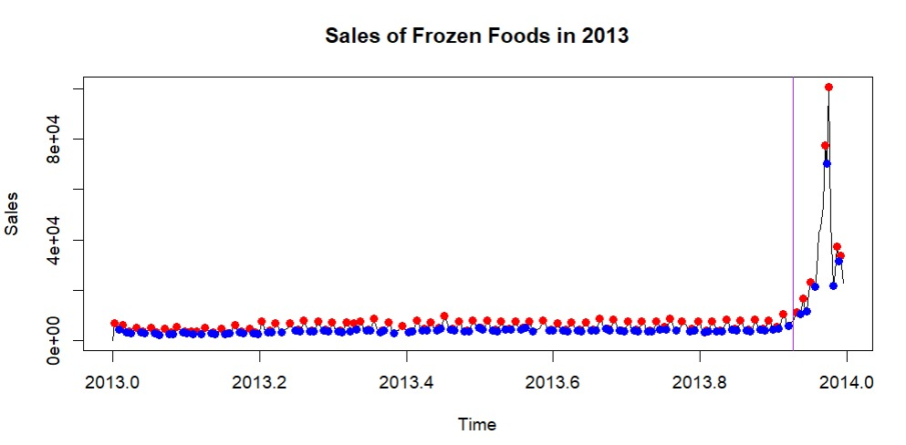

The sales of frozen food products in 2013 shows a clear seasonality within the year, with peaks and troughs occurring at regular intervals. The average sales value throughout the year was 3,500 to 6,500, with the sales peaking in December to as high as 100,000

The sales started slowly in the year 2013, and increased gradually by the month of March to April which could be due to a variety of factors like gradual economic growth due to an increase in oil prices, the GDP, and a corresponding increase in spending power, and then they remain frequently constant throughout the year except at the end when it increases abruptly.

There is a constant and steady demand for frozen food products throughout the year, making it a popular food choice among the people of Ecuador.

The vertical line shows a statistically significant change calculated using change point analysis of the mean and variance combined. This time of the year is close to the second week of December, and goes on until the end of the year. At the beginning of the next year it falls sharply.

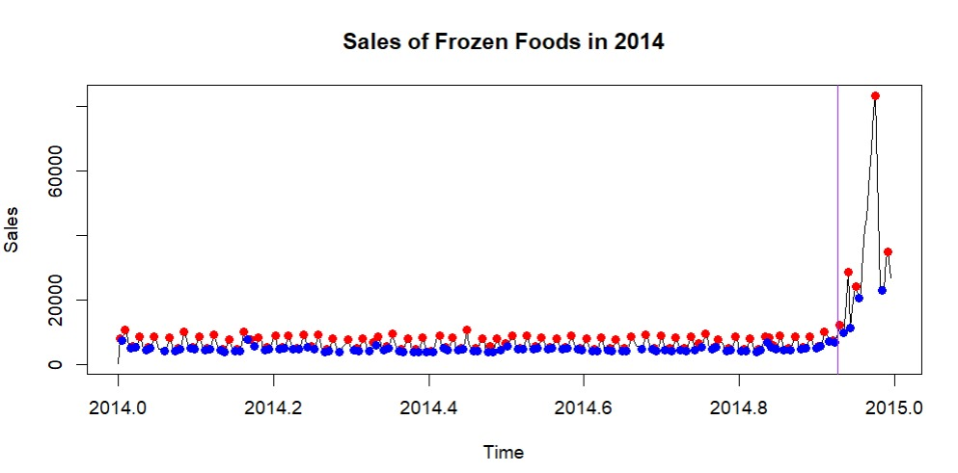

The sales of frozen food products in 2014 looks fairly stable throughout the year with no apparent trend or a lot of volatility, while still demonstrating the strong weekly seasonality. The sales values throughout the year remain between 4500 and 7500 which demonstrates a steady increase from 2013, and peak value of sales is close to 80000, which is a little less compared to the past year. This could be due to the crash in oil prices that remained for a couple of years until mid 2016.

These observations are in strong consonance with the decomposition analysis described previously.

The year begins with a sharp drop in sales on the first day followed by a rather steady pattern. The peaks seem to occur on weekends and the troughs on weekdays which is consistent with consumer behavior.

The sales increase dramatically towards the end of the year from roughly around the second week of December and on until the end of the year.

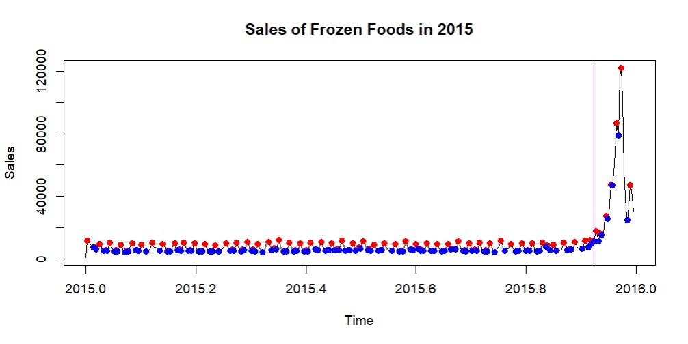

Similar to 2014, the sales for frozen food products in the year 2015 are rather stable throughout the year with no significant upward or downward trend. The sales value throughout the year lie between 5000 and 9000, which once again demonstrates a steady increase from the previous year, and the highest value of sales is over 120,000.

Once again, the year begins with a sharp drop in sales, followed by a relatively stable pattern throughout the remainder of the year, with the exception of the festive month of December, when it spikes abruptly. But this is a very huge spike considering the previous pattern and the fact that oil prices crashed during this time and hence displays anomalous behaiviour.

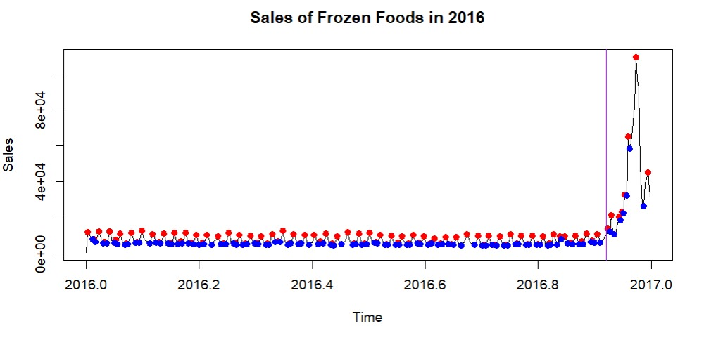

The sales of frozen food products in 2016, like the previous years, follows a rather stable pattern, however there is a slight change in variability through the year. The sales average between 5000 and 9000 which is very similar to the past year indicating a rather stable period, which had been observed in the decomposition of the time series as well.

The sales once again peak close to the December month, with the highest value being, close to 100,000, which is slightly lower compared to the previous year, and can be explained due to a variety of factors like the earthquake and its aftermaths such as infrastructure damage that Ecuador grappled with for quite a while.

This year too began with a sharp decrease in sales, and then a stable trend but with a marked difference in variability throughout the year.

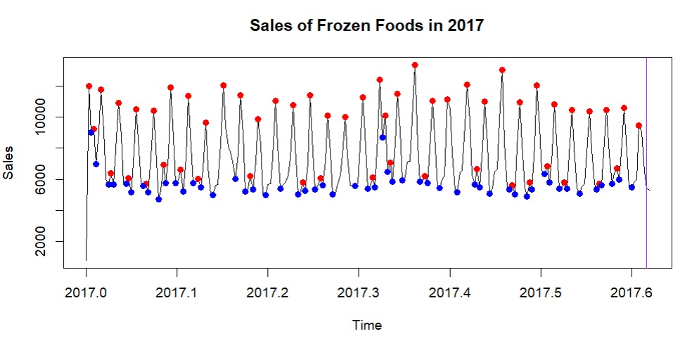

The sales of frozen food products in 2017, follows a rather stable pattern, with a very evident weekly seasonality. The sales average between 5000 and 9000 which is very similar to the past year indicating a rather stable period, which had been observed in the decomposition of the time series as well.

The year 2017, like the previous years, began with an abrupt drop at the beginning of the year, but followed a more stable pattern for the rest of the year.

In summary, for all the plots except 2017 (because it has data only until August 15th) it can be seen that the sales drop at the beginning of each year and rise sharply at the end which precisely corresponds to the second week of december and goes on until the end of the year. The highest peak corresponds to the fourth week of December, which is also the time Christmas happens every year. The increase in sales in December can be explained according to the following:

1. This end of the year coincides with the festivals of Christmas, with Christianity particularly Catholicism, constituting the primary religious identity of the country. This leads to an increase in get togethers and social occasions. This entails food preparation on a large scale and frozen foods provide an easy, cheaper and convenient option doing so as compared to the more expensive meats etc.
2. This time of the year also corresponds to vacation and holidays, when people tend to spend more, and there is a lot of marketing and reduction in prices on frozen foods leading to increased sales. Additionally, this is also when tourism is at its peak and travelers prefer to purchase frozen foods which take up less time to prepare, and have higher shelf lives.
3. Furthermore, in Ecuador the employees are paid a “13th Wage” in December, furthering the tendency to spend.

The decrease in sales towards the beginning of each year which can be explained as:

1. After the holidays and a lot of spending, families would curtail the amount of money they spend as a whole including frozen foods.
2. Moreover, a large number of supermarket stores could probably be closed which has a direct impact on the sales.
3. At the beginning of each year, people make resolutions and try to adapt to stricter and healthier diets which correspond to fresh foods as opposed to frozen foods, leading to a decrease in overall spending on frozen foods.

### Yearly Sales

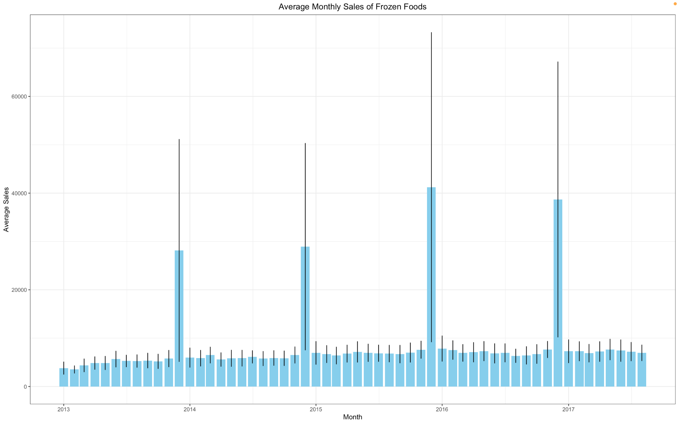

The above plot depicts the sales of each month through the years 2013 to 2017.

It is apparent that the sales increase slowly through the years, with the sales being the highest at the end of each year in November, and particularly in December, the probable factors for which have already been dwelt upon at great length.

### Monthly Sales

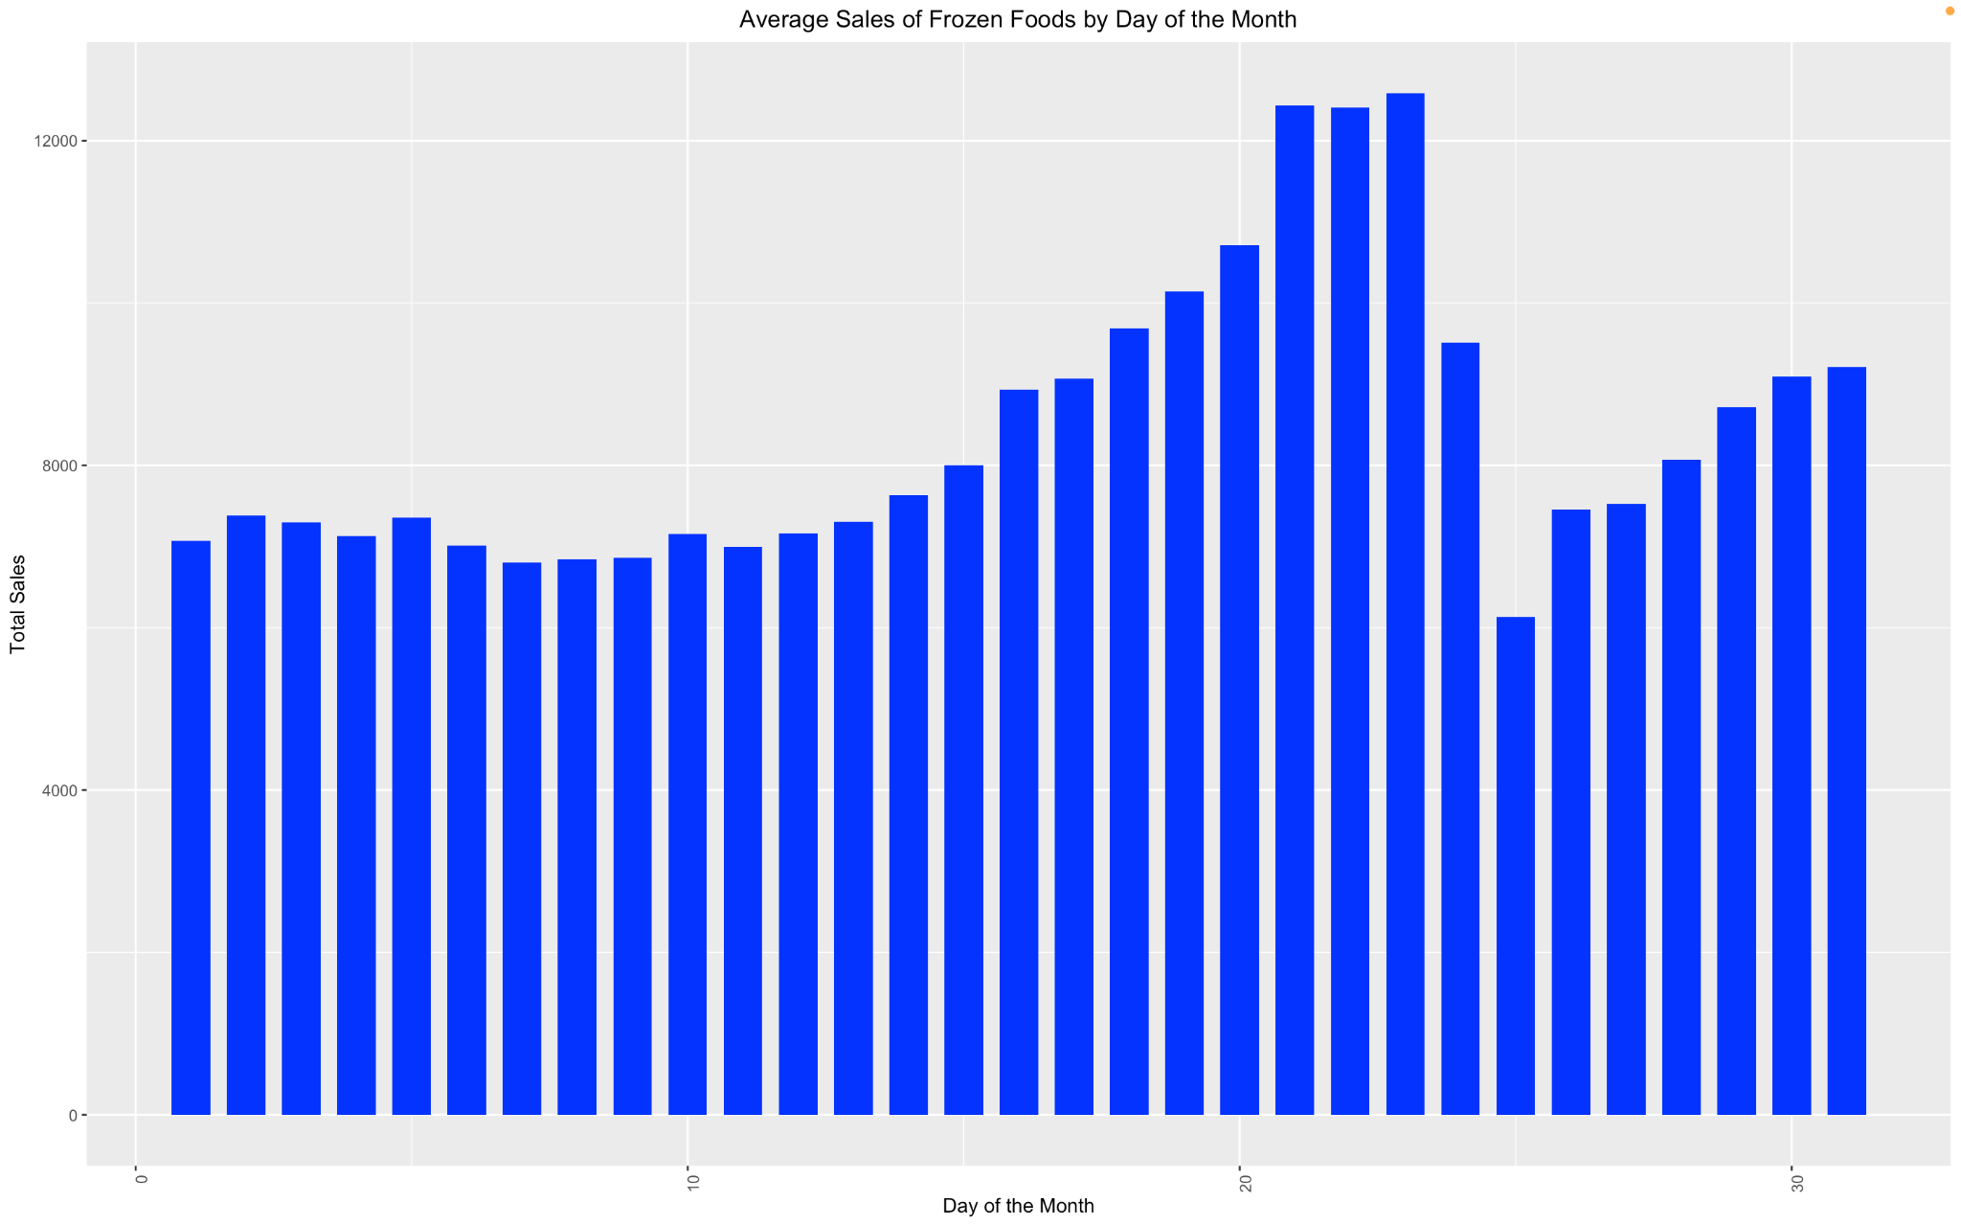

The above plot shows the average sales of each day of the month through the years. The sales values rise through and start increasing close to the end of the second week and through the third week when it falls sharply and increases gradually again.

The above pattern is consistent with the fact that wages are paid on the 15th, which means that people have more spending power and tend to buy groceries and fill up stocks for the rest of the month, and since frozen food products provide a quick and efficient way of preparing meals, they are very appealing options, which fit within the modern day busy schedules and sedentary lifestyles of people. Another plausible reason for having a mid month peak in sales could be due to promotions and effective marketing strategies.

As soon as the initial surge of spending dwindles, and people become more conscious about the amount they spend, the sales fall and then rise gradually towards the end of the month, as wages are paid at the end of the month as well.

### Weekly Sales

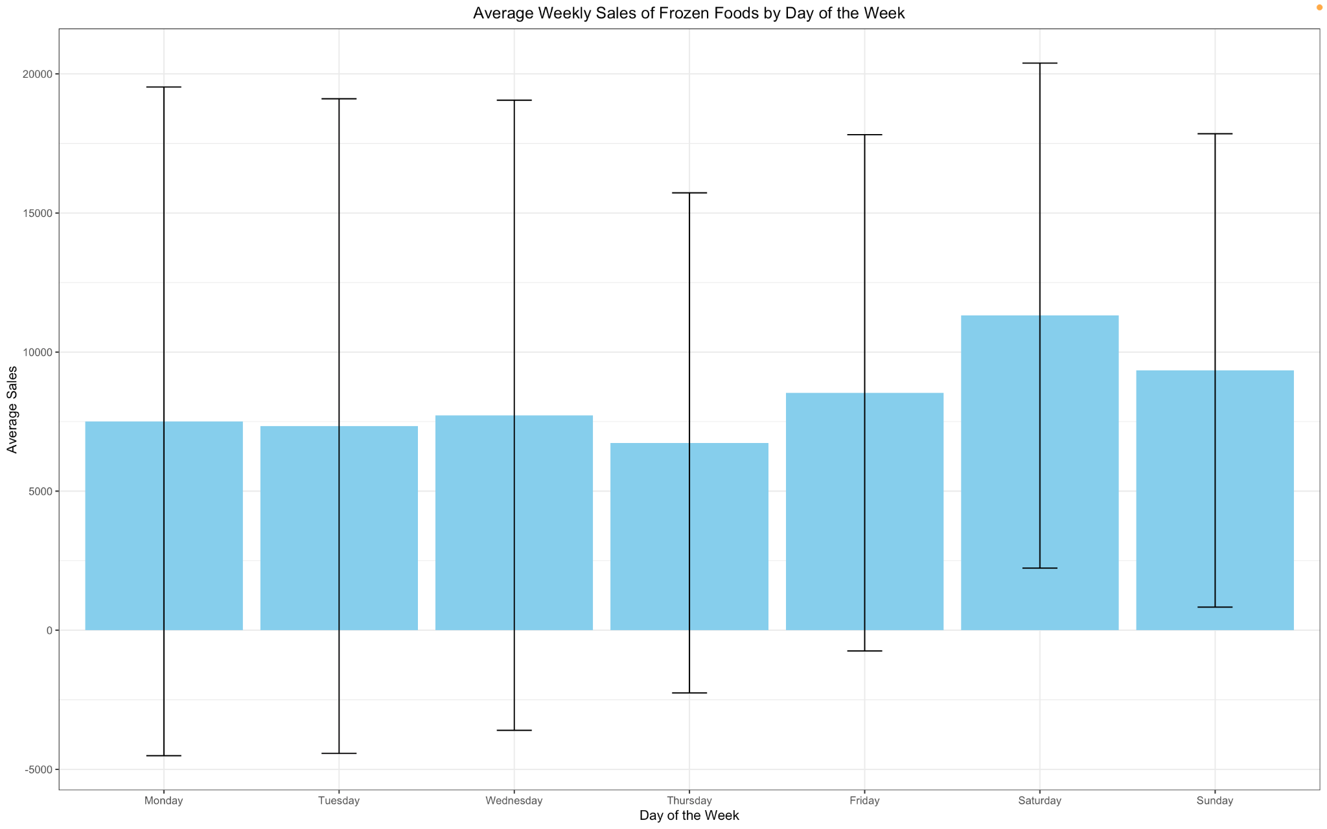

**Daily Sales Analysis:**

Monday - 7500

Tuesday - 7300

Wednesday - 7700

Thursday - 6700

Friday - 8500

Saturday - 11300

Sunday - 9300

Sales are stable throughout the week with a dip on Thursday and an increase towards the weekend with the highest sales on Saturday. This is reasonable because during weekdays people do not get enough time to go out shopping and since Saturday and Sunday comprise the weekend, people have sufficient time to go shopping and pile up stocks for the remainder of the week and next week. Additionally, most of the other weekdays have very low spending because people have other commitments and priorities, which leaves very less time for tasks like shopping for groceries.

### Influence of promotions on daily sales of Frozen Foods

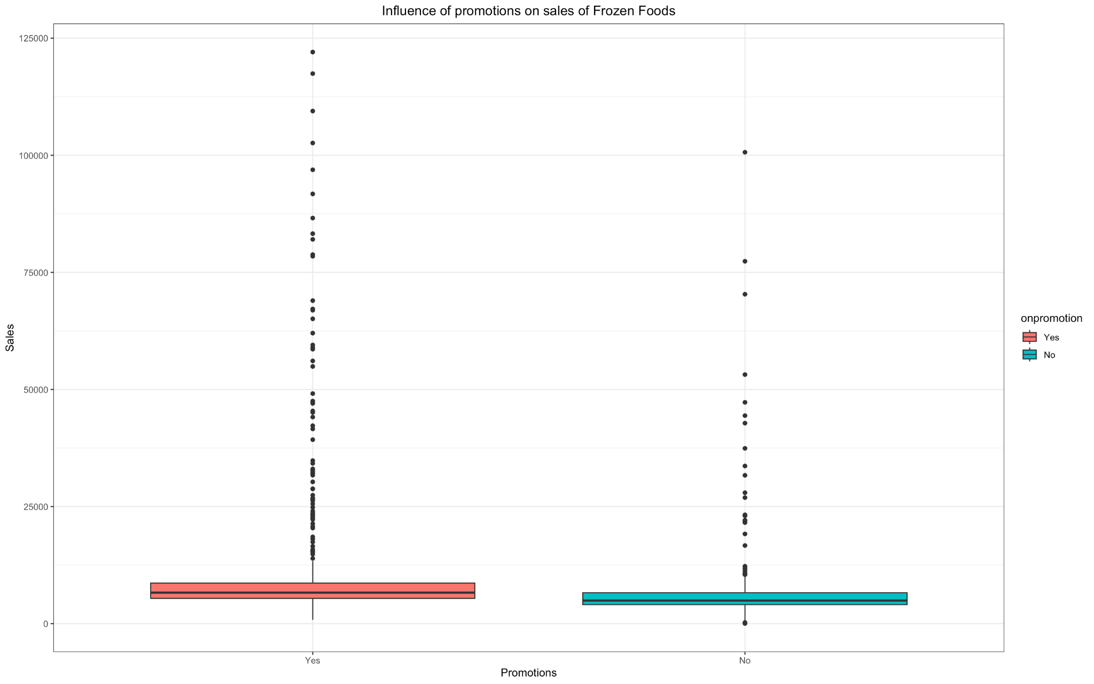

It can be inferred from the above graph that in general, sales of frozen foods are higher when products are being promoted as compared to when they are not. There is a slight difference in the inter-quartile ranges, however there seem to be a lot of outliers that skew the distribution to the right, which occur more frequently when there are promotions as compared to when there are not.

This is reasonable because it appeals more to the people who are often conscious about the amount they spend and this makes frozen foods a more viable option than dining out.

### Moving Averages

**Single Moving Average (SMA) for a 30 day Window**

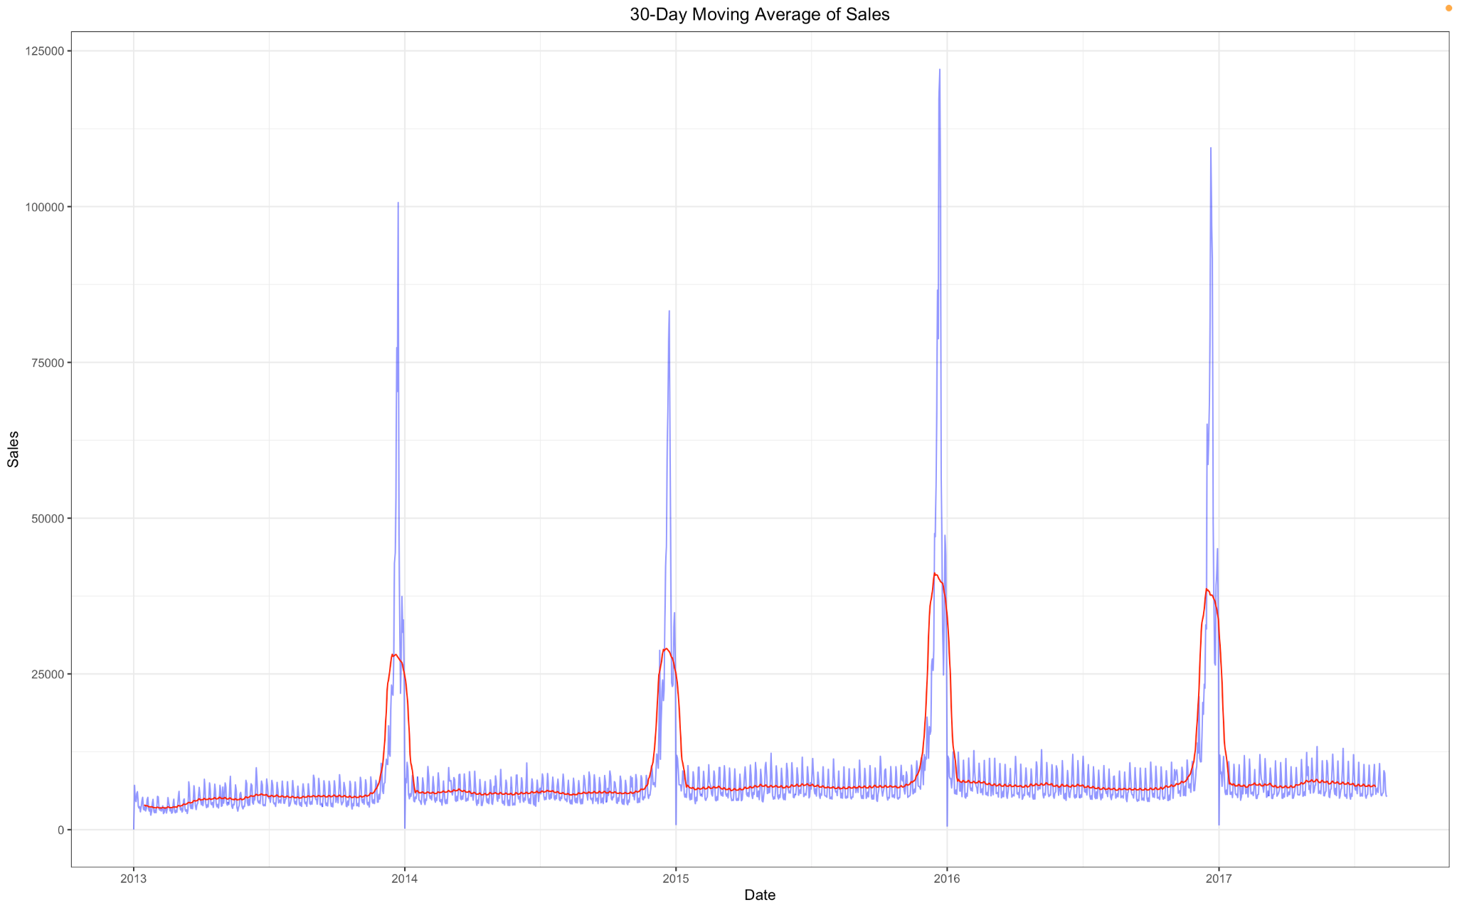

Single moving average is a simple yet effective technique that is used to remove the effect of noise and reveal the underlying trend better.

The single moving average in the above case is very effective in eliminating the impact of noise and clearly demonstrates the yearly seasonality as was described before.

There is a gradual upward trend from early 2013, and into 2014. This could be due to a variety of exogenous factors such as changes in tax policies etc. however this trend does not seem to change a lot until 2016, when it falls due to the earthquake that struck Ecuador in April 2016, which had a lasting impact on the infrastructure and supply chain. However towards the end of the year there is a slight upward trend, which could be due to better marketing and a temporary rise due to piling of stocks caused by future uncertainties.

Moving into 2017 there is a stable trend as the transient increase in the demand post the earthquake dissipates, and the sales converge to a new equilibrium in 2017.

However, the trend is not very apparent, entailing the need for a better model to analyze the trend.

**30 Day Exponential Moving Average of Sales**

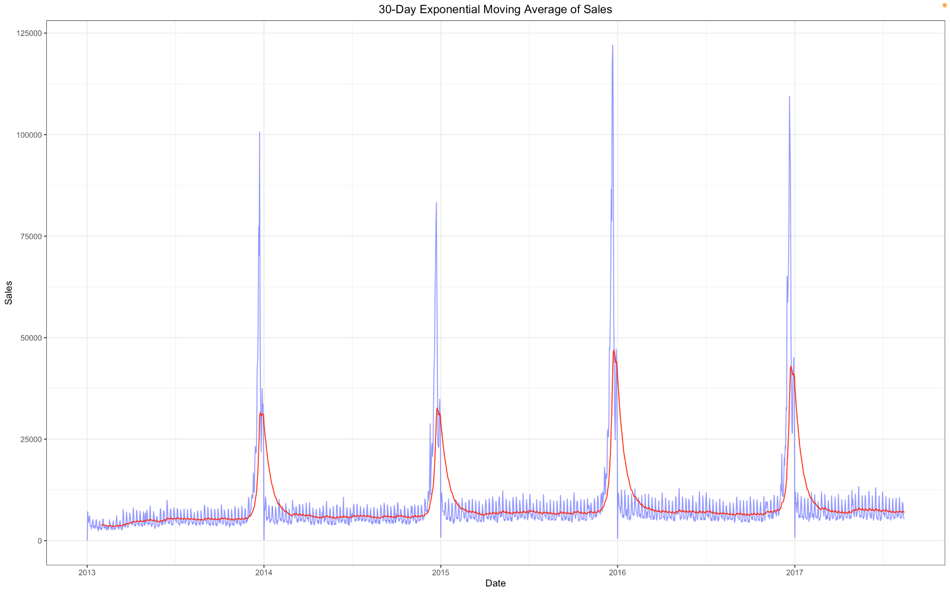

Exponential Moving Average assigns exponentially decreasing weights to past values when smoothing out observations, hence is more responsive than Single Moving Average to changes in the values of the data.

As has been noted before, the trend increases relatively quickly from early 2013 to 2014 due to increase in oil prices and GDP. This is followed by a rather stable period from 2014 to 2016 due to decrease in oil prices, when it finally dips after 2016, due to the earthquake.

The year 2017 has a fairly stable trend which a small increase as markets recover, and customers’ confidence increases coupled with an increase in oil prices.

Although, this provides a better picture than Single Moving Average, it still does not explain the trend accurately.

**Linear Trend In Sales For Frozen Foods**

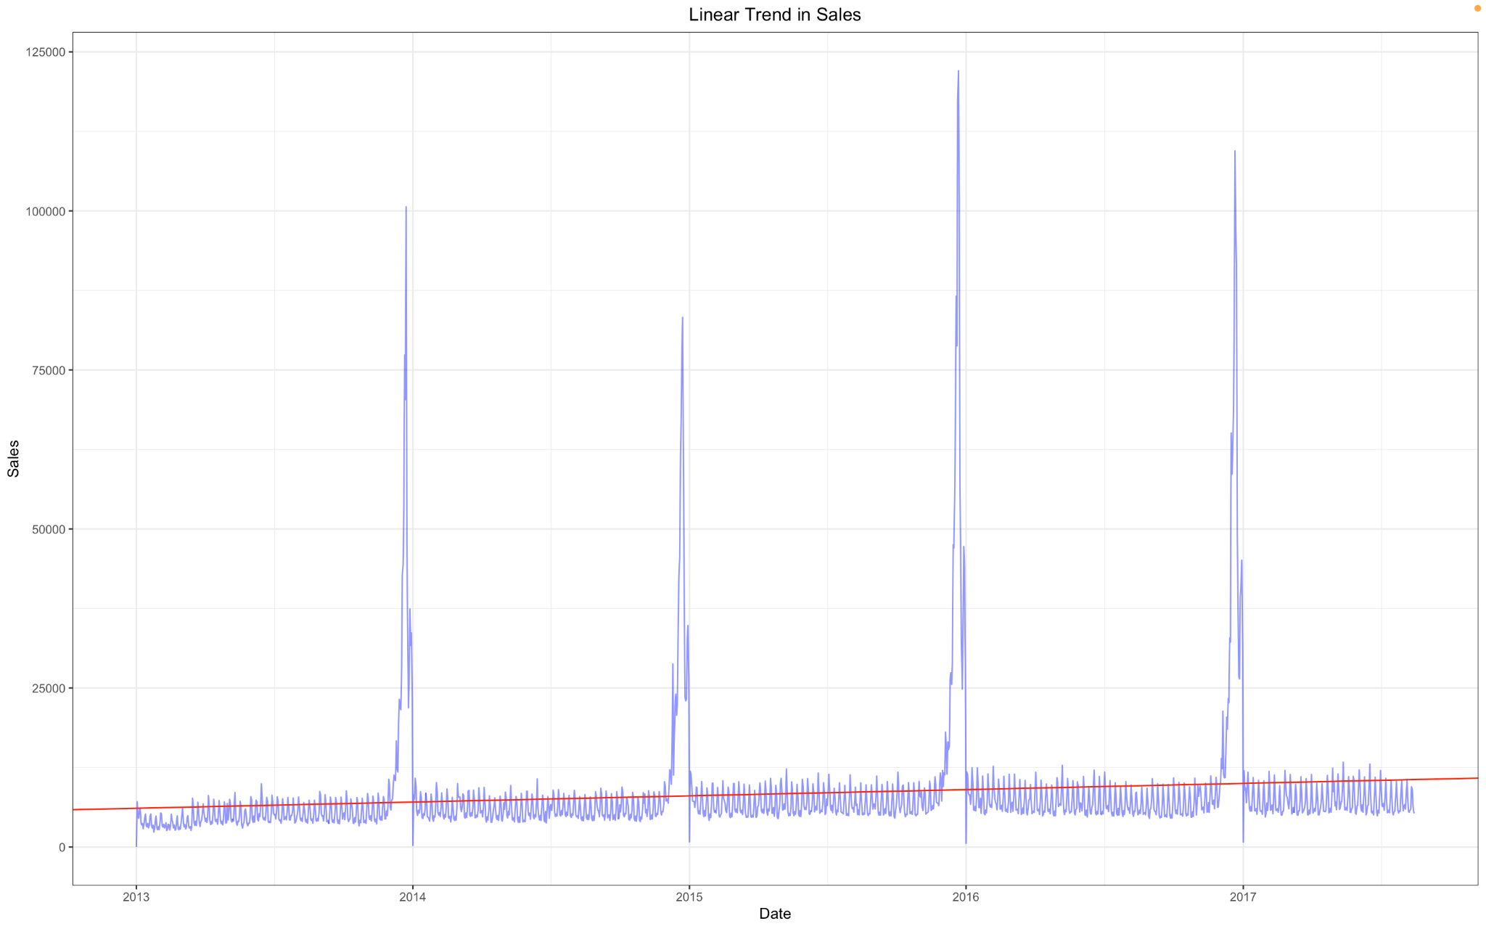

The linear trend is yet another effective technique that uses linear regression to find the best fit and expose the underlying trend.

It has a small positive upward slope, indicating that the sales demonstrate a linearly positive increase through the years, however as has been noted before the time series under discussion encapsulates a lot of nuances which may not be accurately captured by a simple linear model.

**LOESS Smoothing Of Sales**

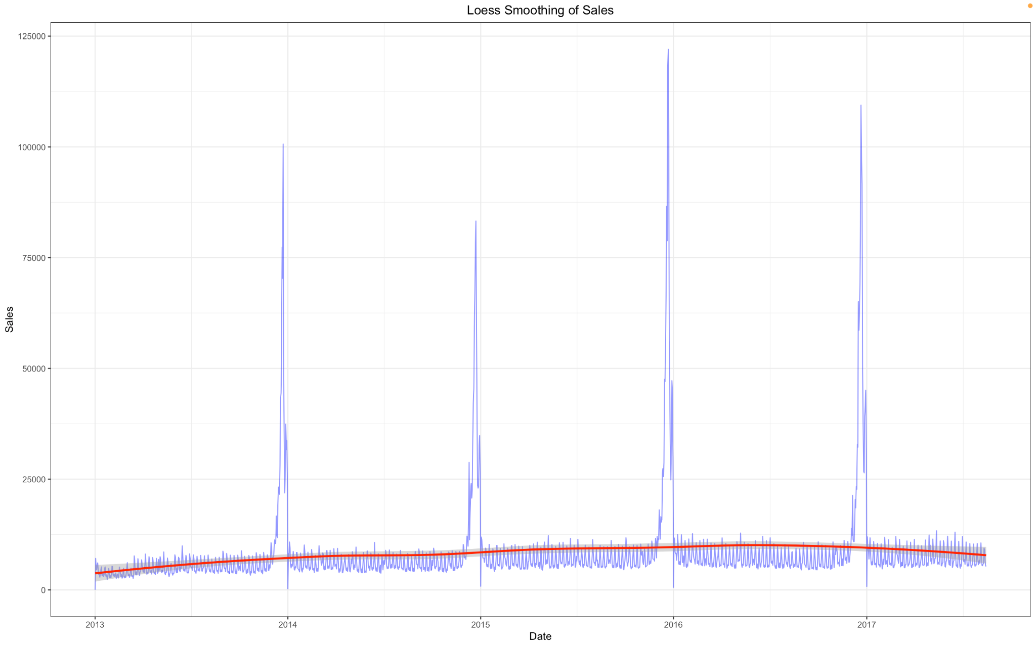

The LOESS (Locally Estimated Scatterplot Smoothing) smoothing is a technique for smoothing that exploits multiple regression in various locales of the dataset, to smooth out the noise and make the trend more prominent.

There is a rather faster increase in the sales from 2013 to 2014, this could be due to a myriad of probable factors due to higher oil prices and the fact that Ecuador’s economy is highly dependent on oil, its GDP rises and so does the spending power of people allowing them to purchase products like frozen foods. The value of sales in 2013 to 2014 demonstrate a range of values from 3500 early in the year to as high as 6500 in the middle and the extremely high values at the end of the year due to the yearly seasonality.

However from 2014 to mid 2016 it has a rather stable trend which could be due to the oil price crashes and the corresponding GDP decrease and the subsequent reduction in consumption of spending power. The values in this period range from 5000 to 9000 and this also carries on into 2017, which depicts the recovery of the markets and customers’ confidence.

In April 2016, the sales decrease because of the Earthquake, however as markets recover from the damage, it increases slightly due to hoarding and future uncertainties, and then decreases again as the ephemeral effects of the post earthquake impact, and stabilizes to a new equilibrium value, hence the stable trend in 2017.

### Structural Break Analysis



A run sequence plot of the sales of frozen foods demonstrates that the time series does not contain any structural breaks.

### Anomaly Detection and Handling

The Anomalize package has been used for the detection of anomalies. It leverages statistical techniques to detect data observations that are significantly different from the rest of the points. It basically decomposes the time series and then after removing the trend and seasonal components analyzes the residuals and uses the gesd technique to detect outliers, and labels them in the original dataset provided. Given below is the plot for the detection of anomalies using the Anomalize function: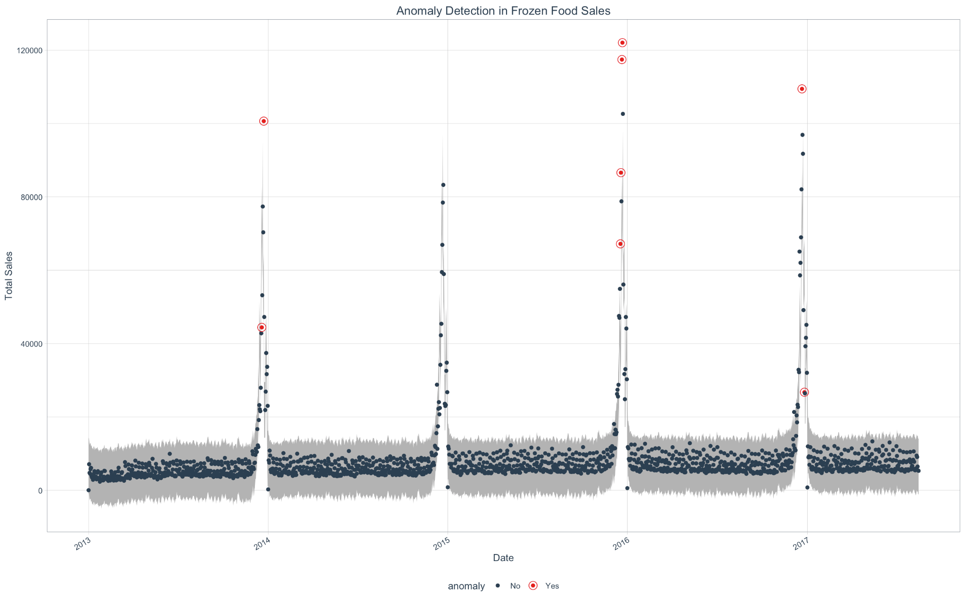

The above anomalous values would have to be imputed. However simpler imputing techniques such as mean, median, mode are not useful because they would distort the time series’ flow. In order to ensure a more robust replacement of outliers we have tried to replace the anomalous values with the multiplication of the seasonal and the trend components at those time periods using multiplicative STL decomposition which performed the best in case of the frozen food products time series, which is a very good approximation of the underlying structure in the data.

### Stationarity Analysis

The stationarity of the time series has been analyzed using the Augmented Dickey–Fuller (ADF) test, Kwiatkowski–Phillips–Schmidt–Shin (KPSS) tests, and Phillips-Perron (PP) Test. These tests are statistical methods used to check for the presence of stationarity in the time series.

According to the tests performed, the time series for frozen food products is non-stationary which was expected because it has a trend and seasonality. This entails differencing the time series, which would convert it into a stationary time series, which is because stationarity is the assumption of a lot of time series modeling techniques like VAR (Vector Autoregression) model which have been used to analyze the multivariate time series for the task at hand.

The above tests were performed on the time series after differencing, and they passed all the tests indicating that the differencing by an order of 1 was sufficient to make the time series stationary.

This is how the time series was looking before differencing:

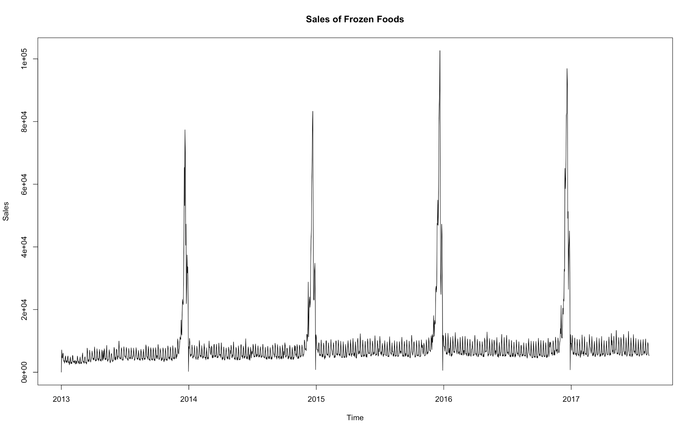

The following plot shows how the time series is looking after differencing:

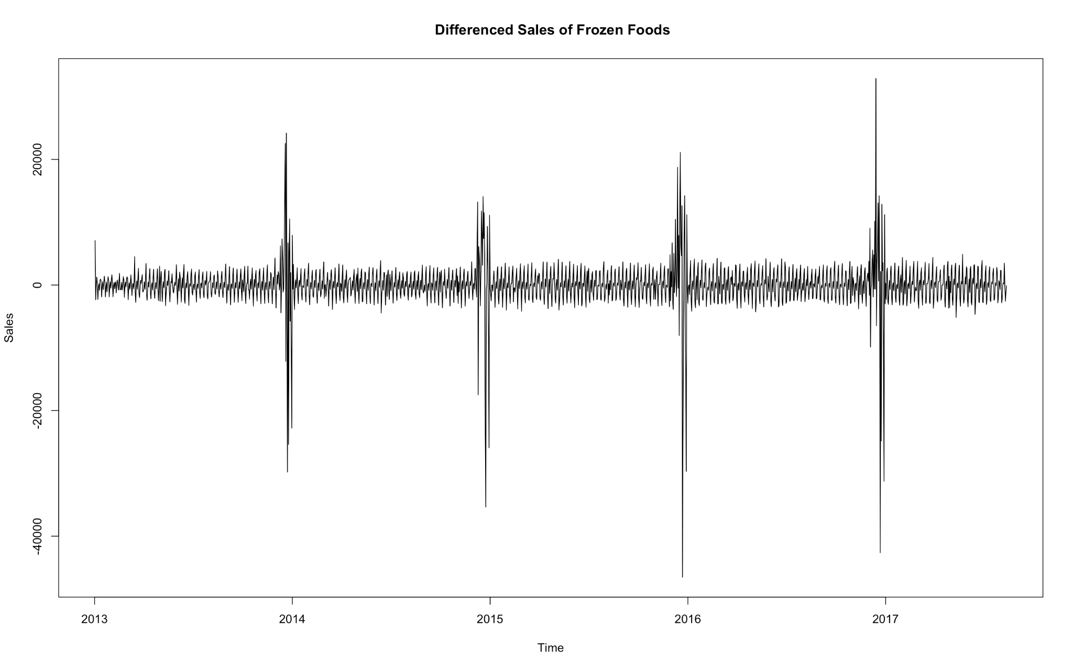

# Examining Relationship between Sales of different Product Families

## Correlation Analysis

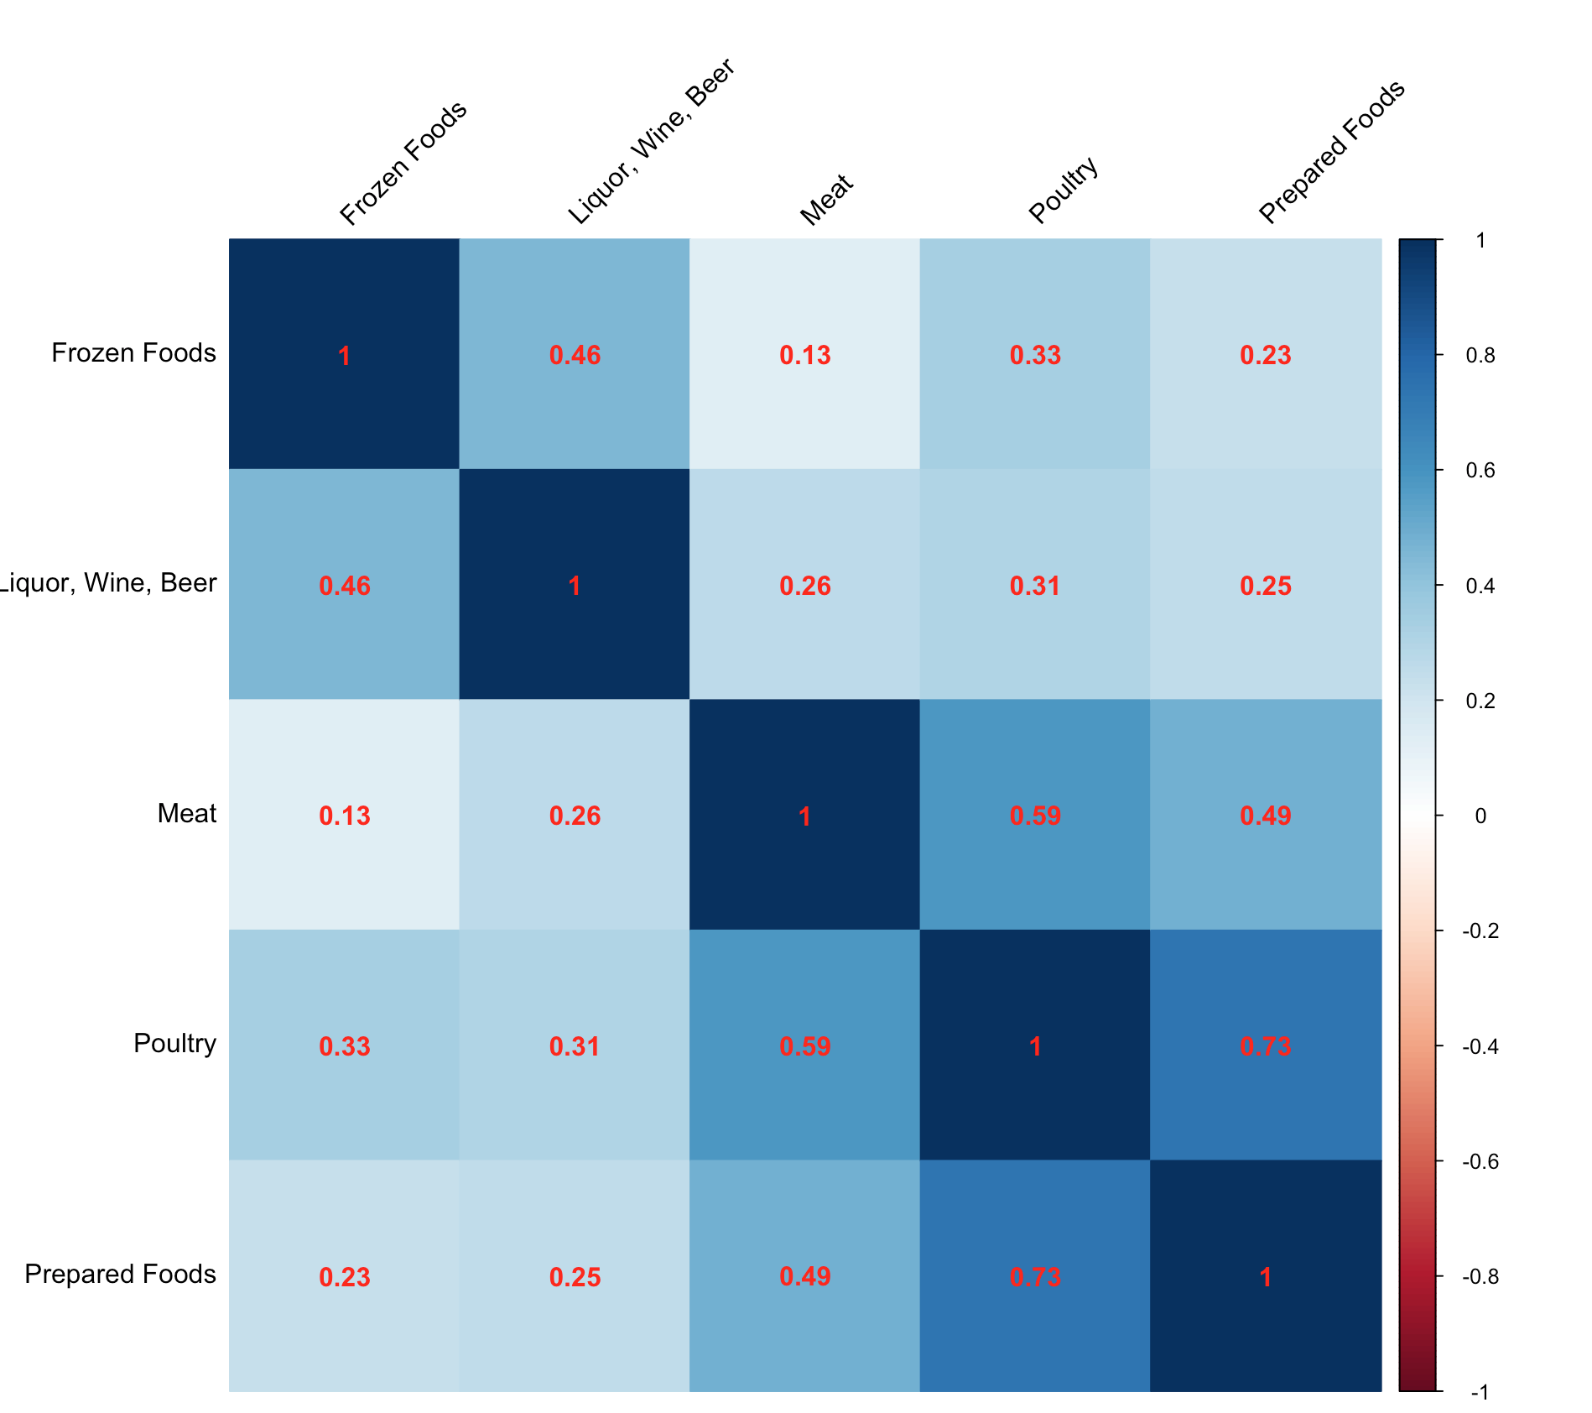

The strong correlations between poultry, meat, and prepared foods indicate that these items are often bought together, perhaps due to their complementary roles in meal preparation.

The positive correlation between alcoholic beverages and frozen foods could be linked to the convenience factor, as customers might be buying these items together for quick and easy meal and beverage solutions.

The relatively weaker correlations involving frozen foods might suggest that while there is some overlap with other categories, frozen foods are purchased by a more diverse group of customers with varying preferences.

## ScatterPlot Matrix

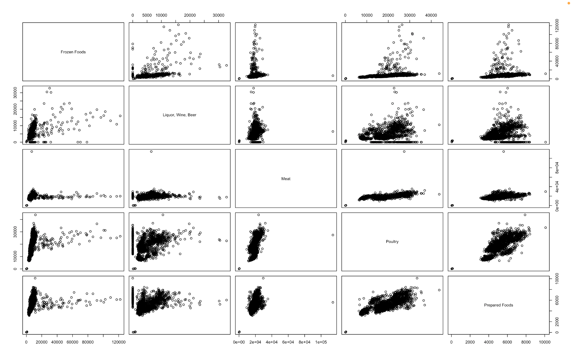

This scatterplot matrix illustrates the relationships between sales of different food and beverage categories. Notable positive trends include strong correlations between poultry and prepared foods, and poultry and meat, indicating that these items are frequently bought together, likely due to their complementary roles in meal preparation. Liquor, wine, and beer show moderate positive trends with frozen foods, poultry, and prepared foods, reflecting that customers who purchase alcoholic beverages often buy these items for convenience and entertaining purposes.

Many plots exhibit clusters of data points near the origin, representing frequent small purchases, with a few outliers indicating occasional bulk buys. For instance, high sales in frozen foods and liquor, wine, and beer coincide in some instances, suggesting a segment of customers making substantial purchases in both categories. The variability in data points, particularly in categories involving liquor, wine, and beer, indicates diverse purchasing behaviors among customers.

The observed trends suggest significant opportunities for retailers to create bundled offers and optimize shelf placement to encourage combined purchases, such as placing poultry and prepared foods in proximity. Additionally, targeting specific customer segments with promotions and loyalty programs can be effective, especially for those making bulk purchases. Overall, the scatterplot matrix highlights complementary purchasing patterns and variability in customer behavior, providing valuable insights for strategic marketing and inventory management.

## Granger Causality Test

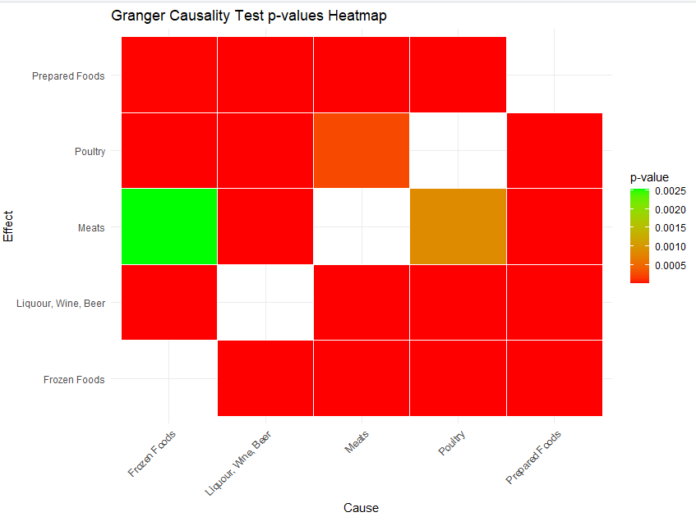

So because over here for example Frozen Foods is causing an effect on Poultry and Poultry is causing an effect on Frozen foods, we can say that even though their p-value is lower than 0.05,

They do not show a cause and effect relationship between the columns here. So from the plots above there seems to be a very strong correlation, and there is a very complex relationship between the variables because the p values of the causality and reverse causality both seem to be less than 0.05, implying causality from both ends, which represents a paradoxical situation, and requires a more in careful analysis of exogenous variables that might be impacting both of these variable.

Based on the relationships identified in the correlation analysis, we will further investigate these connections using VAR and MARIMA forecast models to gain deeper insights and enhance our understanding of the data dynamics.

# Multivariate Modeling

## VAR

### p=14

#### Preprocessing

For the present VAR model we did not apply any specific processing technique apart from handling anomalies using the Anomalize package and applying the differencing to make the time series stationary, in a bid to explore the quality of the results in the absence of any explicit pre-processing techniques. The results however, were not impressive.

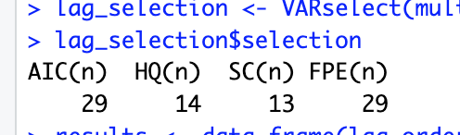

The above criteria were utilized to make a judgment regarding the VAR model. The AIC criterion usually tries to overfit the data while SC penalizes the model for too many variables and is too small usually, however the HQ criterion selects a middle ground between the two and since it also agrees with SC, a lag of 13 has been selected.

The following image shows the AIC and BIC values of the model

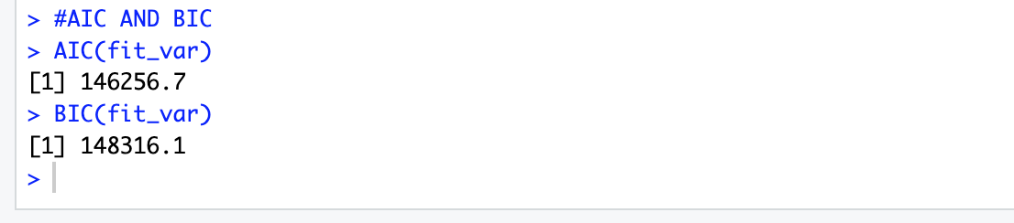

The AIC and BIC values are absolute numbers that are useful for comparison between models, the lower the better. The following tests were carried out on the residuals

The following image shows the results of the serial correlation test

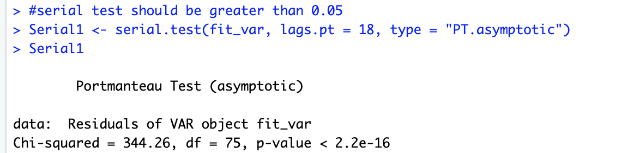

The serial correlation test in the above case, has a p value which is much smaller than 0.05, indicating that the errors are not random and there is significant correlation among the residuals of the model. Serially correlated residuals implies that the model has not been able to capture all the patterns in the data.

The following image shows the results of the ARCH test

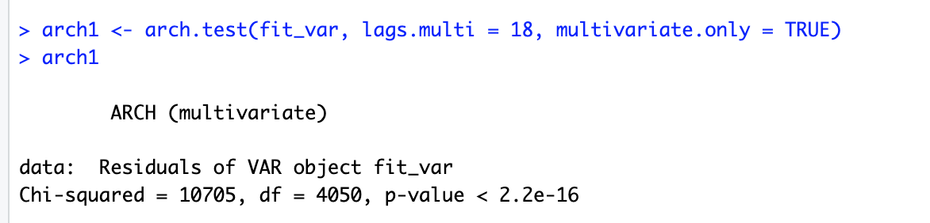

The p value of the ARCH test for the above model has a p value which is much smaller than 0.05, indicating the presence of significant heteroskedasticity. Heteroskedasticity indicates the presence of a time varying volatility and a changing variability in the residuals. Heteroscedasticity of residuals can lead to invalid confidence intervals, and can lead to misleading significance tests. It could also cause the forecast intervals to be too narrow or too wide.

The following image shows the results of the normality test

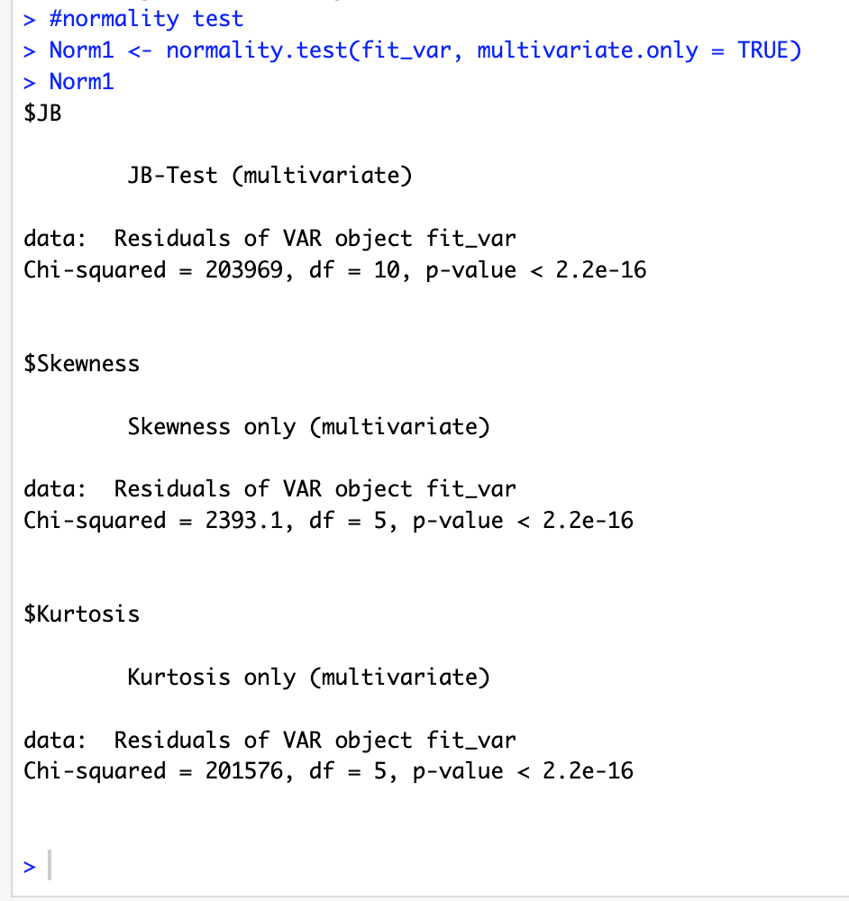

The extremely small p values of the JB-Test and its components which are skewness and kurtosis shows that the residuals are not normally distributed. If residuals are not normal it could mean that the model is systematically over-predicting or underpredicting, which means that the model is not accurately capturing the patterns in the data. It could also lead to incorrect prediction intervals,

The following image shows the results of the OLS-CUMSUM (Ordinary Least Squares - Cumulative Sum) Test for stability 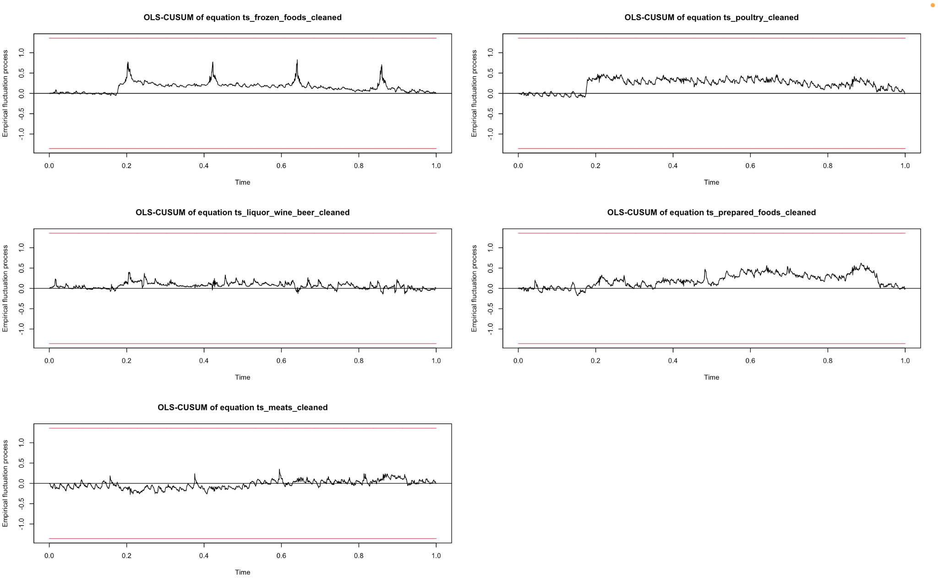

The above test is used to check for the stability of the residuals. If the plots cross the upper and lower confidence bounds then there is instability in the residuals. If that is the case, then it indicates that the coefficients estimated by the model may not be constant and hence are unreliable. This violates the assumptions of a lot of statistical tests leading to incorrect statistical results such as p values. So stability in residuals is paramount for the other types of residual analysis and for predictions to be accurate.

In the above case, none of the plots cross the upper and lower confidence intervals and hence there is a stability in the residuals of all the models.

#### Forecast

It is important to note that the forecasts have been made at the same scale as of the original data by differencing and in the subsequent forecasts all the other processing techniques were also undone. The forecasts have been zoomed into the last 200 days of the sales, although they have been fit on the entire data to give a better view into the forecasts.

#### 

### 

In the above plots the green line shows the forecast while the red and purple show the 95 percent confidence intervals.

### p=14

#### Preprocessing

For the VAR model at hand techniques like handling anomalies, taking a cube root to stabilize variance, scaling and differencing were applied, in an attempt to improve the quality of the results of the VAR model.

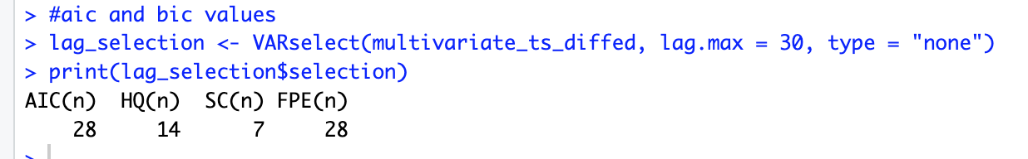

Once again, the above criteria have been taken into consideration when deciding the lag order, and the HQ parameter has been chosen as the driving force behind

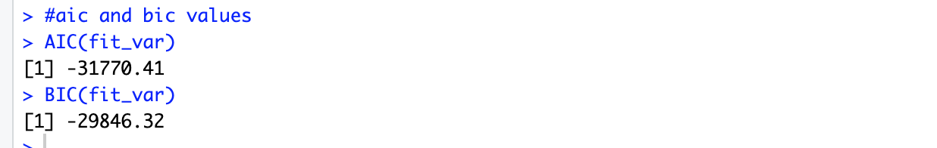

The AIC and BIC are extremely low indicating that the model has fit a lot better than before.

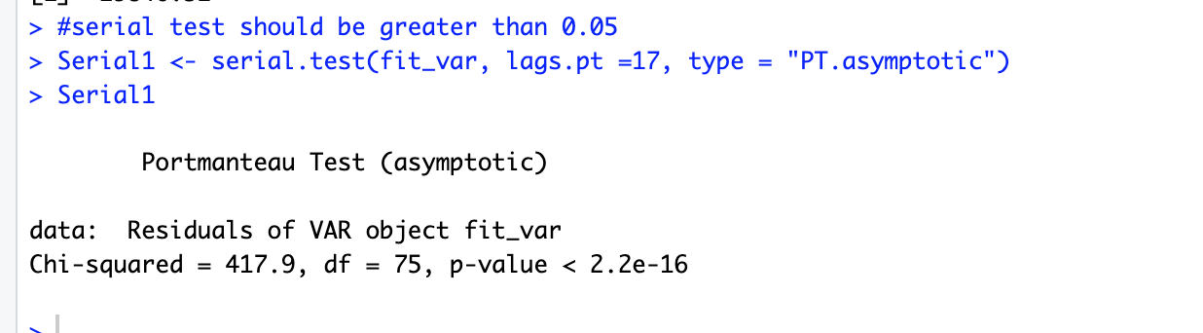

Based on the p value of the above test, there still is a significant correlation among the residuals of the model.

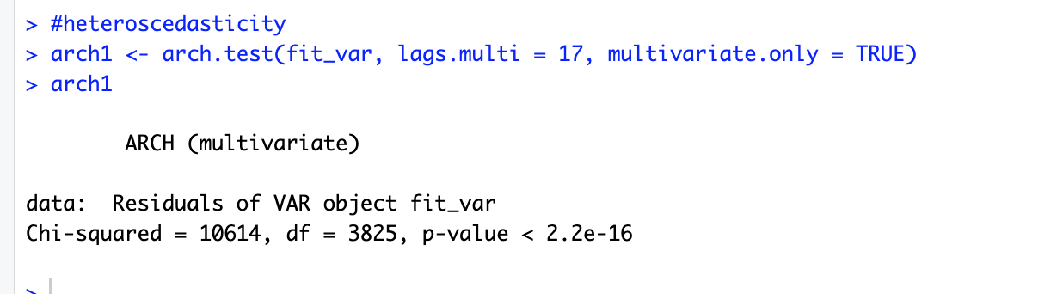

Based on the ARCH test, there is still significant heteroscedasticity in the residuals.

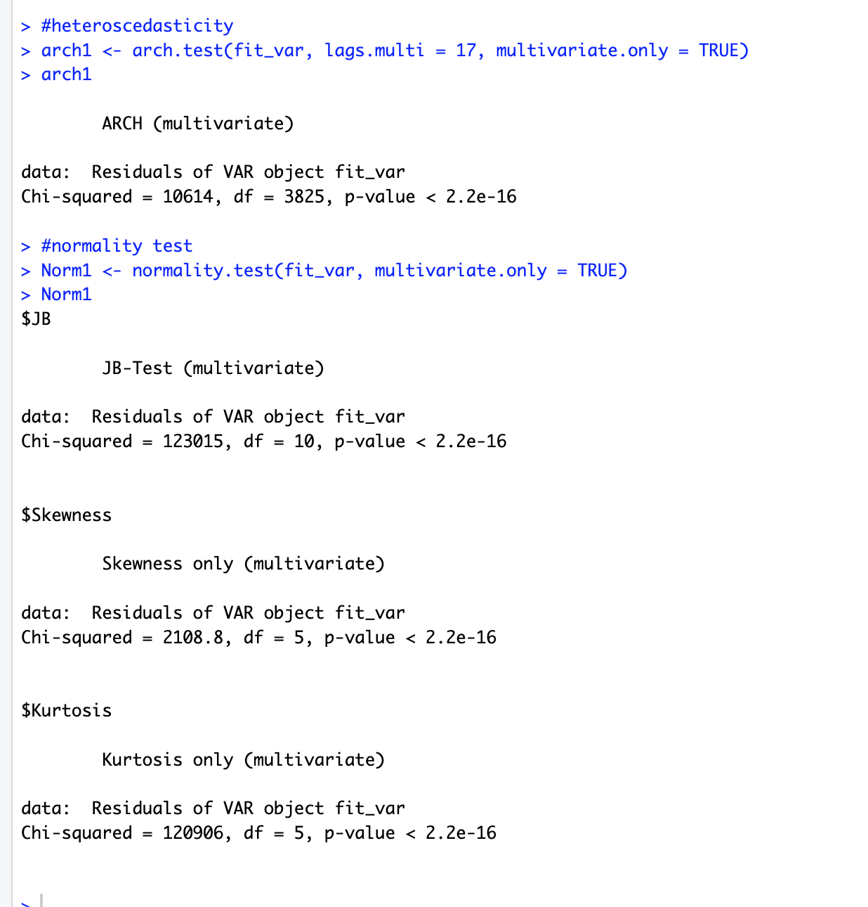

Based on the JB Test and its constituents the residuals are not normally distributed.

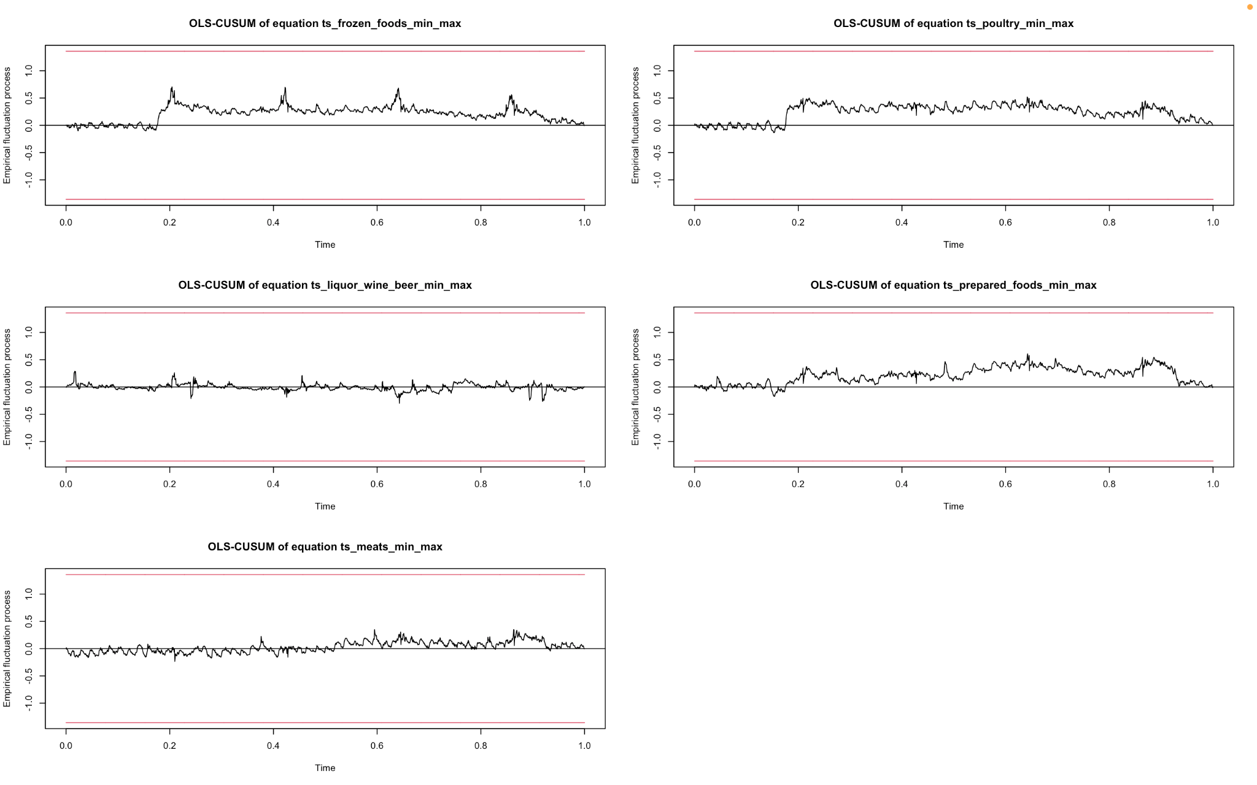

According to the OLS-CUMSUM test there is no structural break in the residuals of a model, which is preferable.

#### Forecasting

The following plots have been plotted after converting the predictions back to the scale of the original data and by zooming into the last 200 days of sales to give a better view.

#### 

### p=25

#### Preprocessing

For the VAR model at hand techniques an attempt was made to improvise the model by handling anomalies, scaling - to bring the time series on the same scale in order to prevent any single variable from dominating the forecasts and to ensure stability of the model and differencing were applied, smoothing - to reduce the effect of noise and better capture underlying patterns, and discarding out observations before the structural break that occurred on April 16 2016 due to the earthquake.

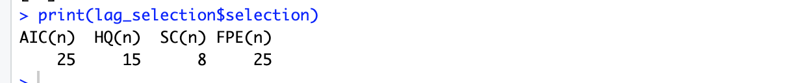

This time around an attempt was made to explore the results provided by the AIC model, with a lag order of 25.

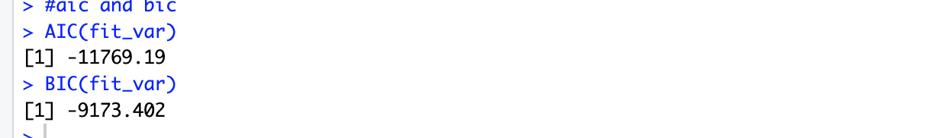

While the AIC and BIC values are negative and low, they are much higher compared to the previous model The following tests were carried out on the residuals.

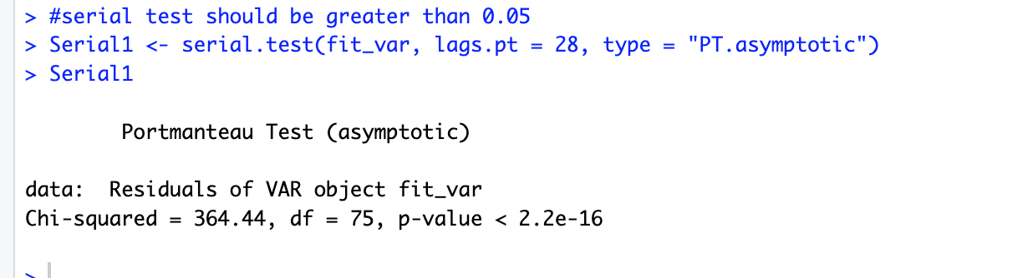

As has been the case with the previous models, the current model also has significant correlation among the residuals, which represents deficiencies in the model’s ability to capture all patterns inherent in the data.

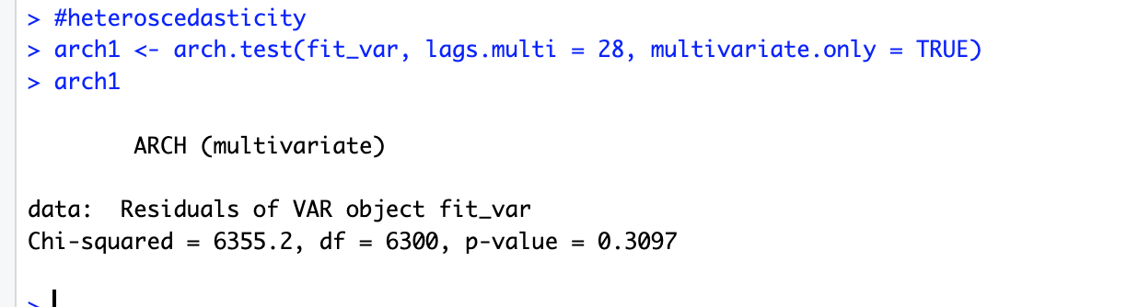

This is a very startling result, because the p value of the ARCH test is much higher than 0.05, hence the residuals of the model are homoscedastic and the variability is constant over time, which leads to better prediction intervals and forecasts.

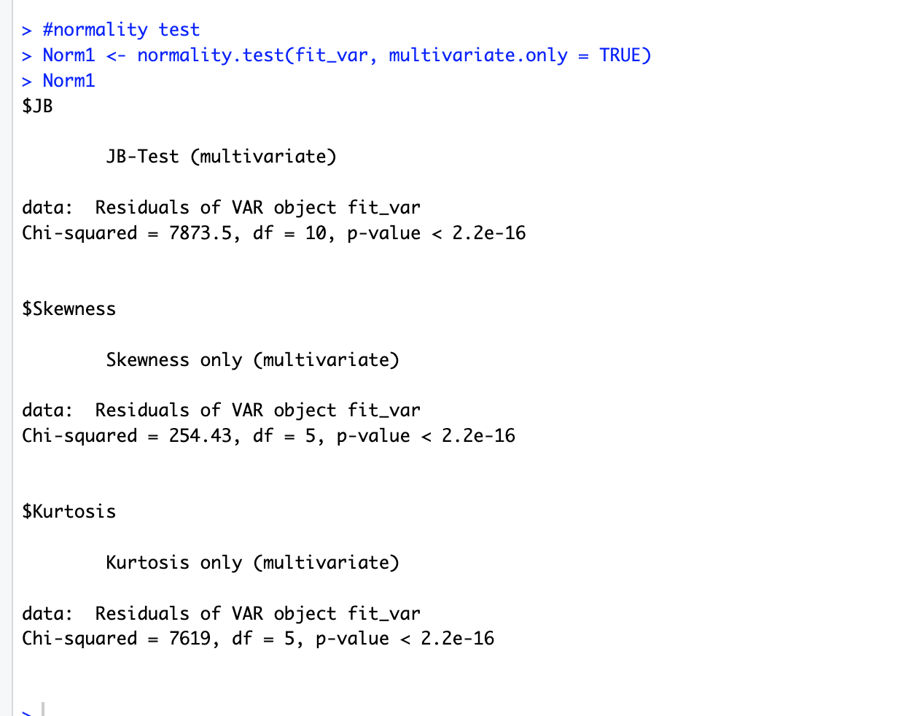

However the p values for the JB test and its constituents are extremely low, indicating that the residuals are not normally distributed.

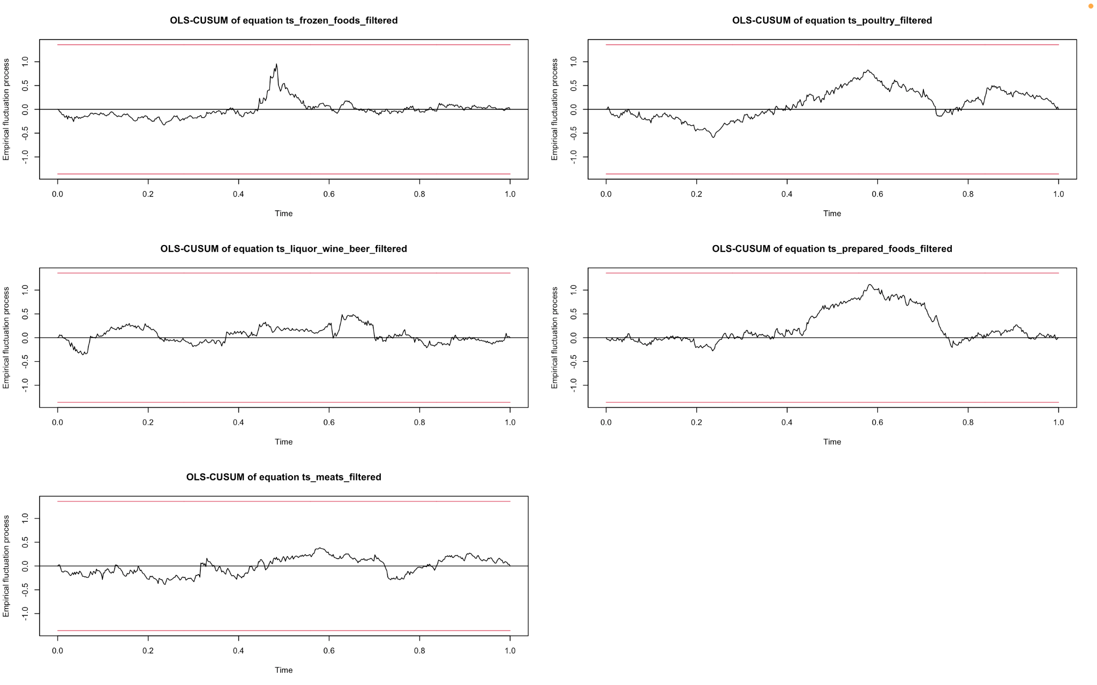

The model passes the OLS-CUMSUM test hence there are no significant structural breaks in the residuals of the model.

#### Forecasting

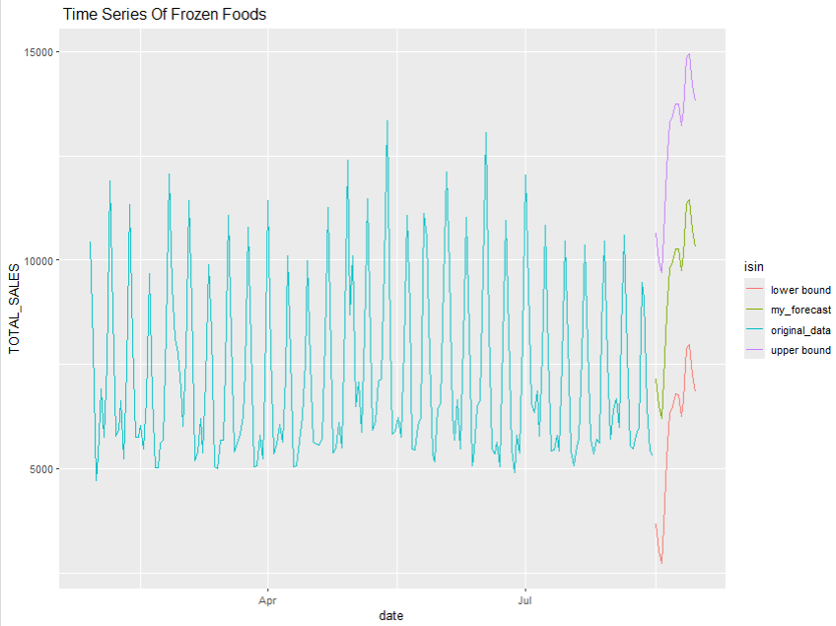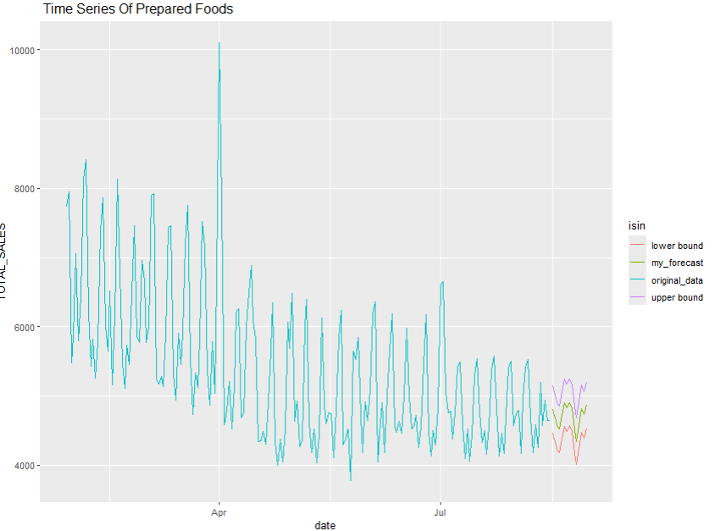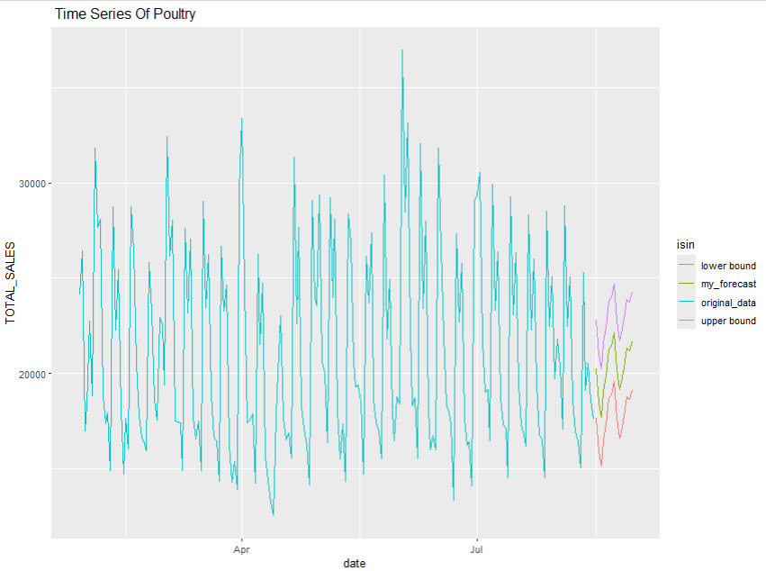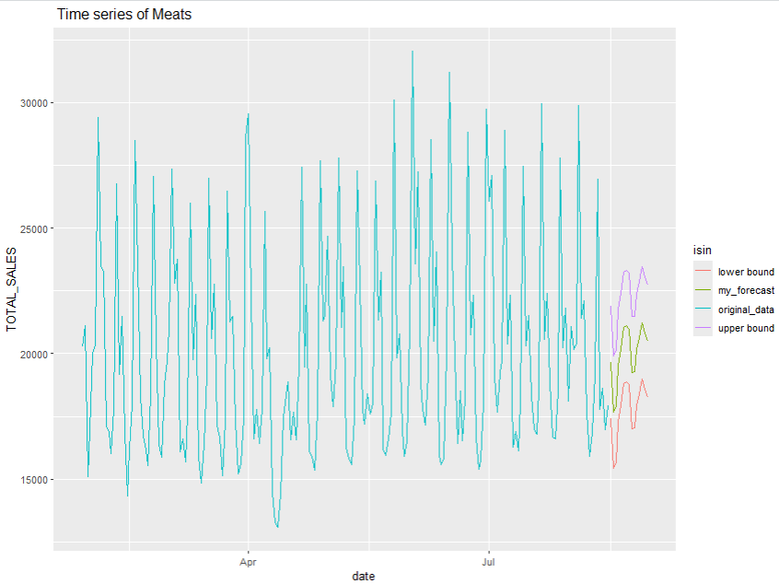

### 

### 

### 

### Excel Sheet Predictions

The predictions of the second VAR model (p=14 with cube root, ) with the lowest AIC and BIC, as it indicates better prediction

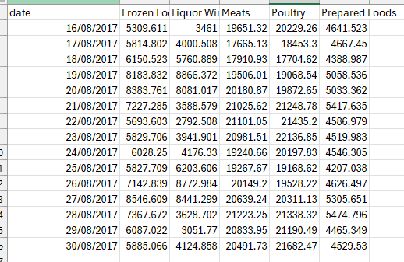

## MARIMA

Marima Residual Plot

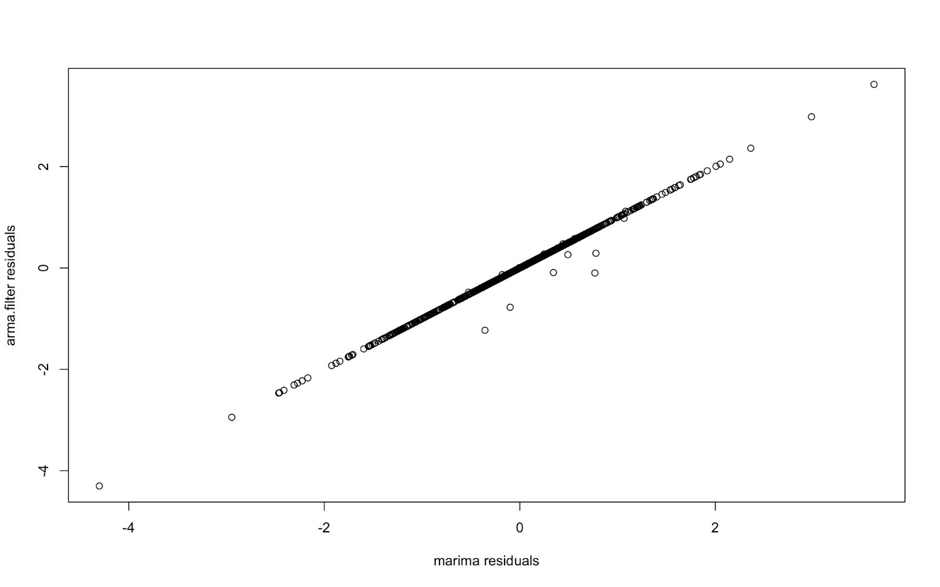

Linear Relationship: The residuals from both models exhibit a robust linear association, suggesting that the residuals from one model are closely linked to the residuals from the other model. This implies that both models might be detecting comparable patterns within the dataset.

Most of the residuals are concentrated around zero in both models, as is common for well-fitted models in time series analysis. This shows that both models are adequately representing the average values of the data.

Outliers present: Some outliers can be observed in the plot. These points are distant from the primary cluster and may suggest scenarios in which one model is more suitable for the data than the other.

Grouping: The close grouping of points along the diagonal indicates that the majority of residuals have similar magnitudes for both models. This means that the mistakes made by both models can be compared.

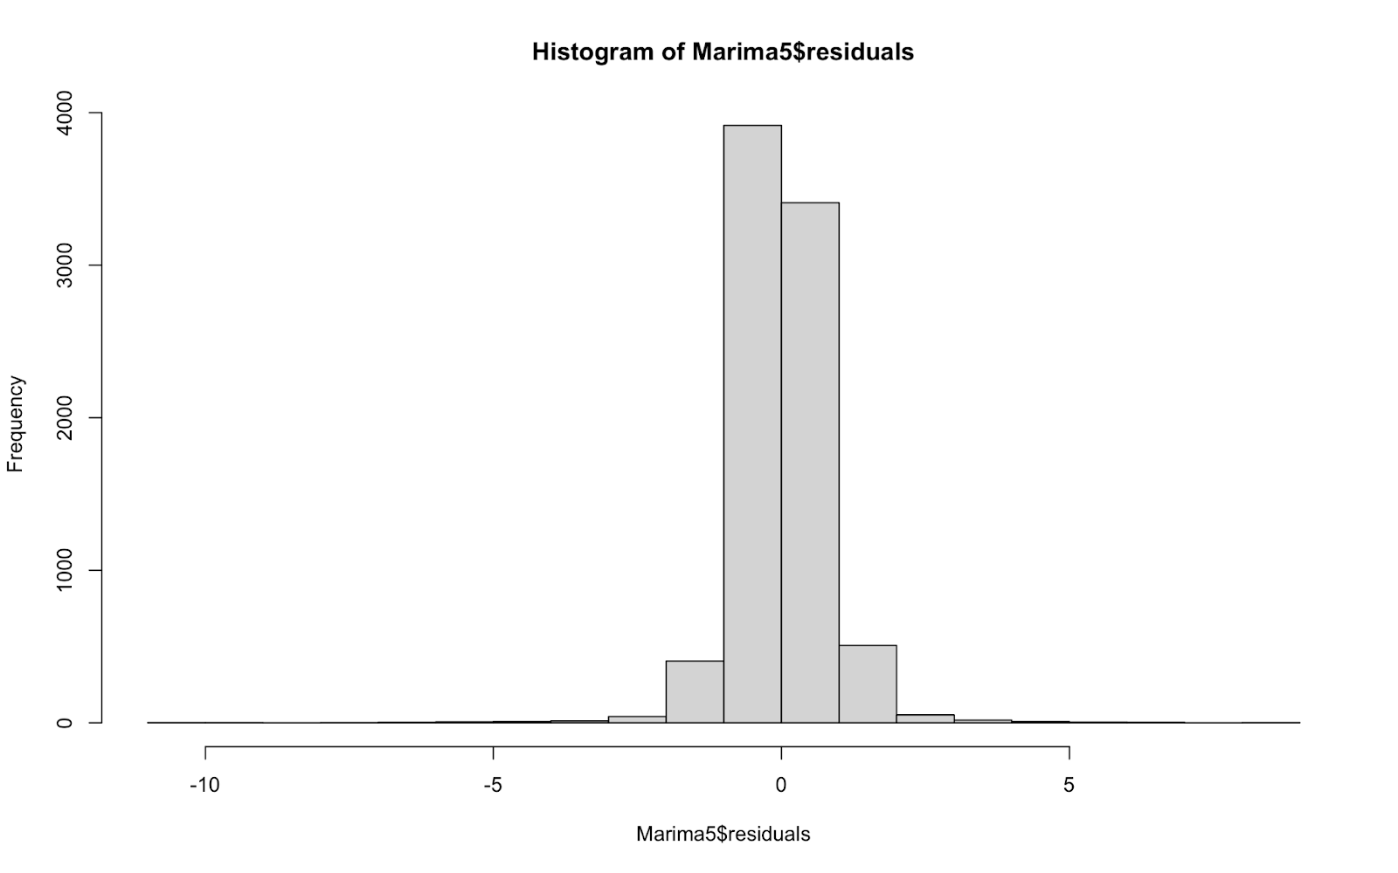

Residuals are distributed in a nearly symmetrical manner around zero.

The majority of the residuals are near zero, indicating a strong fit of the model to the data.

High frequency is concentrated in the center.

A large number of residuals fall within the -1 to 1 range, suggesting that the majority of model errors are minor.

The peaks located in the middle indicate that the model is correctly forecasting the majority of data points.

The tails of the distribution (both on the left and right edges) have long lengths, yet with very rare occurrences.

Some residuals are significantly high in magnitude, suggesting the potential existence of outliers or data points where the model is underperforming.

The distribution seems to be leptokurtic, indicating it has fatter tails and a higher peak than a normal distribution. This indicates that there are an increased number of outliers compared to what is typically seen in a normal distribution.

Symmetry at zero suggests that there is no consistent error in the residuals; essentially, the model is not consistently over or underestimating the actual values.

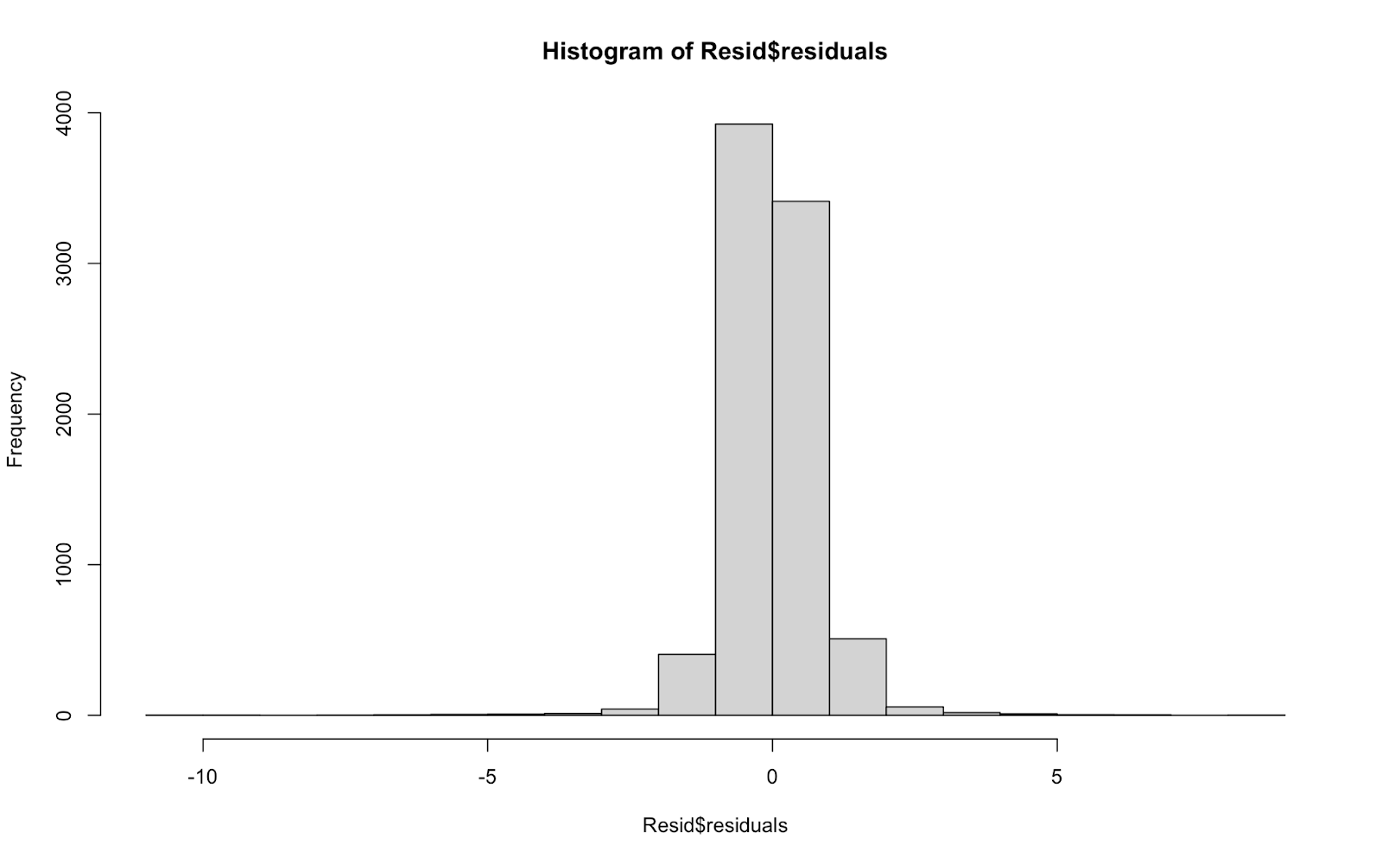

The residuals center mainly around 0, suggesting that most data points have slight discrepancies between predicted and actual values.

The histogram shows a distinct bell curve distribution, which usually suggests that the residuals are normally distributed. This is a positive indication since numerous statistical models (like linear regression) rely on the normal distribution of residuals.

The frequency distribution of the histogram is fairly even on both sides, making it approximately symmetric.

There are a couple of bars near -10 and 5, suggesting the existence of outliers, but their quantity is fairly limited.

The central frequencies (near 0) are extremely high, surpassing 4000, whereas they decrease considerably towards the boundaries.

residuals_ts <- ts(t(Resid$residuals),start=c(2013,1),frequency=365)

plot(residuals_ts)

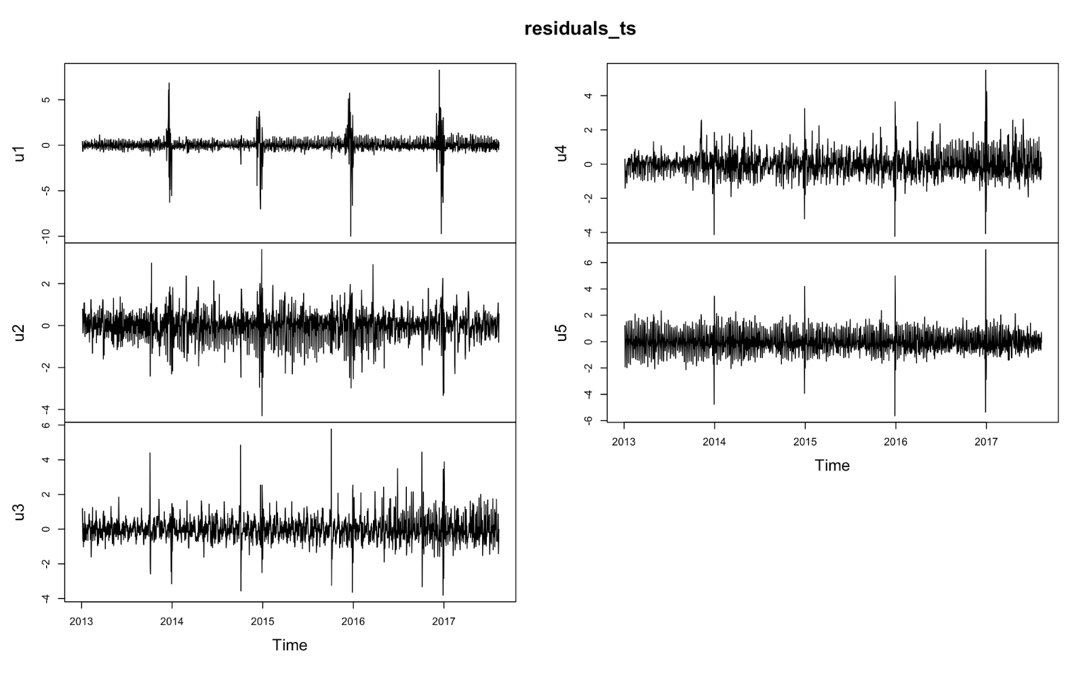

Every series shows a tendency to fluctuate around zero, indicating that the leftovers do not have any substantial prejudice over time.

Each sequence contains intermittent spikes, showing moments when the model's forecasts were notably inaccurate.

The residuals indicate that the model usually performs well, with occasional notable deviations.

The patterns of spikes and fluctuations indicate that there could be specific timeframes or occasions that lead to the model's inadequate performance.

Additional research is necessary to understand why there are spikes and increased volatility periods in order to enhance the accuracy of the model.

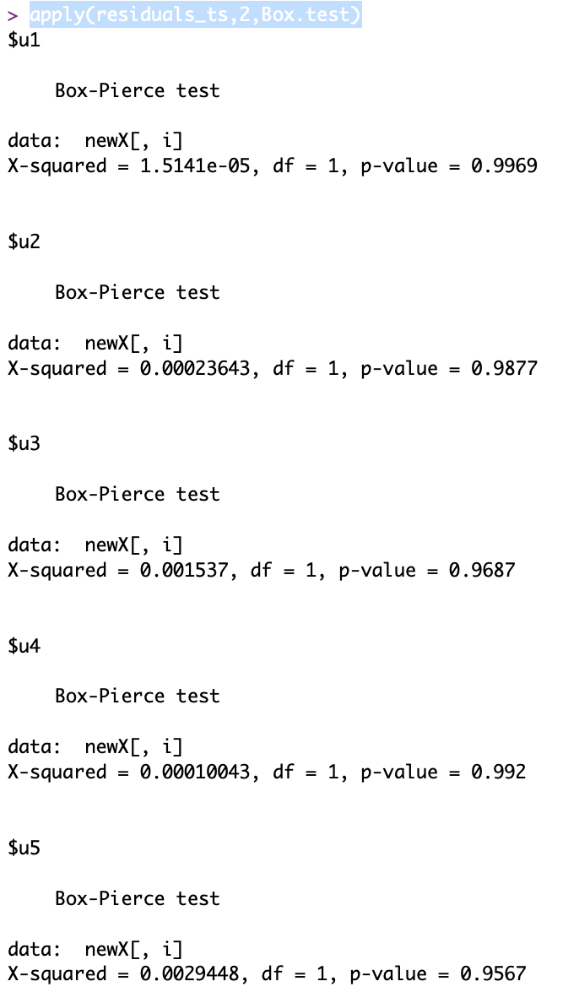

For every test conducted

The p-values are all approaching 1, indicating that we cannot reject the null hypothesis.

Hence, there is insufficient proof of autocorrelation in the residuals.

This implies that the residuals in the time series model are distributed independently, a positive sign that the model is accurately specified.

acf(residuals_ts)

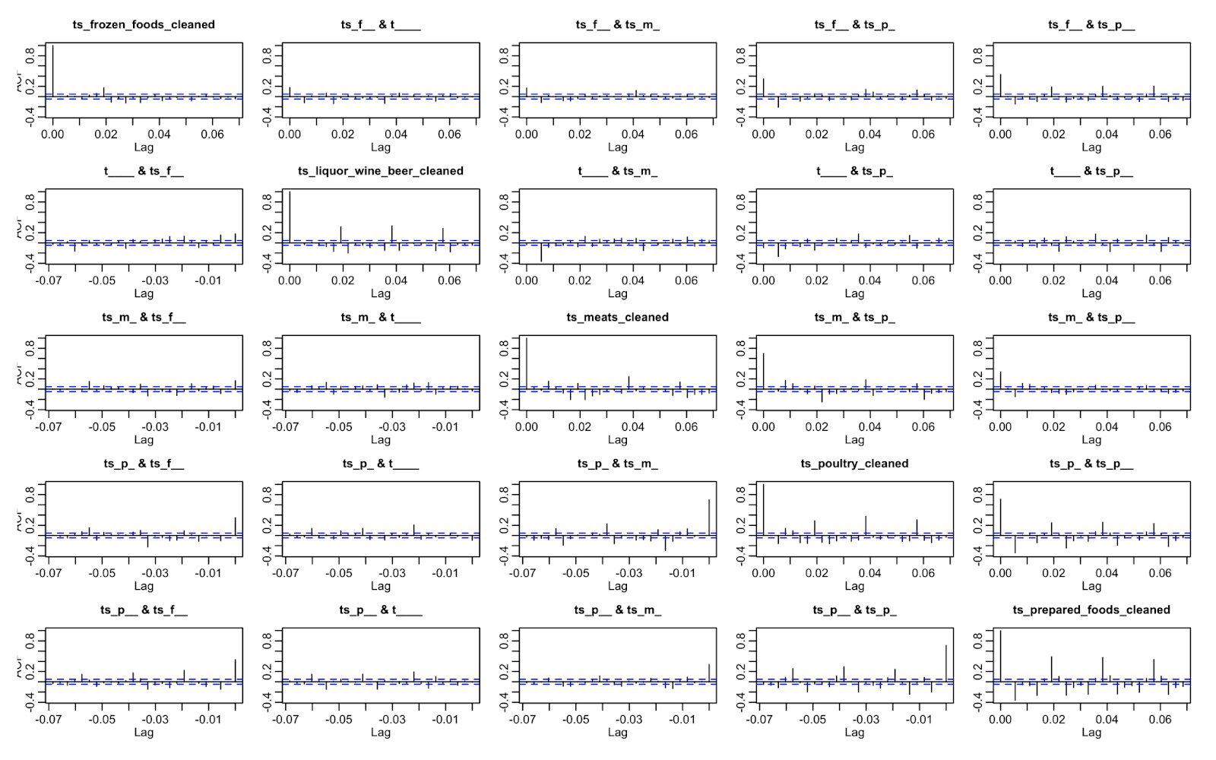

The plot shows several ACF charts for different time series data sets, showing the level of autocorrelation at different time lags for each set. Each subplot shows a separate time series, with the x-axis indicating the lag and the y-axis showing the autocorrelation coefficient. Confidence intervals are represented by blue dashed lines and are generally established at a 95% level. The goal of these graphs is to visually determine if there is any notable autocorrelation present in the data. If the autocorrelation coefficients are within the confidence intervals, it indicates that there is no significant autocorrelation in the time series at those lags.

After a more thorough analysis, it is evident that the majority of the time series show autocorrelation coefficients that fall within the confidence intervals, indicating the absence of significant autocorrelation. This is a sought-after trait, showing that the residuals or series are distributed independently, a key requirement for numerous time series models. Nevertheless, some outliers exist, like the 'ts_liquor_wine_beer_cleaned' series, displaying peaks beyond confidence intervals, suggesting potential autocorrelation at certain lags. Further examination or adjustment of the model may be needed for those particular datasets to ensure that the time series model accurately reflects the underlying patterns and limits significant autocorrelation in the residuals.

pacf(residuals_ts)

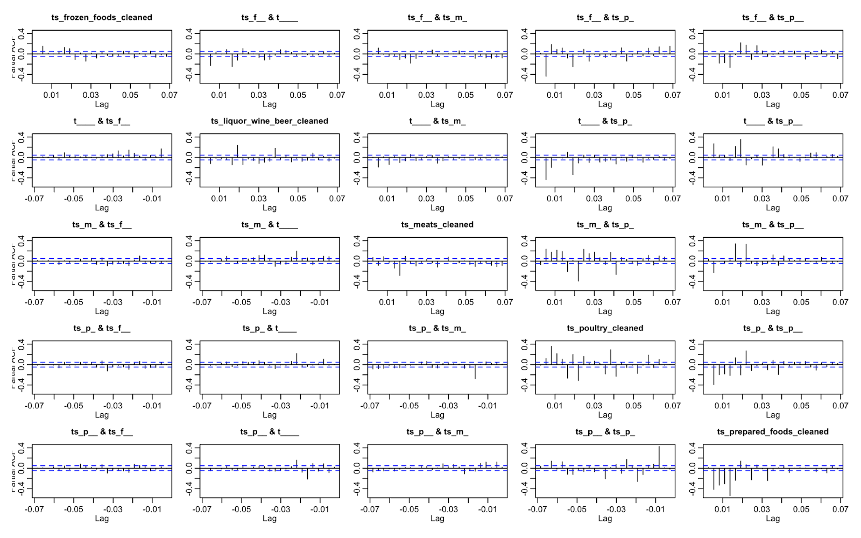

Marima Fit

The majority of the plots indicate cross-correlation values close to zero inside the confidence intervals, indicating a lack of significant connection between many time series pairs at the specified lags. Nevertheless, there are a small number of plots that show sudden increases indicating possible connections at particular delays. For instance, the graph of "ts_meats_cleaned" displays a significant increase, suggesting a possible connection. This examination is important for grasping the dynamic interconnections among various sales or consumption categories over time, supporting businesses in predictive analytics and strategic decision-making.

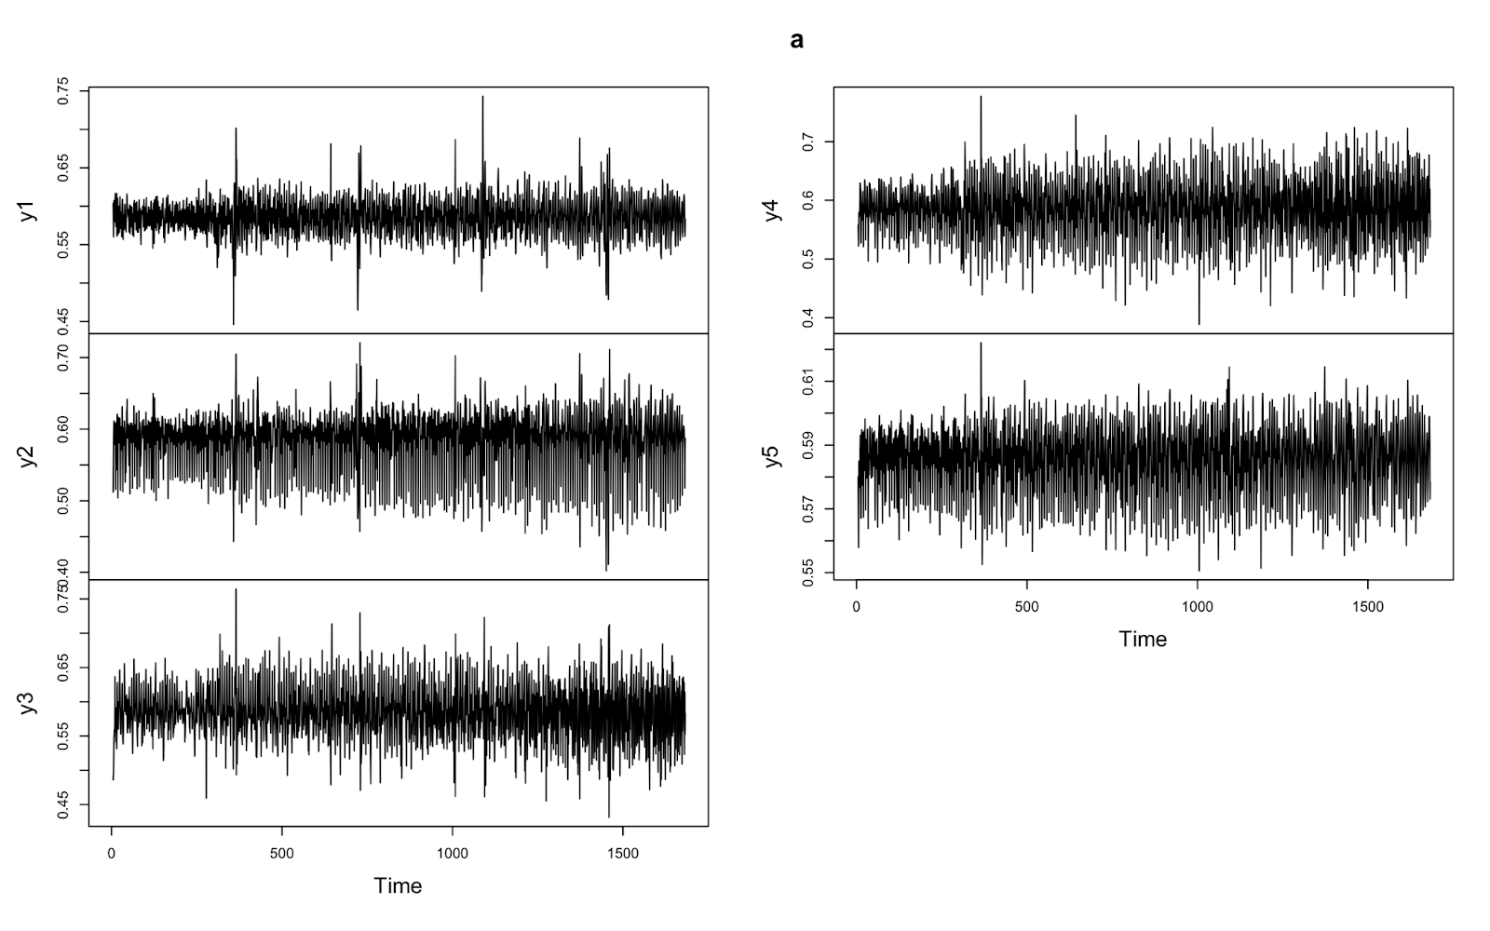

Each of the variables (y1, y2, y3, y4, y5) shows considerable variability with frequent spikes, indicating dynamic fluctuations as time passes.

No distinct upward or downward trend can be seen in any variable, suggesting that they are relatively stable around their average values.

The presence of frequent spikes without a distinct trend implies the existence of underlying periodic elements or noise in the data.

Variables y1, y2, and y4 show similar value ranges and patterns of variability, suggesting they behave similarly.

Variable y3 displays a slightly reduced range in comparison to y1 and y2, indicating lower variability.

Y5 has the narrowest range of all variables, showing the least amount of variability.

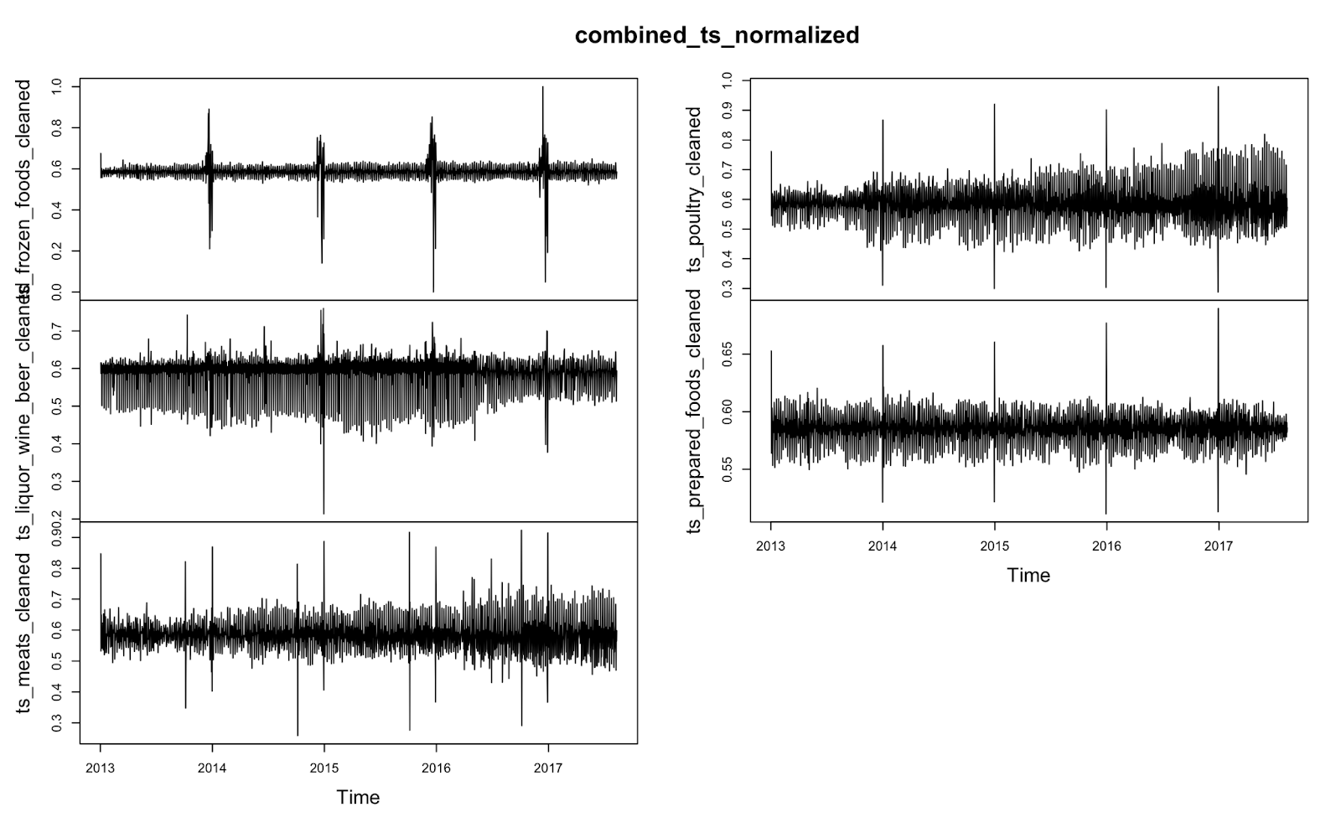

The data seems to display regular increases and changes, suggesting seasonal or cyclical trends in the consumption or sales of these types of food. For instance, there are clear peaks in the frozen foods section, which may align with periodic surges in sales, perhaps during peak holiday or seasonal periods.

On the other hand, certain categories like ready-to-eat meals and chicken show less dramatic increases and more regular fluctuations, indicating a more consistent consumption trend all year round with occasional high points. The overall tendency in most categories portrays a small rise in standardized values throughout the years, suggesting a possible increase in consumption or sales overall.

Time Series Forecast

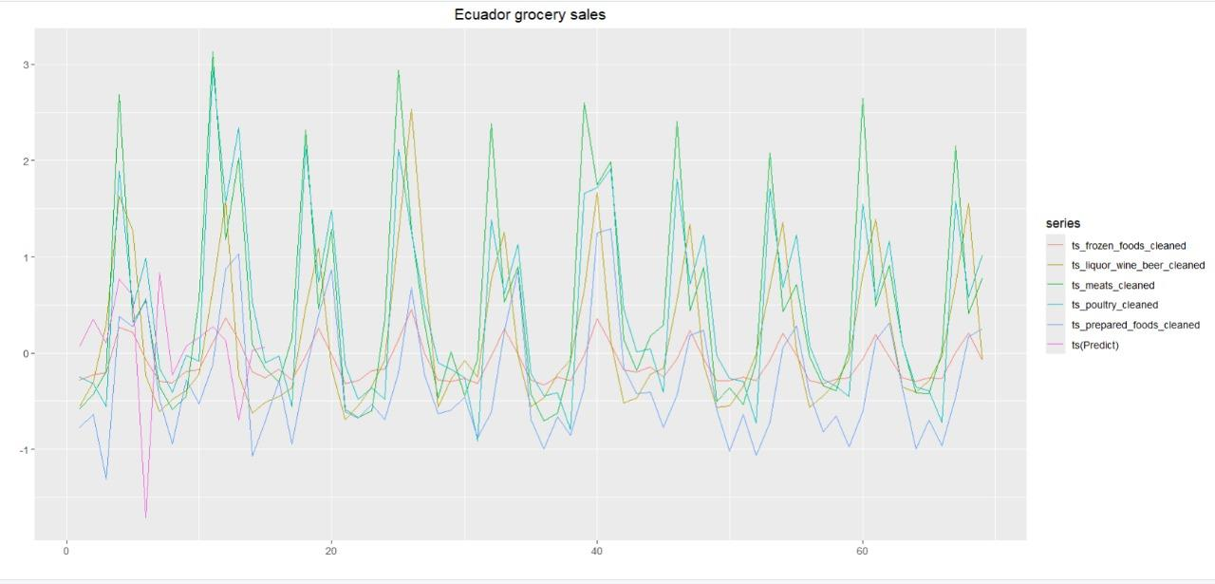

When examining sales data in various grocery categories, several important observations can be identified. The strong seasonal pattern is illustrated by the clear, repeating peaks and troughs observed in the data. This indicates that sales in these categories are affected by repetitive elements like holidays, weekends, or other cyclical events that continuously influence consumer behavior. The alignment of these high points and low points in various categories highlights the existence of common seasonal influences, showing that external factors impact sales trends evenly.

Secondly, the connection between different sales categories indicates a significant similarity in their trends. The highs and lows seen in different categories often happen at the same time, indicating a strong link in how they react to outside influences. This connection indicates that influences on consumer demand in one area probably impact other areas as well, underscoring interlinked dynamics within the market.

The line named "ts(Predict)" closely follows the real sales data, showing that the predictive model successfully captures the overall pattern and seasonal trends of sales. Although there might be slight discrepancies between expected and real values, the general agreement indicates that the model effectively accounts for the cyclical patterns and fluctuations in consumer behavior, offering a dependable method for predicting future sales patterns within these grocery sectors.

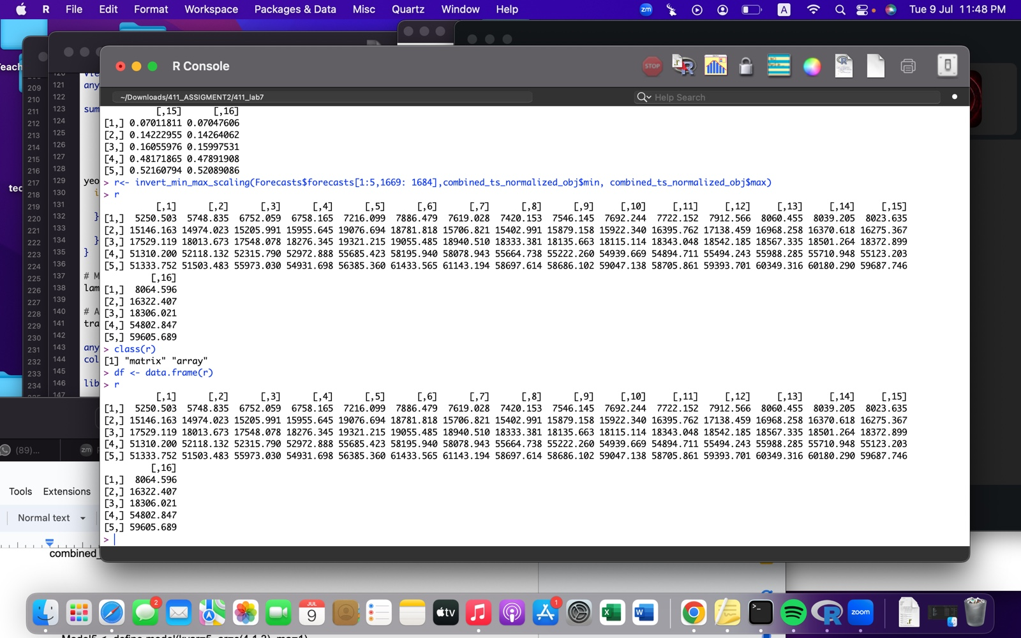

# Conclusion

This presented document dwelt upon and examined the series of processes necessary in time series modeling right from pre-processing to analysis of models and their residuals.

It incorporated several key sections like the basic yet extremely crucial exploratory data analysis, which encompassed a examination of the time series and the underlying patterns at several levels of complexity beginning with the preliminary run sequence plot, which gave a bird’s eye view into the manifestation of the complex interaction between various components, followed by a more comprehensive decomposition analysis, which unraveled underlying patterns, including the very elusive weekly seasonality.

An attempt was made to explain the observations keeping in mind external factors, like earthquakes, oil prices, GDP fluctuations, and the like, which necessitated thorough research and scrutiny of facts.

Structural breaks were examined using change point analysis and a thorough examination of the peaks and troughs by zooming into each year’s sales revealed some interesting patterns.

Sales at various levels of time granularities were examined through the years’ in a bid to look at both local and overarching patterns to gain a comprehensive understanding of the underlying pattern. In order to quantify the relationship between the sales of different product families, several visual and statistical techniques were examined, which provided a basis to perform the multivariate analysis.

The multivariate analysis of data was performed using the esteemed VAR and MARIMA models, where several attempts have been made, leveraging an interesting and well thought out amalgam of processing techniques, such as normalization, smoothing, mathematical transformations (like log, cube root, inter alia), differencing, among several others were used. These attempts were coupled with a detailed analysis of residuals in a bid to estimate the quality of the model, and with an eye to improve further modeling.

# References

[Faith (2023). *Drinking Age in Ecuador: Accurate for 2024 -*. [online] https://3ticketsplease.com/. Available at: https://3ticketsplease.com/drinking-age-in-ecuador/#:~:text=In%20a%20move%20designed%20to [Accessed 9 Jul. 2024].](https://3ticketsplease.com/)

[Johnston, J. and Vasic-Lalovic, I. (2023). *Ecuador: A Decade of Progress, Undone*. [online] Center for Economic and Policy Research. Available at: https://cepr.net/report/ecuador-a-decade-of-progress-undone-full-html/.](https://cepr.net/report/ecuador-a-decade-of-progress-undone-full-html/)

[MEDINA, J.L., LUGO, K., VARGAS, J., MORALES, N., BURGOS, A., MARTÍNEZ, E.P., ORTEGA-PAREDES, D. and REVELO, M. (2019). Ecuadorian mainland industrial poultry production is free of H5/H7 Avian influenza virus: National surveillance program in 2016. *The Journal of Veterinary Medical Science*, [online] 81(11), pp.1597–1600. doi:https://doi.org/10.1292/jvms.19-0253.](https://doi.org/10.1292/jvms.19-0253)